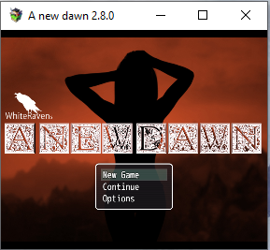
WhiteRaven’s
A New Dawn 2.8.0
Walkthrough
At the start of the game, you are offered a choice to allow watersports and skip the introduction. If you want to access all scenes you cannot skip the introduction. This walkthrough is for ALL scenes.
I will start with a walkthrough for the storyline, then have a listing of how to get the additional scenes.
For anyone who has not played this game previously. Dreams can play a big part into opening new scenes/paths

Day 1.
You wake up alone in your bedroom after hearing a loud scream. You walk south and encounter flames, you still need to walk towards the front door, before you are forced back by the flames. Realising the building is on fire, you must head back to your bedroom and exit the building via the window.
After leaving the building, you need to walk around to the front to witness your parents being kidnapped.
You automatically chase them for a while until you encounter a young man and a wagon.
To view the first bad end, refuse to go with the young man and go on your own. You will need to walk around for a minute or two before you encounter a goblin horde and are captured triggering the bad end.
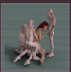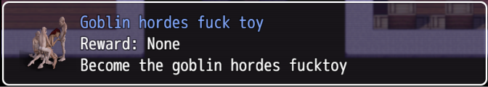
If you did agree to flash the young man and accept the ride, he will give you new clothes and you will have a nap in the cart as he takes you to a refugee camp.
If you did the bad end, you will wake up at the refugee camp as though you accepted the ride.

Refugee Camp
There are 2 ways that you can progress from the refugee camp. You can go with the incomplete slave route, or you can flash the guard captain to go to Human Town.
There are a couple of things you can do while in the refugee camp, to change Victoria’s statistics.
You can talk to the old man at the tent and let him grope Victoria or slap his hand away.
You can comfort or ignore a destitute man. 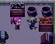
Slave Route
To Follow the Slave Route: 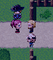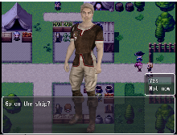
Talk to the slaver captain at the East of the map. (He is the blonde man in the middle)
Agree to take the ship and escape from the monsters.
You will be kidnapped and sold into slavery.
When you are in you cell and allowed to move, you can examine your cell, but to proceed, you must go to the bars/door and scream. The jailer will come and start your training.
(If you continually obey, you will lose the choice to disobey.)
If you disobey him for the first day, you will be placed in a box with Victoria’s head out and forced to give blowjobs all day, when you return to your cell, you are given a dildo and go to sleep.
If you obey him, you will start your blowjob training. You are given a dildo and go to sleep.
In the morning a goblin will enter the cell bringing Victoria’s food. He will ask Victoria to beg for the food. If she begs for the food, he will force Victoria to give him a blowjob. If she refuses, he will make her watch him cum on her food.
(Each day, Victoria should eat her food, and use the dildo for bj practice)
Pull the rope to call the jailer.
If you disobey him on the second day, you will again be put in a box, you will be gagged and forced to suck goblin cock all day.
If you obey him, you will continue your bj training.
By the third day, you can no longer disobey the jailer, and continue your blowjob training.
There is not much content on this path. You can have dreams until Victoria dreams of her face being covered in dicks while sucking dick, and you can start deepthroating the dildo; with your training, you can only get to the point where the jailer mentions you may need to go onto bigger toys.
Touch the orange flame to be teleported outside of the prison and back to the refugee camp.

To go to Human town, talk to the carriage boy, agree to go with him.
Talk to the guard captain and flash him. 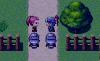
Go back to the carriage boy, he will ask how you managed to convince the captain to allow you to pass. You can tell him or lie. He will then take you to Human town.

Human Town.
On the first day arriving in Human town, your first task is to find somewhere to sleep. You automatically are taken to the inn. Insulted you leave and go into the first house. Bargain with the man for the price of the room. Leave and automatically go to the next house. Ask about the room, then ask about the favor. You will then leave and are supposed to choose a place to stay.
Go north to the tavern, in the corner of the tavern are a group of people. 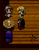
Walk towards them to trigger a scene. You can choose to follow them or not. Follow the people. Leave the taven and walk around the back. You will witness the prostitute having sex with her clients. You can choose to steal the money after they are done.
Go the flashing point just south of where you are to enter the glory hole.
You get embarressed when you realise what it is and leave.
Go back into the tavern and talk to Sarah. (she is the Red Head woman sitting alone.)
She will ask if you want to join her group. Agree, and she will tell you that you need to convince a guard to buy you a beer. If you have done the slave route, your corruption should be low enough to allow this.
Go to a guard sitting at a table and talk to them. Victoria will be offered the option to flash the guard, choose this option. Once you have flashed the guard, you can report back to Sarah.
Talk to Mary (the lady behind the bar.) She will offer you a job, cleaning the bottles off the floor. Accept the job, clean the bottles, and report back to Mary.
It will now be night time and the patrons of the bar are now different.
You can look at the woman dancing on stage to admire her moves. Leave the tavern, and walk around the back of the tavern. You will see two people in the alley. If you approach, you will be offered the choice to watch them, leave, or interrupt them. Afterwards, return to the taven.
Talk to the black patron at the bar, allow him to buy you a drink, and then allow him to grab Victoria’s ass.
Leave the tavern and go towards the inn, head south to the sewers, to view a scene with Jasmine the town whore.
Go East to the town store, you can enter via the crack to the left. Steal the carrots (this will start the watersports path.)
At this point, you are required to choose a place to sleep. (Different scenes are available depending on which house you choose. I have explained them in the additional scenes.)
Go to the room and go to sleep.
You will have your first dream (dreams can open up different paths.) There are 2 dreams per night.
Wake up in the morning and leave the house, as you are leaving you will be told about the tax to stay in town. Leave the house and you can choose to watch the meanwhile scene (this is showing what is happening to your mother.) Talk to the tax man, you can agree to flash him for a discount on your tax.
After this, you will see a note from Sarah asking you to go to the tavern.
Talk to Sarah, she will tell you to leave town, head south and scout the orc camp. Before leaving, talk to a guard and ask about current rumours.
Leave town and head south. You will meet up with Sophie who will take you to the orc camp.
Click on the flashing rock, to scout the camp.
If you walk towards the entrance of the orc camp, you can get caught by the two guards and trigger a bad end.
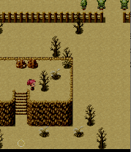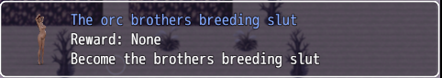
Leave the camp, head back to town, before you get back to town, go to the east of town, to talk to the witch.
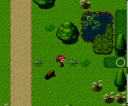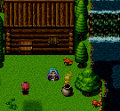
She will offer a solution to your dreams, accept and head back to town.
In town, you will see a new npc near the wash lady. This is Juliette, she shows up in town every three days, she is at the tavern of a night and while at the tavern; Victoria can talk to her to cure her cum addiction.
You need to do two jobs to change from day to night.
You can work for the wash lady (Wendy.)
You can feed the hens (or sell the food for forage.)
You can brush the horses.
You can babysit the grandchildren. (This is only available until Victoria starts flashing while working in the tavern.)
You can also clean up the bottles in the tavern.
If your corruption is low enough, you can enter the door of the glory hole and work at the glory hole. (If you have had a dream of working in the glory hole, you can sneak in again, and watch the lady work in the glory hole.)
At night time, go to the tavern to be able to work at night.
Talk to Mary (the lady behind the bar.) and she will offer Victoria a job as a wench.
Work as Wench and then talk to Blake (the black Patron at the bar.)
Go see Jasmine (the town whore) again.
Go into the shop and steal the carrots again.
***If there is a sack beside the crate of carrots, this means the shopkeeper will catch you if you steal. If the shopkeeper catches you, he will force you to pay him back by working as a prostitute behind his store. If he catches you stealing again, he will make Victoria go to the alley behind the tavern and ask the patrons to piss on her.***
Go to the tax man and pay your tax.
Go to your room, pay the rent and go to sleep.
After you wake the next day, go to the orc camp and scout.
You will see 2 women captured and being held in the camp.
Before heading back to town, go see the witch again.
She will tell you to gather ingredients.
Before you give the ingredients to the witch, you must speak to bogwart or he will disappear for the game. (Bogwart is located 1 map south and 1 map west of the witch.)
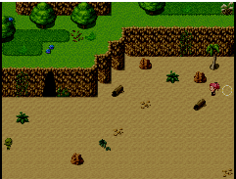
(If you drink goblin cum, you will become addicted and go into a trance when you see a dick.)
Give the ingredients to the witch and go back to town.
Report back to Sarah in the tavern.
Work/See Blake/See Jasmine/Steal Carrots (if you haven’t already been caught stealing.)
Pay your tax, your rent and go to sleep.
When you leave the house in the morning, you will receive a note from Sarah.
Go to the tavern and talk to Sarah.
You will automatically go on a mission to rescue the girls, and you will meet up with Sophie outside of the orc camp. Sarah will ask you to distract the orcs by getting naked. If you agree, you will miss out on additional scenes and characters. Fake undress and Sophie will be captured during the rescue.
Return to town with the two rescued girls. Go to the tavern and look for Sarah, you will need to ask two guards before Sarah shows up. Speak to Sarah and she will tell you to rescue Sophie.
Go back to the orc camp and your way will be blocked by two orc guards.
You will need to find another way to the camp. Go to the south west and there will be a new forest map. Walk to the northeast of this forest and you will encounter a Dark Elf. She will offer to clear the path to the orc camp for a fee.
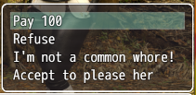
You can Pay 100 and proceed.
You can refuse and not proceed (free to come back at any time.)
If you choose “I’m not a common whore!” she will ask for your virginity. If you agree, she will have sex with you. (It doesn’t really matter if you are a virgin or not.)
If you choose “Accept to please her” when she takes off her clothes, you can trigger a bad end by choosing “What’s This?!” 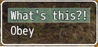
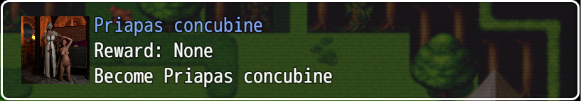
After you have paid the Dark Elf, the path will be clear to the orc camp.
Proceed to the orc camp, and you will hear Sophie screaming for help, you will automatically go to a screen where you see Sophie captured and about to be gand raped by goblins.
If you choose to ask the Dark Elf for help, you will rescue Sophie.
If you choose to wait and watch you can trigger a bad end if you are cum addicted
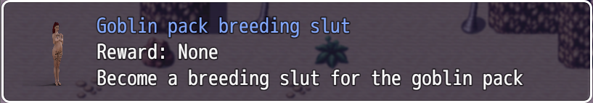
If you are not cum addicted you can watch Sophie get raped, you can then come back the next day and watch again. If you choose to watch on the third day, you will no longer be able to rescue Sophie
Before returning to town, go see the witch and collect the potion she has made.
Return to town (report to Sarah if you have rescued Sophie.)
Work/See Blake/See Jasmine/Steal Carrots (if you haven’t already been caught stealing.)
Pay your tax, your rent and go to sleep.
When you leave the house in the morning, you will receive a note from Sarah.
Go to the tavern and talk to Sarah.
You are now able to work at the brothel. (The paths differ if you are cum addicted or not. This route will follow the non-addicted route.)
Go to the brothel and speak to Debbie (the lady behind the counter)
Debbie will give you a tour of the brothel and ask you to select an outfit.
Once you have selected an outfit, you will finish your conversation and return to the front counter.
***It is advised at this time, to stop the story line and work for several days to open up new scenes***
Go to the work area, get changed and talk to the work girls. You must speak to both Angel and Candy before Ginger arrives. Speak to Candy again (agree with and compliment Candy every time you see her, after 4 days, she will show you the bimbo potion.) Speak to Ginger, she will take you into one of the rooms.
Leave the brothel and go talk to the witch.
(You can choose to mention Ginger or not, as of now there is no difference.)
After talking to the witch, you will automatically be back in town out the front of the tavern.
Report to Sarah.
She will tell you to buy a mirror.
Leave the tavern and go talk to Wendy (wash lady)
Refuse to buy the mirror for 30 gold.
Go to the inn and knock on the middle door.
The girl will offer you a mirror if you fix her debt with the innkeeper.
Go to the innkeeper. Afterwards the innkeeper will offer Victoria the same deal.
Go back to the girl and get the mirror.
Go to the brothel, use the mirror on Debbie (just click on Debbie)
Go to the tavern and talk to Sarah.
At night time, go to the brothel (you can work in the brothel to turn it to night and when you leave) a scene will trigger. Victoria will follow Debbie to the basement.
After discovering the succubus, Victoria will run to the tavern.
Report to Sarah.
Pay your tax, your rent and go to sleep.
When you leave the house in the morning, you will receive a note from Sarah.
Go to the tavern and talk to Sarah.
You will automatically go to a new map with a church and a graveyard.
Go into the church. Go to the alter and get the book
As you leave the church you are confronted by 3 goblins.
You can kill the goblins or…
You can offer them a favour to get Sarah cum addicted (Victoria will offer to give a bj, the goblins will demand both girls; as Sarah is unaware of the effects, she drinks the cum.)
When leaving the church, Sarah will exit her trance and ask if she will be okay. You can lie to her or tell her the truth.
Return back to town.
Sarah will tell you to read the book to the succubus.
When leaving the tavern, Victoria wonders if she should ask the witch. (If you don’t ask the witch, you will have a bad end while trying to capture the succubus.)
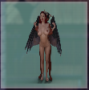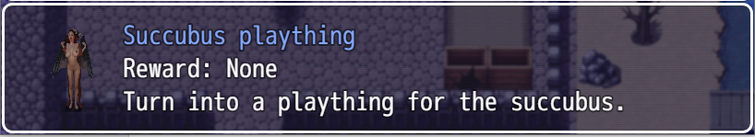
Go speak to the witch.
She will explain how to properly capture the succubus.
Go back to the brothel (You will need to have goblin cum in your inventory.)
Go to the work area and get changed.
Angel will get suspicious and you go to serve a client
After serving a client, Angel will tell you to get her a glass of water. If you agree, you will trigger a bad end.
Refuse to get the glass of water. Get changed out of your work clothes.
Go back towards the work area to trigger the scene to capture the succubus.
Go to the tavern and report to Sarah.
You can now go straight to the inn and recruit the new girls, or you can work as a wench and mess with Sarah’s drink. If she is not addicted to cum, you can add some to her drink and make her an addict. If you have the pink potion, you can add this and turn her into a bimbo. If Sarah is addicted to cum, you can change paths and take Sarah to bogwart.
Go to the inn and talk to the 2 girls you rescued.
After the new girls are working, return to the tavern and report to Sarah.
Sarah will take you to the entrance of Orc City.

Orc City.

You will be captured at the gates of orc city and taken to a minotaur.
You will be stripped naked, and told the rules.
The storyline does not really progress at this point.
You can work in the fuck room, or in the dairy to start the hu-cow path. If you go to the north west of town, there are two orcs in the street who force Victoria to give them a blowjob. One of these orcs will drop a key. After reporting to the minotaur of a night, you will be taken to a cell with other women; talk to the women next to your bed and she will mention “A1”. Go to the church/tavern and on the second level there are a group of doors. Go to the door on the far left and a girl will pull you inside.
***To view the little content for Hu-cow the game currently has. Work in the dairy only.***

ADDITIONAL / OPTIONAL SCENES

Jerk/Breast Enlargement: 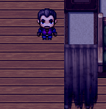
To start the Breast Enlargement path, you must choose to sleep at the Jerk’s house. This is the man who will offer you a room for a favor. (The favor being showing your tits.)
You will need to dream of the jerk groping Victoria to progress on this path
After paying rent for 4 days on the 5th (or 6th) day the rent will change from flashing to going topless.
After 7 dreams the jerk will offer Victoria a salve to help with her Breast Pain.
You will need to be in the bedroom to apply this cream.
After sleeping at the jerks house that night, Victoria will wake up with bigger breasts
In the morning you confront the jerk and can choose whether Victoria likes the changes or not.
If you have two more dreams of the jerk. Leave the house and return. The jerk will introduce you to a new person who will be renting Victoria’s room. The new change will be Victoria living rent free as long as she sleeps in the same bed as the jerk.
If Victoria continues to dream of the jerk, she will confuse real life and her dreams and you will see scenes of Victoria begging the jerk to cum on her face in real life.
After sleeping in his bed a couple nights (and performing sexual acts throughout town.) Victoria will start having sex with the jerk before she goes to sleep.
If you transform into a bimbo, the jerk will have sex with Victoria as soon as she enters the house, and will then demand a blowjob every day for rent.

Old Man(Henry)/ Buttplug & Submissive: 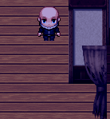
To start the submissive path, you must choose to stay with the old man.
If you have chosen to bargain for the room, you will be asked to go to the shop every day and buy bread for the old man.
When you return of a night, he will ask for the bread. If you do not have it, he will give Victoria a spanking. Afterwards he will go have a bath in his room.
After 3 days of getting bread, the old man will tell you that your bargain has changed. He will now require you to go to the inn and get a bag of flour from the innkeeper.
Victoria can peak on the old man while he washes.
After peaking 3 or 4 times, he will ask Victoria to help him wash.
After washing him 3 times, Victoria will decide to take off her clothes while washing him.
Afterwards you can choose to ask him to lock the door or not as Victoria walks around his house naked.
While washing him, Victoria will try to arouse the old man, and he will try to pretend that he is not interested. This content ends here.
When you have done your first anal at the brothel, Victoria will be in pain and walk slowly as a result.
She can go to the old mans house, when she walks in; he offers her tea and asks what is wrong. She tells him and he offers to help.
After rubbing cream on Victoria’s asshole, he tells her to speak to him again if she wants help with the pain. Talking to him in the morning, and he will give Victoria a butt plug (must have been spanked 5 times and have low corruption.)
After the second or third time using the butt plug, it becomes a daily ritual

Tavern: - Wench/Bunny
Speak to Wendy of a night to start working at the tavern as a Wench.
While working as a wench, you can choose to flash the patrons or let them cop a feel.
You need to dream of being a bunny dancer before you can progress.
After 6 dreams the innkeeper will show up.
You will now be offered work as a dancer.
You need to work as a Wench a couple more times, and work as a dancer a couple times.
Wendy will ask you to choose a nickname.
If you are sucking Blake’s dick, you can choose the name “Toy”
After choosing a nickname, in the daytime, you can speak to Wendy (the wash lady) and she will offer to sell Victoria some new Wench clothes.
Complete the dance dreams until Victoria is giving the innkeeper a lap-dance in her dreams.
You should now be offered the bunny outfit.
You need to dance until Wendy offers you advice on how to dance better, you need to work as a wench until Wendy gives you advice on being a better wench and you have changed your opinion of the innkeeper.
While working as a wench in the new outfit from Wendy, while being groped, the guards will suggest Victoria work topless. After 4 times, Victoria will consider working topless.
If you are groped 4 times while working topless, Victoria will progress to taking off her pants, and then finally working naked.
While working topless, you will be offered the choice to give a blowjob to the tables with 3 guards. If you accept, you will not get any silver.
While working naked, the guards will ask Victoria to turn around and show off her asshole.
After dancing as a bunny, completing the dance dreams, and having a better opinion of the innkeeper. Mary will ask Victoria if she will do a private dance for the innkeeper.
If you agree, you will need to dance 3 more times on stage before you are asked again for a private dance.
The innkeeper can either ask Victoria to dance in his lap or on the floor. If you dance on the floor, the innkeeper will ask for a blowjob. After a couple of private dances, Victoria will finally agree.
If you continue giving blowjobs to the innkeeper, he will progress to sex and then to anal.
Once you are a bimbo, you can work as a dancer or a wench, but you can no longer give private dances to the innkeeper.

Blake: 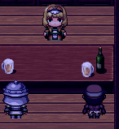
To get the Blake scenes, you simply have to agree to let him buy you a drink the first time you speak to him, then let him grab your ass.
The second day you speak to Blake, he will take you to the alley behind the tavern and force Victoria to give him a handjob.
You will need to give him 3 handjobs before he demands that Victoria give him a blowjob.
After 3 blowjobs, Blake will take Victoria to his Shack and have sex with her.
From then on, Victoria is allowed to choose what her and Blake do in their time together.
After 3 times having sex, Blake will introduce Victoria to his friends.
If you visit his friends 3 times, you will trigger a bad end.
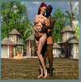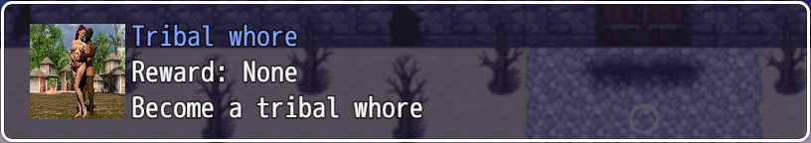

Street Whore: 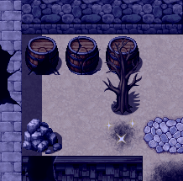
There are a couple ways to start working as a street whore.
The first way is to see the town whore in the sewers (at least 3 times), and have 4 dreams about being a prostitute. If your corruption is lower than 28, you will then be able to be a street whore.
The second way is to steal carrots from the town store. If you are caught, the shopkeeper will force Victoria to pay off her debt by working as a prostitute.
The first offering price is 10, which gets lower every client.
You can progress to doing anal, and all clients will agree regardless of price. This will only happen when Victoria is an anal whore. (This can only be achieved by working at the brothel.)

Watersports: 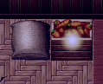
When stealing carrots from the shopkeeper. If there is a sack next to the crate. It means the shopkeeper is hiding and will catch Victoria when she steals.
At first, he will ask Victoria to repay her debt by working as a street whore.
If he catches her a second time, he will force Victoria to go to the alley behind the tavern and ask patrons to piss on her.
Get caught a third time and you will then be able to go to the alley and ask people to piss on her of her own free will.
Bimbo/Buttslut – Brothel: 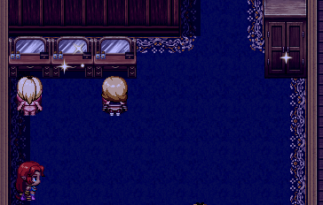
You have to follow the story before you are allowed to work at the brothel.
If you talk to Candy (The blonde Bimbo) and agree and compliment her for 4 days, she will show Victoria where the bimbo potion is kept.
Drink the bimbo potion to become a bimbo. You will need to have at least 1 orgasm a day to remain a bimbo.
When you start working at the brothel, you have access to the 3 rooms. (Blowjob, Handjob, Titjob.)
If you use these rooms twice (2xbj, 2xhj, 2xtj) you will then have the option to have sex with clients.
After 2 times vaginal, you are then offered the option for anal.
After 5 or so anal, you become the brothels buttslut. Once this happens, when you work as a street whore, you will no longer offer oral, you will only offer anal.
When you go visit Bogwart as a buttslut, if you are not a cum addict and choose to have anal sex with him, you will become cum addicted. (He will cum in Victoria’s mouth after sex and demand she swallow.)
Bimbo Scenes:
You can have sex with clients in the brothel as a bimbo.
You can go to the Jerk’s house and at the first meeting he will demand a blowjob. Then he will demand a blowjob every day as rent.
You can work in the tavern as a Bimbo: Both Wench and Dancer. You can also talk to the two guard tables with 3 guards for group sex scenes.
You can see Bogwart as a Bimbo.
When waking up in Bogwarts cave, there is a bimbo scene.
As a Bimbo, you can get sex cravings, this will mean that Victoria wakes up in the morning, strips off her clothes; goes into town and looks for someone to have sex with.
You can have sex with Wendy the wash lady, the old man by the tent in the south west of town, or the man with black hair near the jerks house.

Bogwart: 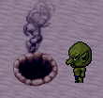
Bogwart will only show up in the game while you are looking for ingredients for the witch. If you do not speak to him before giving the ingredients to the witch, he will disappear for the rest of the game.
If you drink goblin cum, you will become addicted.
This will require Victoria to drink a certain amount of cum each day, otherwise if she sees a dick, she will go into a trance until she drinks cum.
Continue seeing Bogwart on a daily basis to see the progression of these scenes.
As a cum addict, if you go to watch the lady in the glory hole, Victoria will push the girl out of the way and suck the dick (turns out to be the innkeeper.)
When peaking at the old man washing, Victoria will enter and beg to suck his dick.
The second night when sleeping with the jerk. Victoria will enter the room and suck his dick.
When peaking at the innkeeper with his girls, Victoria will enter and suck his dick.
*When getting flour for the old man, Victoria will hear a sound, if you peek behind the curtains; Victoria will enter, kick out the prostitute and suck the innkeepers dick.
**After returning the rescued girls to camp, if you visit Emma and then come back; her door will be locked. If you peek on her, Victoria will enter her room and fight Emma to suck the innkeepers dick.

