Ver. 5.0.1
WALKTHROUGH by MKRUdesign

https://www.patreon.com/MKRUdesign

Foreword

Welcome to the Crimson Veil Walkthrough! Before you begin playing, please note that this is a game that is currently in development. This walkthrough is also a work in progress and it’s content goes as far as the version number above. If you are unaware, this is an adult oriented game primarily focused on vampire content. The majority of the lewd scenes in this game revolve around getting a bad ending. At certain points in the game, if you fall into a trap, or are defeated by an enemy, a scene involving the fate of your character will play out, followed by an illustration.This ending will result in a game over, so remember to save often and before any bad endings you want to view. Illustrations for each bad ending can be collected throughout the course of the game, so you can use your gallery collection as a guide to how much of the game you have completed! I hope you will enjoy my game!

Things to note: Pressing F4 on a windows machine will make the game fullscreen or return it to a default window size. Holding the Enter Key makes scenes play out faster. Hold down the Shift Key to walk faster. Holding down the PGDN Key on a windows machine will make text scroll super fast (May cause some scenes to not run as intended. Use at your discretion).

CHAPTER 1 4
•NOCTORNA HQ 4
•MOR TOWN 5
•SLIME RANCH (OPTIONAL) 6
•Eastern Mountains 7
•Cliffside Library 8
•Underground Lab 10
CHAPTER 2 14
•Humilem Woods 15
•Humilem Village 15
•Abandoned Manor 17
•Humilem Village cont. 19
•Abelleth Village 23
•Besilly Cathedral 24
•The Rotten Grove 24
•Ilbrooke 26
•Cliffside Library Revist 26
CHAPTER 3 28
•Fallholt 30
•Fallholt Castle 31
CHAPTER 4 37
•Lingrave Wastelands 39
•Lingrave Clinic 40
CHAPTER 5 51
•The First Shard 55
•The Second Shard 58
•The Third Shard 60
•The Test of Resonance 62
CONTRACTS 65
•Contract 2: Avenge the Fallen Daughter 65
•Contract 3: The Scrawled Contract 66
•Contract 4: Dark Dreams 67
•Contract 5: Cleansing the Cathedral 70
•Contract 6: A Lesson in Botany 73
•Contract 7: The Blood Temple 76
•Contract 8: The Lost Wife 82
•Contract 9: Suspicious Snake Oil 84
•Contract 10: Keeping Mindful 87
•Contract 11: Beneath the Full Moon 92
•Contract 12: The Tragic Bride 95
•Contract 13: The Forgotten Treasure 97
-SIDE QUESTS AND EXTENDED BAD ENDINGS 103
•Viviene’s Servant 103
•Serenity Sleuth 106
•The Heart of the Library 107
•Dubious Ingredients 108
•Becoming a Member of the Blood Temple 109
•A Simple Delivery 110
•The Cursed Attire 116
•A Major Wager 117
•Turned into a Bunny Succubus 119
•Slime Cave 120
•Turned into a Slime Girl 121
•Fenrir Glade 122
•Records of a Bookworm 125
•Bianca’s Request 127
•Bianca’s Second Request 128
•Bianca’s Final Request 129
•The Rocky Relationship 130
•A Bat out of Her Element 131
•The Fall of Noctorna 132
VAMPIRE ROUTE 133
Chapter V-1 133
•Abelleth Town (Future) 137
•Ilbrooke (Future) 137
•The Rotten Grove (Future) 137
•Noctorna HQ (Future) 140
•Mor Town (Future) 141
•Eastern Mountains (Future) 142
Chapter V-2 144
•Humilem Village (Future) 146
•Friedrich Knights Sanctuary 148
PETS 150
•Ophelia 151
•Bianca 152
Gold Chests 153

CHAPTER 1

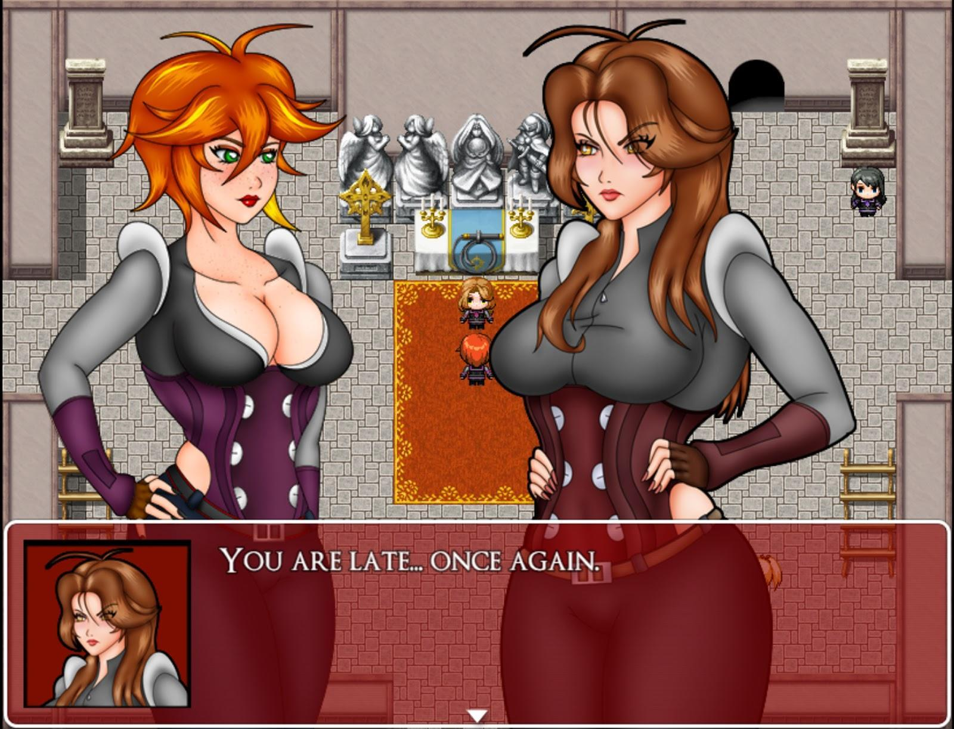

•Noctorna HQ

Waking up from Mila’s room, immediately check the drawer in front of you for 50 gold.
You can also examine the other objects in Mila’s room to get a few interesting dialogues including, though you may notice the dialogue regarding her diary is a bit different from the others… We’ll be back here for sure…

Head downstairs to be scolded by your older sister. After receiving your mission orders, she will give you your first weapon, Sacred Whip. Afterward, speak with your fellow Noctorna allies to receive a few free items. Speaking to Iris who is sitting by the table will give you a free Medicinal Herb, a weak healing item. Further to the right, you can speak with Maria who will give you Holy Water, an invaluable item early on that will cure the Vampirism status. On the left, you can speak with Bridgette who will give you Liquid Silver, which weakens undead enemies. Follow her upstairs and speak with her again to receive a Supply Cache (S), which restores 30 SP. For now, using this item is the only way to recover SP so be sure to grab this free one while you are here!

The last two NPCs you can speak with here are Maye, Noctorna’s information specialist, and Faahlda Noctorna’s personal trainer. Maye will provide you with a few hints and lore early on, including the ever important tip to SAVE OFTEN, but be sure to return to Falda frequently during the adventure. By giving her either 4x Vampire Dust, 2x Vampire Fangs, or 1x Vampire Heart, she will raise your Hunter Rank or HR. Each time your HR increases, your stats will go up and reaching certain levels will grant you new skills as well. Before you leave, search the two bags next to the bookshelves near where Iris is sitting to collect 20 Gold. While you’re here there is also a short optional scene you can watch by searching Maye’s bookshelf on the second floor. Her bookshelf is found on the leftmost side of the room. That’s all there is to do here for now, so exit Noctorna HQ and head to the town to the south to continue.

•Mor Town

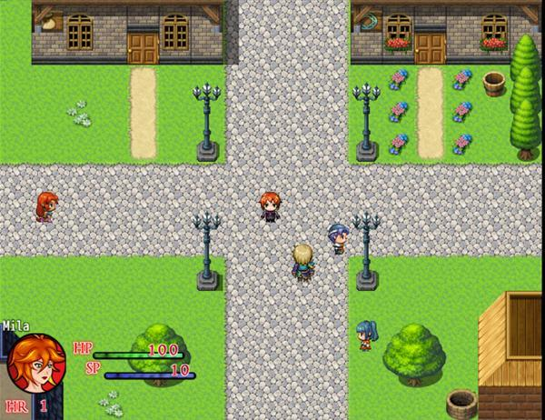

Mor Town can be entered from either the North, South, East, or West. We will start off in the North area, which is the residential district. On the left is an NPC who has lost his house keys. Go around the house and search one of the pots next to his house to find them and return the keys to receive an Ammo Pouch. In West Mor Town, you can find a chest with a Supply Cache (S) in plain sight by the connection to North Mor Town and you can find 50 gold inside one of the barrels beside the growing crops. In South Mor Town there is a green chest hidden slightly behind some trees. Open it to find a Vulnerary, a more potent healing item. On the right side of the Antique Shop, you can also collect a single gold coin. You can also speak to Gestel who talks about a shop he will be opening and then will give you a Felix Laurel. There is also an NPC here who will tell you about Cursed Vampire Equipment. Keep this man in mind, we will return to him later. East Mor Town has nothing to collect for now, so let’s head to Mor Town Center.

Mor Town Center has 3 items to collect. The top-right of the map has a small red chest with 100 Gold, to the left of the Tavern is another small red chest with a Medicinal Herb, and going north from there you can find an out of place looking set of vines next to a statue. Interact with it to get another Medicinal Herb. Mor Town Center has all the shops you need for your adventure.You can get extra supplies here with the money we’ve collected so far. Be sure to invest in some Holy Water in the general store. The vampirism ailment makes upcoming enemies more of a threat than they seem so be sure to buy a few just to be on the safe side.

Enter the flower shop and speak to the owner and she will give you a free Viribus Laurel, an item which permanently raises your attack stat by a bit. The flower shop sells more stat raising items, but they are pretty pricey at the moment. Grab a hidden 50 gold in the small palm tree to the left of the store and leave. The armor shop has some equipment for you to buy, but you should return here once you have collected some more gold. Lastly is the weapon upgrade shop. In exchange for Silver Ore, the blacksmith can upgrade your whip! The first upgrade requires a single Silver Ore, but further upgrades will require more. Check with the blacksmith to see how many more ores you will need for the next upgrade.

We need to begin our first Hunting Contract, so head into the Tavern. Inside the Tavern, you can speak with the bearded man with long hair to the left to get your first accessory, a Defense Brooch.Make sure to equip it! Speaking with the bunny waitress will net you 50 gold searching the pot next to the bar will earn you another 10 gold. Lastly, you can speak to the hopping man to the right and speak to him to receive a Slice of Pork. Another weak, albeit free, healing item.

You can view the first bad ending in the Tavern by sitting at the empty table and continuing to order drinks. Once you are ready, enter the room in the back. Read the job posted on the wall to accept the contract (This large wall only has one job for you at the moment, but as you progress further in the story, more quests will become available for you to do.) After accepting the job, you can leave the Tavern and go outside. You will also unlock the Contracts Journal! You can view it in the main menu to track your progress on story quests, side quests, and contract quests! Head right and speak with the man near the roaming puppy, this is your job contact. He’ll tell you that we need to clear out the ghouls in the Mountainside area and check up on his client, the Librarian. We are done in Mor Town for now.

•Slime Ranch

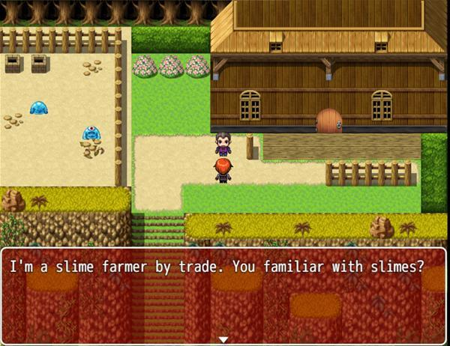

You may have noticed a small house to the east of town on the overworld. You can visit it to come upon the Slime Ranch. Speaking with the man here will grant you a Hunting Bow. Oddly, this isn’t a weapon, but rather a tool to farm slime jelly. This slime rancher will pay you gold for each Slime Jelly you bring him, so it’s a good way to earn gold for items and equipment in town if you aren’t feeling very confident. In the upcoming Mountainside area, You’ll notice roaming slimes. Tagging one of them will knock them out and earn you a Slime Jelly. These slimes will respawn after a short while, so spend as much time as you need hunting them down. Don’t forget to pick up the hidden Medicinal Herb in the leftmost flower bush while you are here!

•Eastern Mountains

If you haven’t saved yet, now would be a good time. This open area has rampant Ghouls who will attack you if you bump into them. They are relatively easy, dying in about two hits or so from a basic attack, but be wary of their Bite attack. If it lands, it will infect you with the vampirism status, which can currently only be removed by using Holy Water. Losing to one ghoul will net you another bad ending. I recommend defeating each Ghoul in this area. Each one you kill will earn you 50 gold and have a 25% chance of dropping Vampire Dust, which you will need to level up later. Additionally, Ghouls may also drop garnets and garnet shards which can be sold for a small profit later in the game. Exploring this first open area, you will find 100 Gold in a chest to the left, a Praesidio Laurel in a chest hidden in some trees to the south, and another 100 Gold in a chest to the right on the river. There are two other alcoves that you can enter. They can be found by following the arrow pattern of grass to the right side of the map, which leads you to a red chest containing a Holy Water and another alcove to the north west that has a ghoul and a chest containing 200 Gold.

Head north up the mountain to find a few more ghouls and some hidden items. Interact with a lone log sitting on some grass to the left to find a Medicinal Herb. From there, go up one flight of stairs to see a lone rock on your left. Interact with it to find a Liquid Silver. Coming up, you’ll find a cavern. Inside is what appears to be a vampire lair, with four coffins and a chest containing 150 Gold. Be careful, the coffin on the left is boobytrapped and will infect you with vampirism if you try and examine it! Heal yourself with holy water if you have one as vampirism will damage you even as you walk around! If you die while on the overworld with vampirism, you will get another bad ending.

Exiting this cave and continuing to head north up the mountain, you will find one last red chest containing a Holy Water. It will come in handy if you decide to check the boobytrapped coffin! Proceed north and enter the Library,

•Cliffside Library

Here we have a dumpster of a library which has certainly seen better days. There are plenty of books scattered about, each of which contain some unique text. From the looks of things, it seems that someone was frantically searching for something in this library…

There is only one chest here and it’s currently locked. Near the top left half of the library is a blond ghoul. After defeating her, she will drop both a Vampire Dust and a Precious Locket. The locket isn’t an accessory, but rather a key item which you can examine from your inventory. Checking the locket will net you a Tiny Key, which will open that locked chest from earlier which contains the Bat Medallion. Continuing on the left side, you will see a book on top of the bookshelf which can be reached using a convenient ladder. Check the book to get another medallion, this time the Drake Medallion. Also, be certain to inspect the open book on the top left half of the library. Reading it teach Mila the Treat Wound Skill

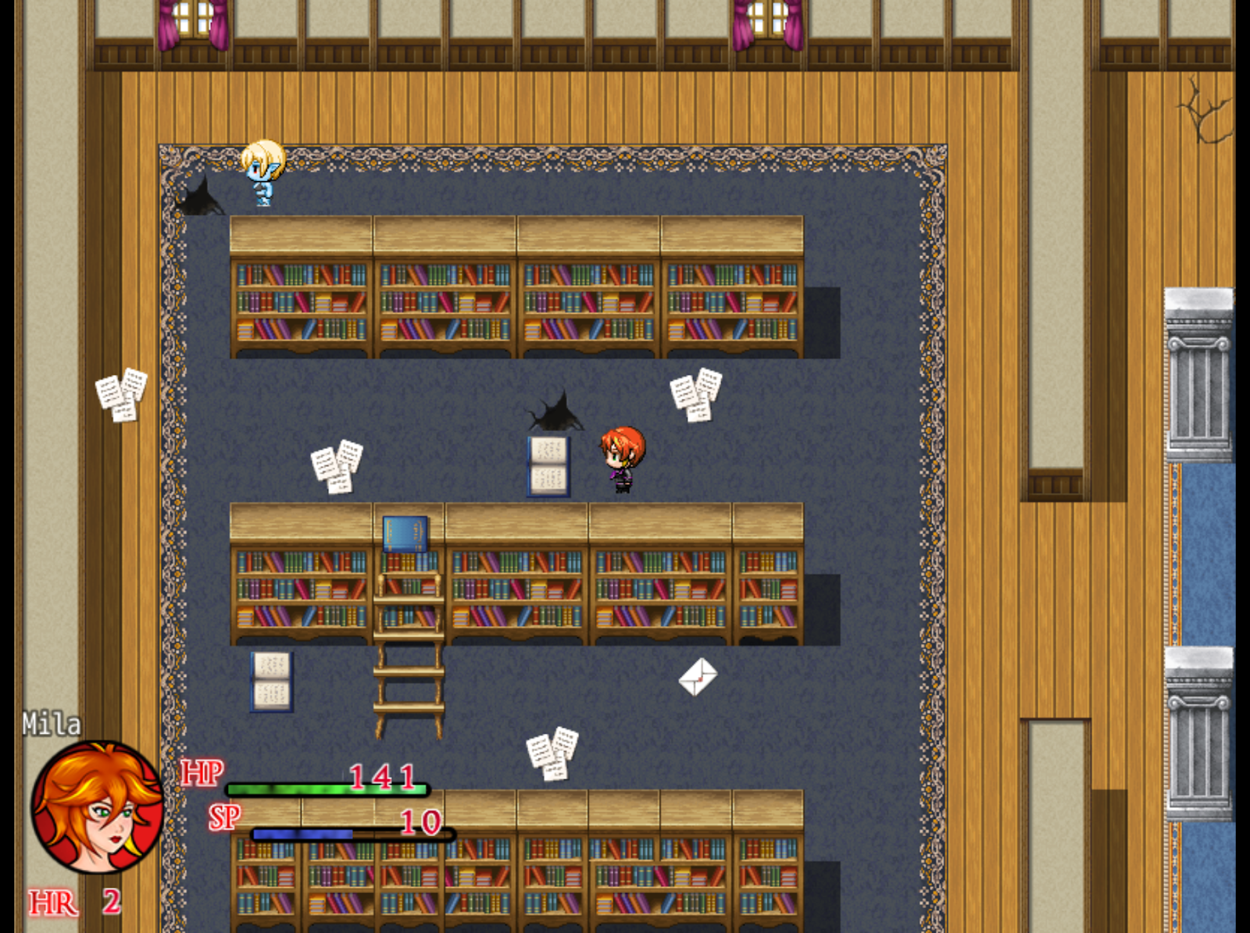

Optionally, on the right half of the library, we come across our first mini boss.

Bookworm
Max HP: 400

The Bookworm is pretty shy and will occasionally skip her turn as she nervously looks around, she shouldn’t be too much of a threat, but like the ghouls we’ve fought previously she may attempt to bite you, which will complicate things. Losing to the Bookworm will earn you another bad ending. After beating her, you are presented with a choice: Slay the vampire or spare her. Your choice will affect future sections of the game and if you want to collect every picture in the picture gallery, you must choose to spare the bookworm. Whatever you decide to do, we will now head to the dragon statue behind the main desk in the library.

Inspecting the statue will reveal that it has a combination lock. Clues to the answer can be found
In the 3 envelopes on the floor of the library.. The secret to their order is to look at the words that are incorrectly capitalized in these letters. Reading these, we can infer that the combination
Is 941. Enter that code and you will be granted access below the library.

•Underground Lab

Underneath the library is what appears to be a high tech lab of some sort. Your forward path is immediately blocked by a laser, but the laser can be disabled by inserting both of the medallions we collected into the two statues you see in that small room. Continue into the hallway to find 3 doors and a lone ghoul. The rightmost door is locked and the leftmost door has a chest we can’t reach yet, but the middle room contains a chest with a Lab Key. This key’s only purpose is to unlock the door to your right. Inside that room you will finally meet the Librarian! After your short dialogue with her, be sure to check the objects in her room for some goodies. The small bookcase houses 40 Gold, the glass case has some Vampire Dust, and the wardrobe contains an Ammo Pouch which permanently increases your SP by 25! You can also try and read the librarian’s diary, but she keeps averting your eyes away from what’s inside ... strange…

If you have defeated the ghoul that’s outside, speak with the Librarian again and she will bolt out of that room to safety. There’s nowhere else to go but through the north hall, but the doorway is also locked. If only we had a key… If you try to head back towards the room with medallion statues, You will be stopped by the librarian who has taken a liking to you. It turns out, she is already a vampire and if at any time during your dialogue you gaze into her eyes, she will have you under her control and she will turn you, leading to a Bad Ending.

Denying her attempts to sway you will result in another mini boss battle (You can also get to this boss battle by looking into the mirror before telling the Librarian you’ve defeated the ghoul.)

Librarian
Max HP: 650

This fight is similar to the Bookworm boss battle. She will occasionally waste a turn gazing at you, which should give you more opportunities to punish her with your whip. Her attacks hit a bit harder than the Bookworm, so use your liquid silver if you still have it to weaken her attacks and heal with your medicinal herbs when necessary. This fight will be over before you know it. The Librarian falls and will drop the Lab Master Key which will not only open the door to the north, but can also be used to disable the lasers in the leftmost room by inserting the key into the machine on the wall. The chest here contains a Silver Ore, an item that is used to upgrade your whip at the weapon shop in Mor Town Center!

By now, you should have a good amount of gold and vampire dust accumulated from your previous battles. At this point, we are about to face the boss of this chapter and it is recommended that you head back the way you came and visit Faralda in Noctorna HQ to level up as well as purchase some armor and items in town. Leaving the library after defeating the Librarian will give you the option to fast travel back to Noctorna HQ if you desire. You can now also turn in your quest to your client in Mor Town to receive your payment, but our job isn’t done yet. Once you are all ready, head back underneath the library and follow the hallway north to unlock that door.

You’re deep underground now! This dungeon has some women behind bars, but they appear to be under some kind of influence and won’t respond to you. There are two doors to your right. Let’s check out the bottom right one first to find a room with 5 coffins. You can examine 4 out 5 of these coffins to get 50 gold from each one. Exploring the remaining fifth coffin will result in a bad ending.

The last room to explore houses the main villain of this chapter, Faye. This vampiric scientist is Maye’s twin sister and is allegedly working on a cure for vampirism. You can listen to her for more details on her plan, but if you agree to become her test subject you will get a bad ending. Whether you ignore her or refuse to be her test subject, you are in for a boss battle.

Faye
Max HP:850

Faye doesn’t hit hard, but she can be annoying. Her main method of attack is tossing random vials of chemicals at you which can lower your attack, lower your defense, numb you, or surprisingly, heal you. She can still bite you and if she decides to attack you, it can hurt. When Faye is close to dying, she will tell you that she is about to fire off a powerful attack. Her Flying syringes will do a great amount of damage and paralyze you on the next turn unless you Defend. If you came prepared with a full set of equipment, this battle shouldn’t give you any trouble. Faye is defeated, you’ll get a short cutscene and collect an ominous Dark Orb. What could this be…?
After the cutscene with Amber back at Noctorna HQ, You will unlock the Picture Gallery along with Pic 1-6, 8, 9, 23, 24, 38, 39, 66, and 93 ! Yeah, that’s a lot of pictures to unlock at once! From the Bad Endings we have been able to witness until this point. There’s nothing more to do for now. Head back to your room and go to sleep.

This marks the end of Chapter 1.

CHAPTER 2

Head downstairs and have Amber give you a briefing of your next mission. Your hunter ally, Iris has gone missing while on duty and it's your job to finish her contract and find her if she still lives. Before you storm off, Amber will give you The Virgin’s Cross, an heirloom of your father. You had better take good care of it!

You won’t be able to leave this time until you speak with each of your allies, so go do that. Maria will give you a “short” lecture and confer upon you a new skill, Purify, which removes the vampirism status from you at the cost of Light Points, or LP. Bridgette will take out the Supplies Chest, which will fully restore your SP at any time and will give you the Quick Travel Widget, a device which allows you to warp back to Noctorna HQ by interacting with Gemmare Statues, the statues seen in places such as outside the Cliffside Library and Mor Town Center. Upstairs, Maye can be seen reading through Faahlda’s diary, which makes Mila quite nervous. Maye is just playing a prank on her, but it just makes the contents of Mila’s diary more suspicious. You can speak to Faahlda to level up if you haven’t already, but speaking to her is optional. After you’ve spoken with all the ladies, you can leave the HQ.

Exiting the HQ, Mila will have a short monologue that she thinks she should get rid of her diary. You now have the option to go up to Mila’s room and peer into her diary’s dirty secrets. You can read it, destroy it, or ignore it. If you read through it, you will discover Mila’s true intent as a vampire hunter. If you decide to act upon her desires, you will get a bad ending. Destroying the diary instead will give Mila another new LP skill, Brave Soul and unlock Pic 7, 10 and 11 in the Picture Gallery.

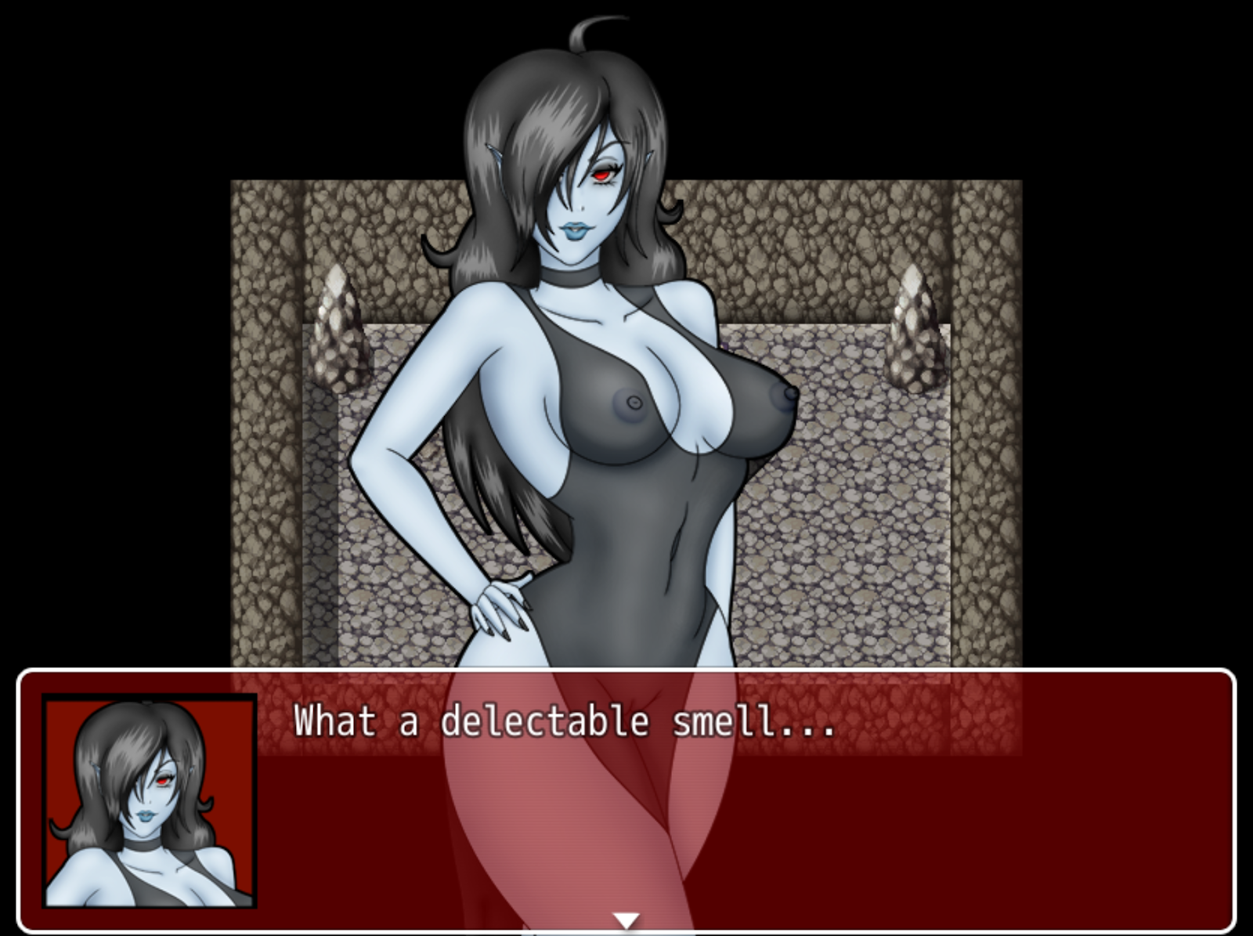

You have two choices of what to do next. If you would like to detour from the main story and get a free vampire dust as well as a new skill, a new hunting contract is available in the tavern. Please check the Sidequests section of the walkthrough for more details.

•Humilem Woods

Head to Humilem Woods on the west of the map. Immediately as you enter, head up and left to find a Viribus Laurel inside a chest hidden by the trees, then proceed back onto the main path leading west into the forest. You’ll be stopped by a mysterious vampire. After a short cutscene, you’ll be forced into a battle. There is no way to win or surrender, so just keep fruitlessly attacking until you are defeated. After losing, the vampire will rip away your Virgin’s Cross and flee, leaving you to solve the forest’s maze.

The trick to finding your way in the forest is to follow the white flowers that precede each pathway. If you go towards a path with the grass, you’ll end up back at the forest’s entrance. From the first maze room, just go North, West, South, West. You will also notice a change in the audio as you get closer to the forest’s end. Solving this maze will lead you into Humilem Village.

•Humilem Village

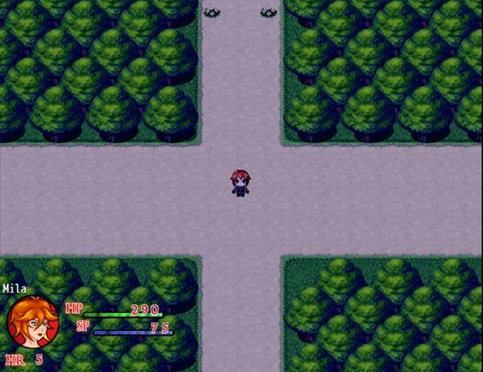

The villagers here are dedicated to their spiritual leader Viviene, but seem nice enough. Following the path west will lead you to what looks like an old building. The gate to enter is locked so there’s nothing to do here at the moment. Going north instead will lead you to the Waterfall’s Ridge. To the northwest of that map is a chest containing 200 Gold. Following the path to the left will take you to a small shrine that has a hidden chest that contains 300 Gold. If you jump down the well, you will find a Gemmare Statue to warp back to HQ if you need to and a chest with a Supply Cache (S). The way forward is blocked by a man trying to move a rock out of the way, so head back the way you came and enter the Humilem’s tavern, which is the larger building by the village’s entrance.

Inside the Tavern, we find a drunken Iris. Speak with her and she will tell you she’s already completed her contract and is just enjoying some R&R and will leave with you after a few more drinks. When you try to head out of the tavern, you’ll bump into a cute blond who is meeting her friend at the tavern. Go and speak to the girl and you will find out the two of them are hunters who got the idea to complete Iris’ contract before she did. After the chat, leave and head up the path that was originally blocked by the man and the boulder. You may also notice a creepy blond woman different from the other NPCs whose gaze is constantly following you…
Odd...

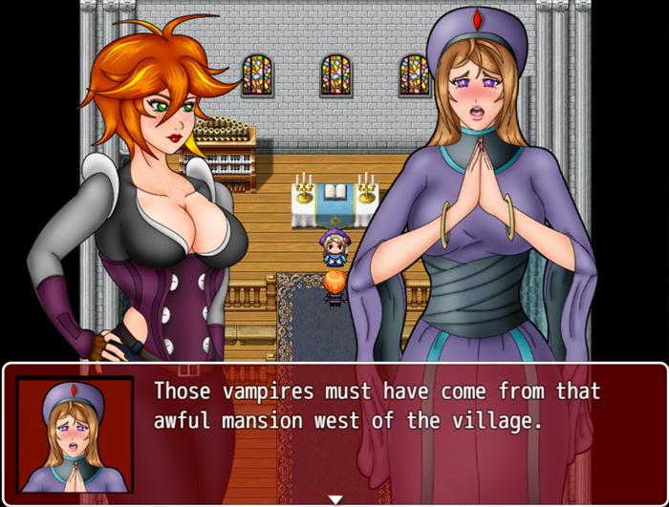

Following that path will lead you to the cathedral where you can finally meet this Saint Viviene the villager’s are clambering about. While speaking to her, you will offer to investigate that spooky mansion to the west. Although the gate itself is locked, if you return to Waterfall’s Ridge after speaking with Viviene, that creepy girl from earlier has disappeared and in her place is sparkling light. Investigate it to get a Rusted Key. Use this key to open the gate blocking the mansion’s entrance. Before you enter the building, go around the left side of the mansion to grab a Praesidio Laurel from a chest hidden in the back.

•Abandoned Manor

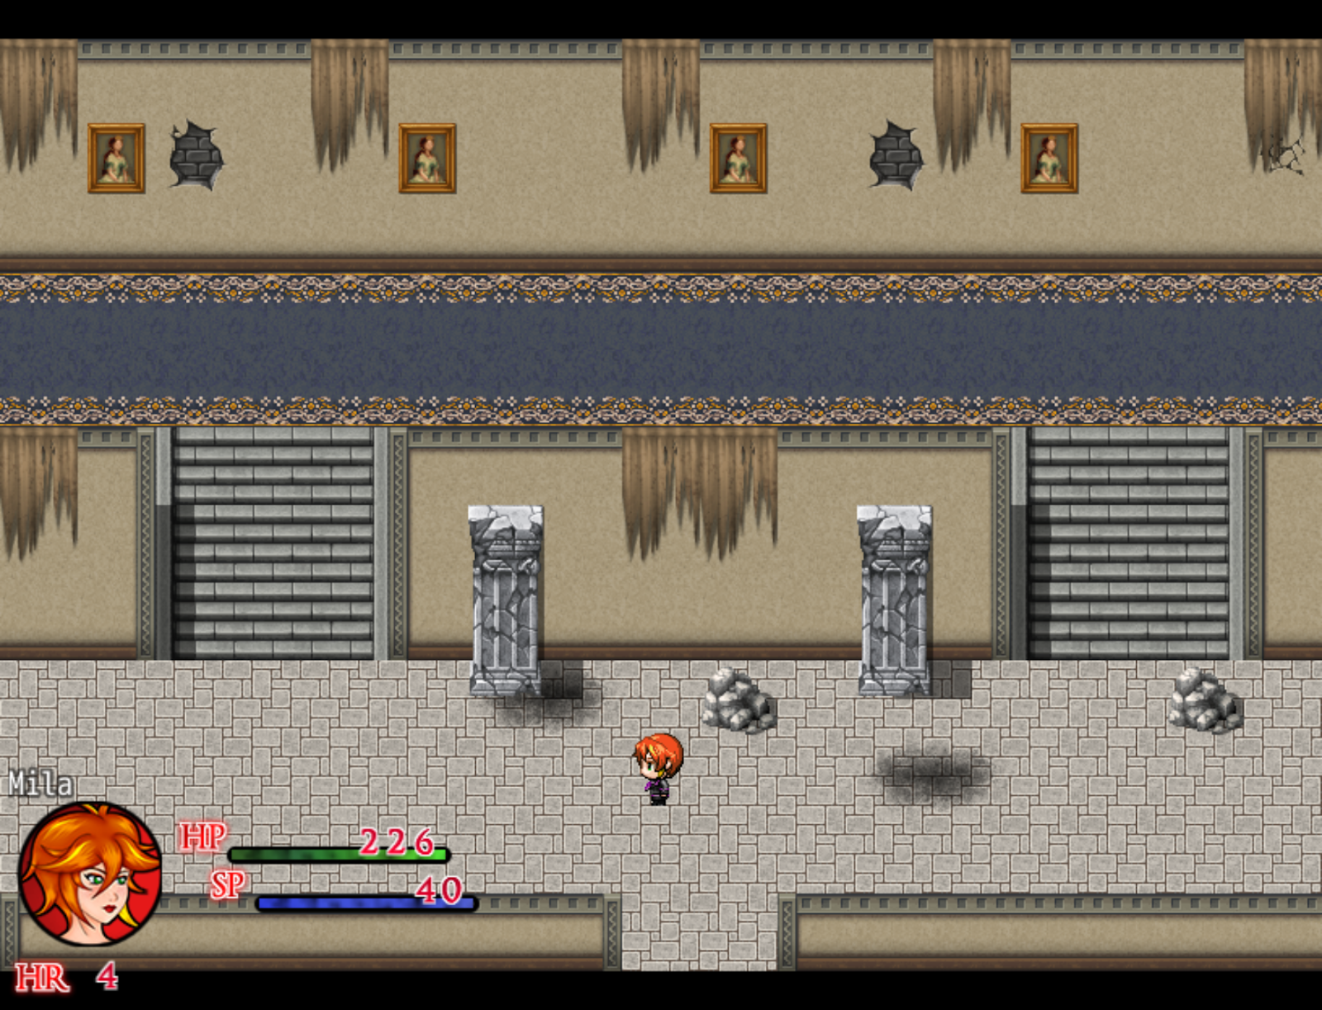

As soon as you enter the building, you’ll hear a large crash coming from the room to the west. Head that way to find the two hunters from before. They introduce themselves as Lucy, (blond) and Evelyn (redhead) who were searching the place for the rumored vampires. They will remain there searching the west wing for any clues which leaves you to explore… basically everywhere else.
Go to the second floor’s west wing and you will see an inaccessible chest and the gap where Lucy and Evelyn fell through. If you search the shelves in this room you will find a Holy Water and a Medicinal Herb right next to it. The bedroom on the east side will have a bookshelf that you can search to collect the Encyclopedia Vol. VI. Head down to the first floor and explore the Dining Room to the right. Examine the shelf to the west to get a hidden Salutem Laurel and also be sure to get the Wooden Plank that was left on the floor. You can use that wooden plank to cover the hole that the two hunters fell through to open a chest that contains the Ghost Pendant, an accessory that slightly increases evasion. Back in the Dining Hall, place the encyclopedia we got earlier on the rightmost bookshelf to reveal a hidden staircase leading to the basement.

This basement is none other than a vampire’s lair, but the vampire is nowhere to be found. What you kind find however is another one of those sinister Dark Orbs. Grab it and an ominous light will flash. The orb’s altar will crumble and that’s your cue to get out of that mansion.

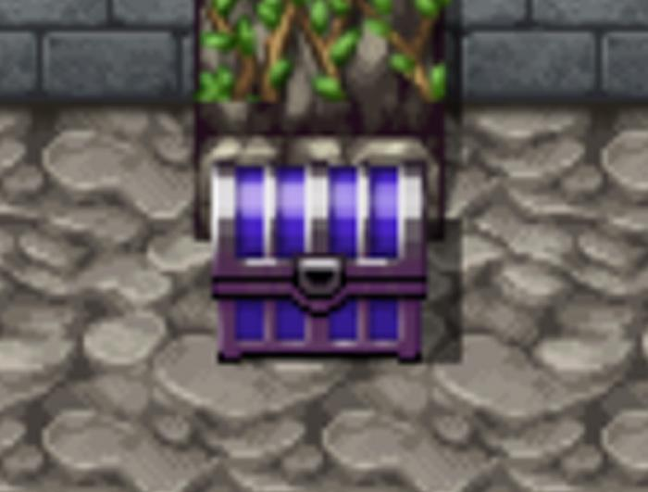
Before you leave, we can’t forget about that ominous Dark Chest that you will find in the basement. Open the chest to find a Vampire Cape. If you try and wear this piece of equipment, you’ll have a brief scene of Mila saying that she enjoys how it looks on her. This piece of equipment is part of an ongoing questline. There are 4 pieces of equipment to find in total.

If you try and leave or head towards the room where Lucy and Evelyn are, you’ll hear Lucy screaming in terror in the distance. Enter the room to see that the two are missing and the fireplace is no longer lit. Examine the fireplace to find a crawl space you can enter. Follow the path and you’ll find Lucy in terror as Evelyn is bitten by that creepy girl we saw before who was in fact, a vampire! Who would have guessed?!

The vampire will disappear and there will be a short cutscene. You have no choice but to leave Evelyn behind and Lucy will join your party temporarily.

•Humilem Village cont.

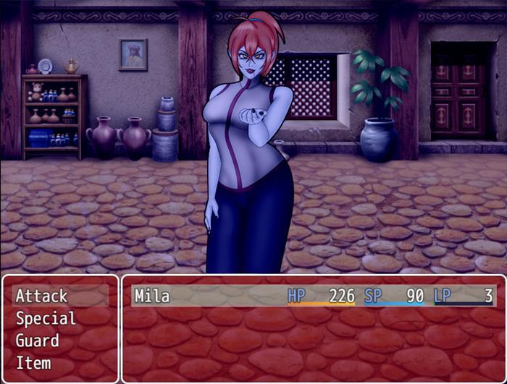

As soon as you leave the mansion, Lucy will leave your party to collect her thoughts.Head east back into the village and you’ll see that all the residents of the village are now vampires. After the short scene, Lucy will head towards the cathedral to protect any survivors, which leaves you to find Iris. Unfortunately, the tavern is locked so all that’s left to do is clear out some vampiric villagers.

You need to kill at least 3 Corrupted Villagers before a male vampire villager will exit his home and stand outside, blocking his door. Once you defeat him, you can enter his home to find a woman who has already been drained and remains motionless on the floor. Examine her to get the Bar Key. As you are about to leave, the woman’s vampiric form will rise up and attack you. This corrupted villager has slightly higher stats than the last few villagers but not by much. Beat her and exit the house.

Before you enter the tavern, make sure to save and to be at full health as we are about to fight a mini boss. Entering the tavern you will discover that it’s unfortunately too late for Iris. She has already become a vampire and must be stopped.

Iris
Max HP:1050

Iris can be tough if you don’t come prepared. She is fast and hits hard. If you are at less than half health, remember to use an item to heal instead of Treat Wound, since items have priority over other actions. If she is too difficult for you at this point, I would recommend coming into this fight with plenty of Liquid Silver to weaken her enough for you to take down. You should have the Axe skill by now, so spam it until you are out of SP. After defeating Iris, she will cry crocodile tears and ask you to help her. If you help her, you will get a bad ending. Deny her, and she will burst into ash. Bye-Bye Iris, we hardly knew you. Once you defeat Iris, You will Unlock Pic 13 and Pic 40 in the Picture Gallery.

For this next part you will want to be at least level 4, so that you can have the Cross skill. You may want to head back towards HQ anyway since you now have two Vampire Fangs in your inventory, enough to raise your level. Be sure to restore your SP and grab some more items in town if you need to, then head towards the chapel. Right before you enter the chapel however,
You’ll be stopped by a horde of Corrupted Villagers. You will be fighting off 4 Corrupted Villagers at once in this battle. Use your Cross skill to hit all of them in one attack and keep doing it until they are all dead. They don’t hit hard. The only thing to worry about in this battle is if one of them manages to land a bite on you. Once you beat them, heal up, restore SP with any Supply Caches you are carrying, and save. We are about to fight the chapter’s major boss.

The cathedral looks a lot more fleshy than the last time we visited it! Viviene has Lucy under mind control, leaving her as a helpless puppet. You’ve arrived just in time to prevent Viviene from performing a ritual that would turn her into one of the village’s corrupted residents, but Viviene does offer you the choice to join the ritual instead of fighting her. If you agree to the ritual, there is an extended ending where you play as Viviene’s servant. If you want to follow that ending in more detail, it will be covered in the Sidequests section. Refuse to take part in the ritual and the boss battle commences.
Viviene
Max HP: Form 1: 1650
Max HP: Form 2: 1400
Max HP: Form 3: 1100
Max HP: Form 4: 1000

Viviene is a multiphase boss fight. Despite her high HP count per form, she doesn’t really have that much health… Let me explain. When each of Viviene’s forms loses a certain percentage of HP, she will lose one of her wriggling tentacles and shift to her next form. Additionally, she will automatically become weakened for each tentacle you slash off. In her final form, Viviene will be left fighting alone and severely weakened. While in this form, she is more likely to land a more accurately placed bite on you. Her tentacles can ensnare you and prevent you from taking action, but her attack stat isn’t very high. Bring healing items just to be safe. Losing to Viviene will give you a different Bad Ending than accepting to take part in the ritual from earlier.
The battle is over and Viviene is defeated, but not before she tries to make Lucy kill you instead! Miraculously, Lucy breaks through Viviene’s control and stakes her, putting an end to this cult leader. The cathedral returns to its original state and Lucy and Mila return to HQ.

A few days pass and Mila mourns Iris’ death. Lucy comes over and hands Iris' pay for completing her contract and the two mourn the friends they’ve lost. After this scene, speak with Amber in her room upstairs inside Noctorna HQ. She wants you to return to the Cliffside Library and see if you can find any research documents on the Dark Orb that Faye had on her. After speaking with Amber, you will unlock Pic 12-16 and Pic 82-85 in your Picture Gallery. You can now access the eastern half of the overworld by following the road if you wish, there are some items that can be obtained by exploring them.

•Abelleth Village

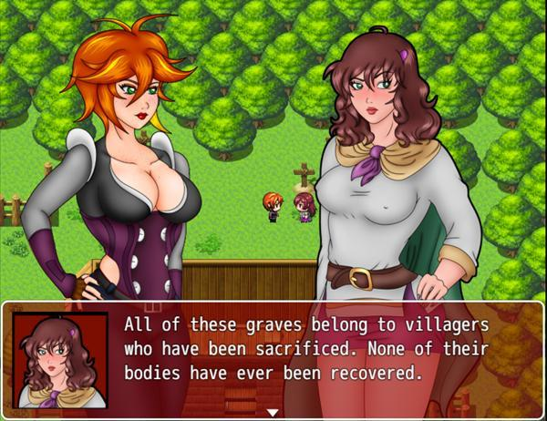

This humble village houses the grim tradition of sacrificing young women to their guardian for prosperity’s sake. It is also home to two important locations, the Silver Mine to the north of the village, which will sell you Silver Ore for 10,000 Gold a pop. To the southeast of the city, you’ll find the Hoarder’s Paradise, a place to sell any of your unwanted items. To the right of this pawn shop is also a chest with a free Silver Ore! You can also enter the village leader’s office, but without an appointment, you won’t be able to speak with them. Seems like they are getting chewed out by someone in there already anyway. Before you leave, be sure to grab a cup of Sunlite Tea, a healing item which permanently raises your attack by 1! Be sure to speak to the blond NPC McCall who will give you a Salutem Laurel. Lastly, speak with the woman overlooking the graves outside. She will tell you that the graves are actually empty and belong to the women who were sacrificed to the village’s guardian, whose bodies were never recovered.She’s concerned that there will soon be another grave planted here and wishes there was something she could do. Speaking with this woman will unlock the Blood Temple contract in Mor Town’s tavern!

•Besilly Cathedral

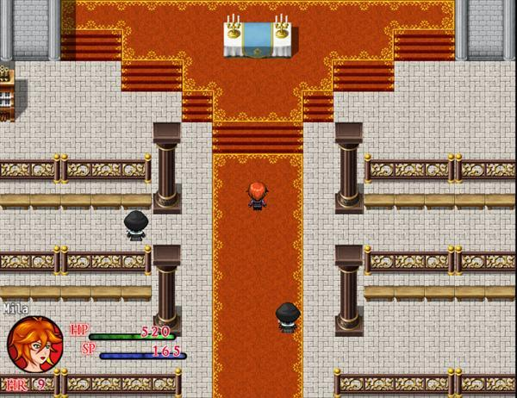

Outside of this cathedral, walk around to the right side to find a chest containing a Silver Ore.
You can enter the cathedral to speak with some NPCs if you like, but there is nothing left to collect here for now. We will be revisiting this location when you accept the Fallen Friends and Unholy Vows contract

•The Rotten Grove

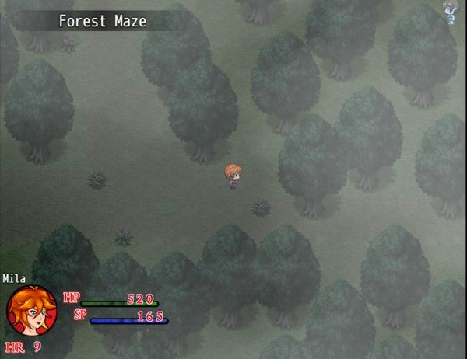

This is an expansive and maze-like forest with a couple of collectibles to get and some vampires to slay if you would like to earn some extra gold and Vampire Dust. Aside from that, there isn’t much to do in this area unless you are doing one of the sidequests or contracts. Right by the entrance is a chest in plain sight containing 300 Gold. In the same area, if you follow the road north, then head right towards the trees, you’ll notice there’s a wooden chest obscured by the trees. Open the chest to get a Celeritas Laurel.

If you go to the area to the west of the entrance, you will be in an old looking graveyard with some ghouls you can fight if you like. There is also a chest containing 60 Gold you can grab. From the entrance, if you follow the road heading east, you will enter the Forest Maze. This area is easy to get lost in and introduces a new enemy type, the Nosferatu. These monstrous looking vampires are resistant to physical attacks and smashing attacks like the Axe, but are weak to piercing attacks, like Knife and Dagger. They can also use sharp claws to cause the bleeding status, which will make you lose a slight bit of health each turn until you cure it with a Tourniquet.

There are two chests in this area.The first is another dark chest is found in front of a large tree which is near the center point of the forest. Inside, you will find Vampire Boots. Just northwest of there is another chest containing a Silver Ore. There are 4 paths that lead to other areas in the Forest Maze. One at the northwest edge of the map, another just to the right of that path, a third path to the west, and a fourth path heading south.

Following the first path to the northwest edge leads us to a dead end, although we can see there is a cliff above us and there is a chest to the right which has a Supply Cache (S). The path to the right of the first one leads to an area with a few enemies and a broken bridge to the left. From the Forest Maze if you follow the area leading south, you’ll find a small grotto with a few paths, but containing no enemies. Nothing to do here for now. Finally is the path leading east, which has a small pond, bridges to cross and vines to climb, eventually leading you into the other side of the area with the broken bridge.

In this area, you’ll see some vines you can climb to put you on a small cliff heading west. Following the path north from here will lead you to a cavern. This is the entrance to the Blood Temple, the home of Humiilem Village’s guardian, however it is locked and there is no way to enter at the moment. There is a Gemmare Statue by the cave’s entrance to quickly leave the area. Lastly, you can follow the river leading east to return to the last area with the pond and wooden bridges. Keep following the path leading south, then where the path seemingly ends, keep moving south, hugging the edge of the water to reach a green chest with a Goddess Pendant, an accessory that raises LP regeneration in battle.

•Ilbrooke
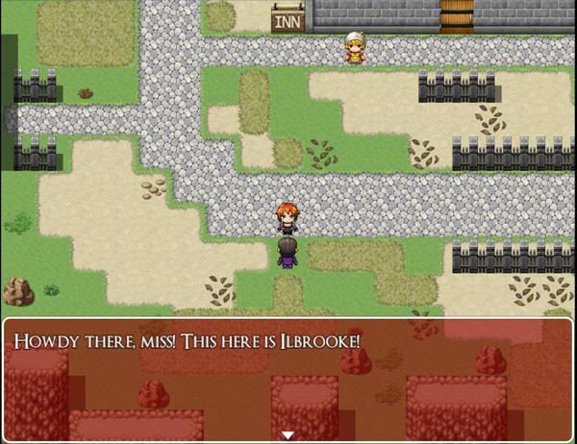
This gloomy village has a few things to nab, so let’s go over them quickly. In the southwest corner, there is a chest containing a Mysterious Dress. Check all of the barrels in town and you will come across 290 Gold, 30 Gold, and a Tourniquet is in the barrel next to the locked shack. You can explore the caves to the north if you like, but I will cover that area in the contract 10 section of this guide. The last place of interest here is the Ilbrooke Inn and Diner. Here you can purchase food items that will provide temporary stats buffs and healing. These are always useful before major battles so stock up if you have the gold. Be sure to check the barrels here to collect a Liquid Silver and a Moonlite Tea.

•Cliffside Library Revist

This next part will change based on if you killed the Bookworm in Chapter 1.

If you killed the Bookworm…
Head towards the room where you fought Faye back in Chapter 1. Once you reach the dungeon, you’ll notice that the cage door is open and the women inside are nowhere to be seen. Head inside the prison cell to find a Gemmare Statue and a wooden chest containing a Supply Cache (S). As you try to enter the room where you fought Faye, you’ll be stopped by the women who were inside of the cage, who have turned into ghouls. You’ll have to fight the 3 of them at once, but they are much easier than the villager horde we faced before. Defeat them and continue into the lab room and examine the book laying on the ground where Faye once stood to collect the Research Notes. Once you’ve got those notes, use the Gemmare Statue inside the prison cell to warp back to HQ.

If you spared the Bookworm…

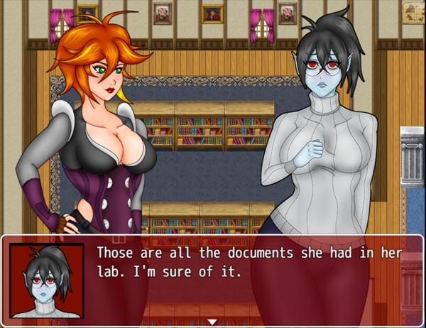

The Cliffside Library is now all neat and tidy. The dragon statue leading underground is also back in its original place, but if you try and input the code, it won’t budge an inch. What gives? (If you didn’t collect the Silver Ore in the underground, the same chest will appear next to the dragon statue). To the left half of the library, you’ll find the Bookworm vampire you spared in Chapter 1. Speak with her and she will be shocked to see you. It turns out she busted the dragon statue, which is why it can no longer move. Thankfully, she was thoughtful enough to clean through Faye’s old things. She leaves you for a moment and returns to hand you the Research Notes.

Although this vampire is timid and oddly tame, Mila is skeptical and attempts to slay her. You will have the option to slay her or spare her for a second time. If you do slay her, you will merely get a Vampire Dust for your actions and you permanently will miss out on collecting an image for your Picture Gallery. Choose to spare her instead and she will tell you how she has never tasted human blood before, choosing to die instead of hurting another human and that her previous actions were influenced by the one who turned her, the Librarian. She will then drop a bookmark to the floor as she sobs. The bookmark is actually a Photograph of the Bookworm before she was turned. She no longer wants it so you decide to take it with you. She says she won’t hurt anyone and will remain at the library and you’ve got the Research Notes you came for. Head outside and use the Gemmare Statue to the left to warp back to HQ.

Now that you have the Research Notes, enter HQ to find a panicking Amber. Seems like someone stole both of the Dark Orbs we had collected so far. A certain someone with silver hair… The two of you need to get those stolen items back somehow, but for now you will return to your room to reflect on all that has happened so far…

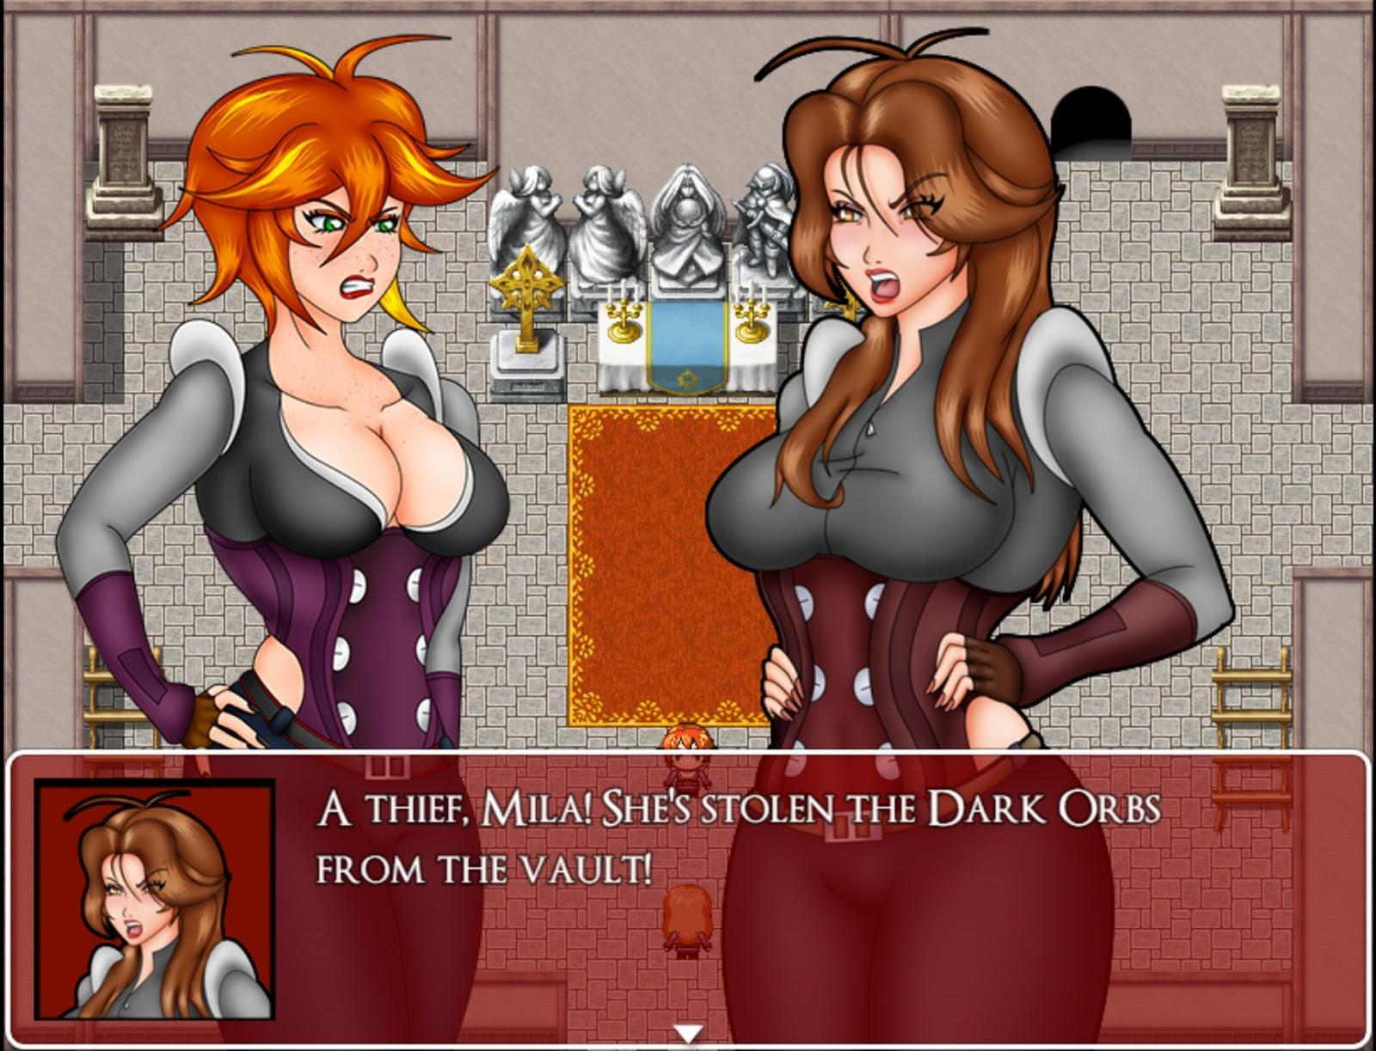

This marks the end of Chapter 2. More contracts will be unlocked for you to play once you have completed this section. Once you are back in control of Mila, speak with Maria to receive a free Moonlite Tea, which permanently raises your Agility stat by 1 and heals you a little. When you are ready to begin the next chapter, simply rest in Mila’s bed.

CHAPTER 3

After waking up, head down stairs to have a short scene with Maria regarding the state of Noctorna HQ. Enter Amber’s room and speak with her. There will be a scene where she will describe the Guardia, a race that she believes once aided their father in battle. You’ll eventually be tasked with picking up a package for Amber in South Mor Town’s Antique Store. You will receive Amber’s Package. You will also unlock Pic 46 in your Picture Gallery after the scene.
Head downstairs and after another short scene, Lucy will join your party temporarily. Before heading to South Mor Town though, be sure to speak with Maria as she will grant you a new Light Skill, Holy Purify, which not only removes the vampire status, but also heals HP a bit!

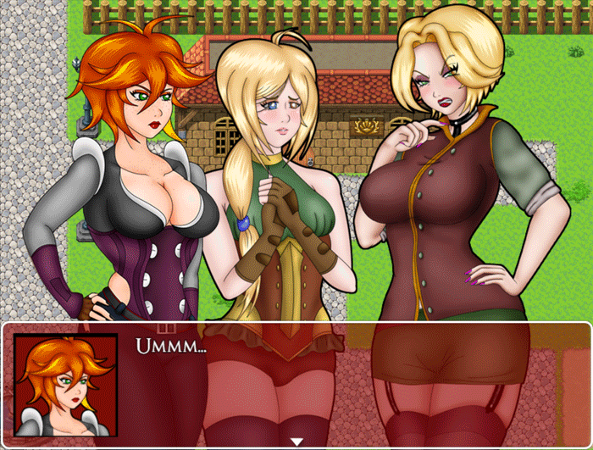

When you try to enter the Antique Store in South Mor Town, you will bump into the mayor of Mor Town, Charlotte Sholz and have a short scene. Once that’s done, enter the shop proper and speak with the owner. This man’s name is Dealer and will hand you the Dagger of Verderbt in exchange for Amber’s Package. Dealer will also offer you a quest to deliver an item for him and before you can even accept will hand you 3000 Gold, as an incentive to return to him. If you wish to tackle this quest, it will have to wait until after Lucy has left your party, but you can talk to him again at any time to get started on his quest. For more details, check out the
Side Quests section under A Simple Delivery

Return to Amber in her room where Mila will scold her sister for spending such an insane amount of money on the dagger. Amber will inform Mila and Lucy that they have been tasked with assisting the king of Fallholt, the city to the north. She tells you to prepare and to meet her at the Port of Mor when you are ready. Shortly after the scene Lucy will leave your party and you are once again free to complete any side quests or activities you choose to take. Once you are ready to continue, meet with Amber at the Port of Mor, which is north of Noctorna HQ. Check one of the barrels to the left for 60 Gold and then the vase for a Holy Water. You can also speak to Roman who will give you a Sunlite Tea. Next, the three of you will board the ship to Fallholt and then a scene will play.

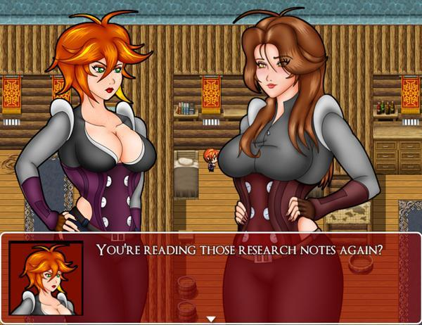

Once you dock, you will have Amber and Lucy in your party temporarily. Check the barrels that are to the left to find 20 Gold and 30 Gold. It should be noted that both of these ports have a small store with supplies, but nothing beyond the very basics. Once you are outside, you will have to head straight to Fallholt in the north. There are two other places to explore, but are inaccessible until you reach Fallholt first.

•Fallholt
Once Lucy and Amber leave your party, you are free to explore the big city (As well as a few locations outside of the city!). Your goal is to reach the castle at the north end of the city, but there are some goodies to collect first, so let’s do that.

You can find a Silver Plate in a red chest just to the northeast of the residential area, sitting along the river. In the northeast end of the park, there is another red chest with a Ruby Tiara and a small brown chest containing a Vulnerary is found northwest of the park, by the road. On the east side of the town is a small brown chest containing Holy Water and finally there is a small brown chest with a Mighty Tea to the left of the shopping district on the east side of town. Inside of the Tavern you can speak to the NPC Alexander who will give you a Viribus Laurel.

On the subject of shopping, Fallholt has some interesting things to buy in the shops! There is a new Flower Shop here for purchasing Laurels, though since it's more expensive, you should exhaust the Mor Flower Shop before buying from here. The prices for equipment can also be high, but the effects will prove useful. I personally recommend purchasing the Revenge Plate, if you can afford it! Being able to counter attack occasionally will be useful in tougher fights. Lastly, there is the bistro where you can purchase some food items which heal and provide buffs for a few turns. There is also a man inside the bistro who will give you a free Fruit Smoothie just for talking to him! Fruit Smoothies boost your natural HP regeneration each turn! Keep in mind that these benefits can all be applied outside of battle! Give yourself an edge and have a full course meal before a major fight! When you are done, go ahead and go north to Fallholt Castle and meet up with Amber there. Don’t forget to collect the Viribus Laurel to the right of the castle’s entrance!

There are other areas of interest you can choose to explore before heading to the castle, the Casino, the Slime Cave, and Fenrir Glade. For more information on them, check out the Side Quest section!

•Fallholt Castle

You’ll be stopped by the Captain of the guard, Samantha Friedrich. She finds you suspicious despite having an order from the king. She sends you away to a waiting room while she verifies it. There are a few people you can talk to in this room while you wait, but only 3 are necessary for progression. You need to speak with Amber, Mayor Sholz who seems to be here on her own business, and Fall- I mean Maahlda. Keep Matilda's location in mind, you can return to her to level up instead of going all the way back to HQ. ONce you’ve spoken to the three of them, Captain Friedrich will return and escort you to the king.

The King will explain that he requires help with his daughter. Follow the king into the princess’ room where he explains that she’s been bitten by a vampire and tasks the two hunters with saving her. Amber says she has a plan, so we will have to take her word for it. After all the scenes have played out, you will be back in control. In this guest room, Amber has laid out a supplies chest to restock your SP and left a small brown chest containing 2 Liquid Silver, 2 Holy Water, 3 Medicinal Herbs, and a Supply Cache (S). It’s a good idea to stay prepared, and this small kit certainly helps! In this same room check the northern drawer for 40 Gold.

Your goal now is to speak with the princess again, though I recommend first getting familiar with the layout of the castle. There’s a few things you can grab now, but I will detail them shortly, once we have full access to the castle. After speaking with the princess, be sure to check her drawers on the right side of the room for some Lucky Panties! Also, check the King’s closet on the west end of the room for an Ammo Pouch! You can return and speak with Amber if you wish, she will tell you to stay nearby in case she needs you. Head back towards your guest room where you will hear a scream coming from one of the guest rooms! Enter the opened guest room to find that same silver haired vampire we met in chapter 2. She seems to have cornered the mayor and you will be given the option to fight her. Regardless of your option, the vampire will flee and the mayor will tell you that she is after the princess! Rush back to the Princess’ side, though ultimately you will be too late and a boss fight will ensue against the princess herself.

Anja
Max HP: 1900

Use either dagger or Liquid Silver to immediately weaken the vampiric princess. Her attacks do a fair amount of damage at this point, especially if you haven’t upgraded any of your equipment. Anja is capable of wounding you and using the tempt skill to reduce your LP to 0 on a whim, so don’t be conservative with using Light Skills when they become available. It should be noted that if your HP gets reduced to 20% or lower, a prompt will appear offering you to surrender. Be sure to ignore this prompt unless you want to get a bad ending.

Once she’s downed, Amber will enter the room. She finds the princess’ weakened body on the floor and before the two can decide what to do, they are interrupted by the king and Captain Friedrich. The two hunters are arrested for harming the princess and are placed in a jail cell. Once the scene is done and you are back in control, you will unlock Pic 50 in your Picture Gallery. Speak with Amber to continue. After some dialogue, the silver haired vampire returns, introducing herself as Ashe. She offers to free you from your cell if you decide to help her, but regardless of your choice, Amber will cut your discussion short and shoo away the mysterious vampire. Without much hope, the two sleep for a few hours. Before long, they are rescued by Lucy, who is in disguise as a Fallholt soldier. Once you are free from your cell, head up the stairs to return to the castle’s main hall.

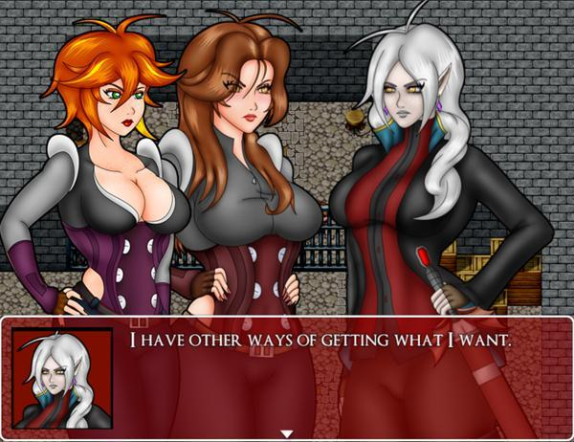

Amber feels uneasy seeing the castle so empty. Her fears are found to be true as they are soon attacked by Fallholt Soldiers who have been turned into vampires. Amber leaves you to go and protect the King and she tasks you with clearing out the castle of any vampires that threaten it.

Clearing out every single vampire is not necessary but you will want to clear out as many as you can, since these vampires will not respawn once you have cleared this part of the story!

Start by heading to the west wing of the second floor and enter the kitchen, which is the second room on the right hand side. Interact with the vampire maid on the far right to engage in a battle with her. Once she is taken care of, collect the shining object in front of her, which is the Forked Tongue. Go one room south of that to the guest lounge and open the chest there for a Maid Hairband. Go downstairs to the first floor and enter the library. Collect the Research Notes that Amber left behind and you will be attacked by a Vampire Guard. Once he is defeated, he will drop the F.Castle Guest M-Key. This key will open all of the guest rooms on the second floor hallway.

Return to the main hall’s first floor and enter the wooden door on the west side. It will lead you to the castle armory, which has a few free chests. Here, you will find a Hex Plate, Steel Plate, and a Silver Ore in chests. You are unable to open those gold chests at this time. Back in the main hall’s first floor, enter the gated doors to enter the courtyard. There are a lot of vampires in this area so you should take out at least a few of them to give yourself some breathing room. Pick up the Viribus Laurel in the green chest to the north and then interact with the dragon statue in the center. Place the Forked Tongue we picked up earlier to open a secret passage underground. Inside, you will find a silver chest containing the Fallholt Family Emblem. Now let’s go back to the second floor hallway. Restock your supplies in your room if you need to then begin opening the locked doors in that hallway.

Starting from the leftmost room, check the drawers for a Medicinal Herb and 60 Gold. To open the third room, you will have to fight the vampire blocking the door. Once she’s beaten you’ll find the surviving humans all gathered together in this one room waiting to be rescued. Checking the drawers on the left, you will find a Holy Water and an Ammo Pouch inside the red chest. Inside the fourth room, you will find a Sunlite Tea and Liquid Silver inside the drawers as well as a Sapphire Tiara in the red chest. The fifth room is empty and can be skipped. The sixth room has three vampire maids looking very happy to see you. EIther fight them or leave. Finally, the eighth room has a Liquid Silver inside one of the drawers on the left and locked chest. Use the Fallholt Family Emblem on the chest to unlock it and get the F.Castle Treasure Key.

Return to the main hall’s first floor and enter the east wing. In the hallway, take the first door which will lead you to the treasure room. Unlock the door using the key we just obtained and claim all of the goodies inside, including: Noble Robe, Elixir, 4600 Gold, 2 Silver Ores, and the War Room Key, the last key we need to progress in this area! Take the key to the east wing second floor to unlock the door leading to the war room and prepare for a battle.
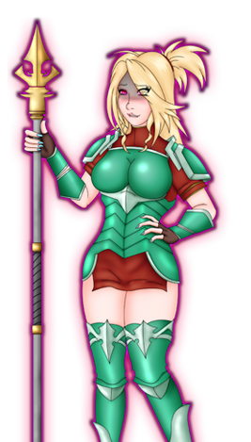
Samantha
Max HP: 2700

Captain Friedrich’s mind is being controlled by a vampire and she attacks you as you enter the hallway to the war room. Daggers and Liquid Silver are ineffective against her, since she is still a human. Her physical defense is rather high due to her armor. Bombs are an effective way of getting around this. Watch for her spear stab which can wound you and also be wary of her multi hitting spear attack. After beating her, you will unlock Pic 51 in your Picture Gallery.

Proceed into the War Room to find Anja feeding on one of the maids. You’ll be forced into a fight with her, but despite your best efforts, she will defeat you. Thankfully, you are saved by Ashe and get to play as her briefly! Just use her Blood Moon Crescent skill to finish her off in a single hit. Your new objective is to save Amber from the real villain of this chapter, but before leaving the war room, check out the cabinets to find a Salutem Laurel and 130 Gold! Go to the throne room and the villain will reveal herself to you. Get ready for the main boss fight of chapter 3.
Charlotte
Max HP: 4700
The mayor starts off the battle by giving herself a 30% boost to her attack and defense, a boost which lasts 6-8 turns. While her attack is the highest we have seen so far, her defense is pitiful. I opt to guard the first few turns to help build up the LP meter faster. Using skills like Brave Soul, and Compassionate Soul are helpful to bide your time until Charlotte’s buff runs out. After 10 turns, Charlotte will cast her buff once again but once that runs out she will not cast it again. Charlotte likes to waste turns laughing at you while her HP is still high, so use those early turns to set up debuffs on her while buffing yourself with Light Skills, but also be aware that she occasionally attacks you twice.

If you are defeated in this fight or surrender, you will be treated to an extended bad ending where you play as Lucy. While playing as her, just enter the throne room again to watch the scene.

Charlotte is defeated and Lucy joins you still in her guard disguise. Go into the King’s bedroom on the west side of the room to watch the scene. There will be a few scenes that play back to back, but once you are in control of Mila again, you’ll be back in the throne room. You will also unlock Pic 49, 52, 53, 54, 78, and 96 in your Picture Gallery. You must now head back to the port to return home, but before doing that pay Princess Anja a visit. She’s still a vampire, but her demeanor returns to what it once was. She will reward you with a Felix Laurel for helping her.
Once you join the others at the port, the final few cutscenes will play for the chapter. New contracts become available after this, so tackle them if you’d like. Otherwise, head to bed to start the next chapter.

CHAPTER 4

Chapter 4 begins with a dream sequence. Once you watch it, you’ll be back in control of Mila. Head downstairs to watch another cutscene and when you are in control again, you will have to speak with all the Noctorna members before you are allowed to leave. Bridgette will upgrade your Quick Travel Widget into an “Enhanced Q.T.W” which allows you to warp to any other warp point you have visited previously. Handy! Speaking with Maria will unlock a powerful Light Skill called Magna Flash, which damages all enemies with light damage, but also heals you and removes vampirism. You won’t be able to use it for a few turns after, but unlike the Summon Aeriseth Skill (which I recommended you unlock for this chapter) it can be used multiple times per battle. Lastly, speak with Maye and Faahlda. If you haven’t destroyed your diary to unlock the Brave Soul skill yet, a short scene will play out and you will unlock it along with Pic 7, 10 and 11 in the Picture Gallery. Once you have finished speaking to everyone, head to Mor Town.

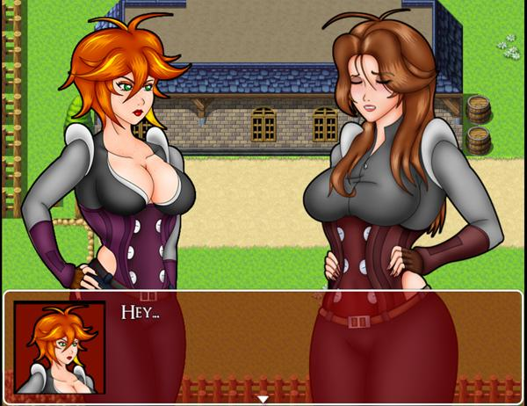
Speak with Amber for a short scene where she explains her anxieties a bit. Both she and Lucy will then head back to Noctorna HQ, leaving you to look for some contract work inside the Mor Tavern.

If you haven’t done many contracts up until this point, use this time to complete some!
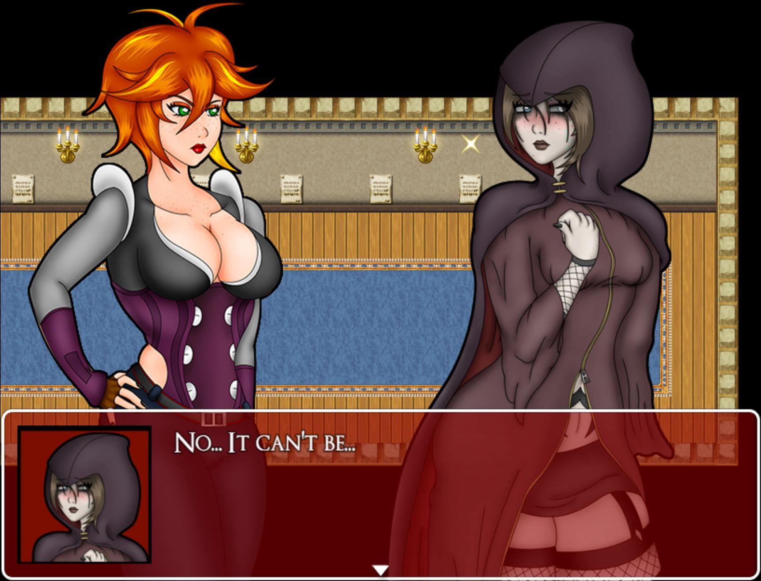
Inside the contracts room will be a woman dressed in a cloak. Speak with her and she introduces herself as Morgan Gerver. She’s looking for Mila’s dad to complete a contract, but he’s, well, dead. Mila then says she’s his daughter and so Morgan allows her to complete the contract in his stead. She asks you to meet her at her home in the southeast corner of the Lingrave Wastelands, south of Mor Town. Take Morgan’s advice and purchase some Antitoxin from the shop in town if you don’t have any already. The Wastelands are filled with poisonous bogs you can fall into and lamias with toxic bites.

If you haven’t already, while you’re in town check out the Mayor’s office in South Mor Town. After returning from your adventure in Fallholt, this building is opened to you and inside you will find a chest with a Prism Core, a valuable item that permanently increases LP generation in battle!

Once you’re ready, head south towards the Wastelands.

•Lingrave Wastelands
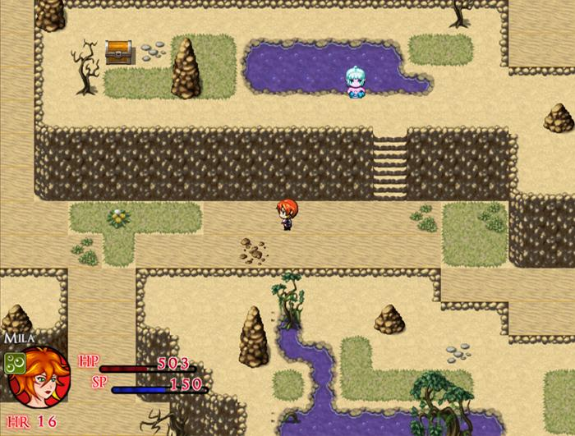

The Wasteland area is separated by a series of tunnels. While the outdoor areas have Toxic Lamias, the caverns are filled with strong Ghouls and Nachzehrer. There are also some optional items to find in this section. In the outdoor areas, you can explore to find: 2x Antitoxin (in separate chests), Supply Cache (M), Sapphire Shard, Viribus Laurel, Praesidio Laurel, 600 Gold, Elixir, Ruby, Jade Shard and a Silver Ore. Head towards the southeast corner of this section leading east to find Morgan’s house. Enter the house and go to the second floor. Explore if you wish, but there are no items to grab here. Leave the house and Mila will want to check elsewhere for Morgan and her father’s whereabouts. Enter the cave behind the house.

This cave is a bit bigger than the last few cave sections. There are no items to pickup here, but there is a diary you can stumble upon in the southwest corner, if you are curious. To continue, make your way to the northeast corner of the cave that will lead to several cutscenes that play back-to-back.
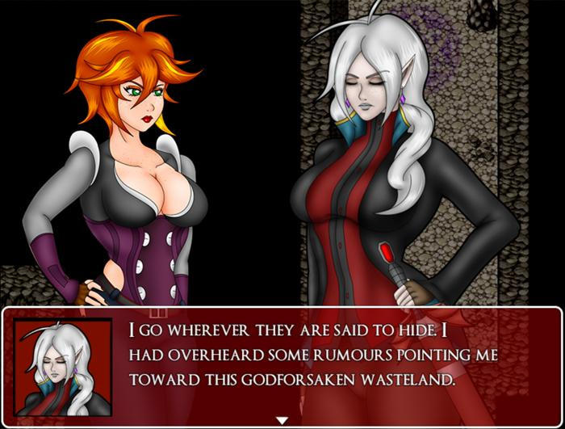
After the cutscenes, you will be placed back at the entrance of the cave, so you’ll have to traverse it once again. Once you reach the light at the end of the cave, you will reach the Lingrave Clinic, and would you look at that! There’s a Gemmare Statue we can use to warp back here! As counterproductive as it might seem, warp back to Noctorna HQ to pick up some handy items. Rinaldo’s Vault is now open and the loot inside the chests, pots, and barrels can be collected now. In the vault you will find a Viribus Laurel, an Ammo Pouch, Silver Ore, and an invaluable Moonstone. You can augment a piece of your equipment with Moonstone to add additional augment slots to it! Be sure to save it for a great piece of armor with few slots! Be sure to restock your SP while you’re here and then warp back to the Lingrave Clinic’s exterior to continue. Be sure to also collect the Sapphire found behind the Clinic before entering.

•Lingrave Clinic

Enter the clinic and you will find that it’s oddly quiet. There’s not a soul around and little as far as exploration. Most doors, as you will come to find out, are locked. In the lobby area, you can find a Vulnerary inside of a locker. The center room of this floor is an outdoor area that is polluted with poison. There is another Antitoxin for you to collect here. The only other areas open to us are on this floor’s east wing. In the easternmost bathroom, you can collect 40 gold in the locker.

You may want to save before proceeding any further, as the next section will lock you away from accessing supplies and may pose a challenge depending on how prepared you are at this point.
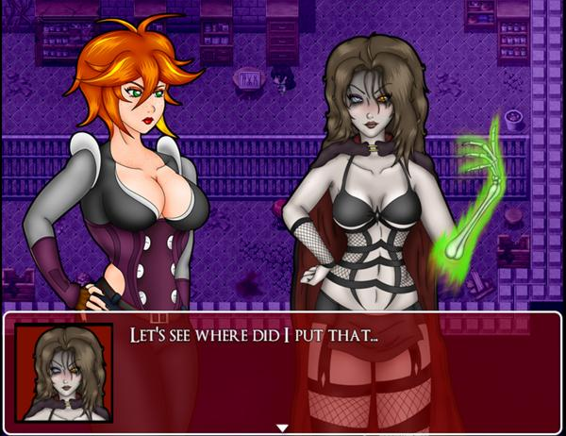
Finally, the room in the northeast corner has a chest that upon opening will trigger a trap door that Mila will fall through. After a cutscene where Morgan reveals herself as a villain, reveals the name of the Dark Orbs as Malispheres, and relays some other exposition, you will have to find a way to escape your cell and hide before Morgan returns.

You will have 80 seconds to escape before Morgan returns, leading to a bad ending.

To escape, check the large pot for a Rusty Pin. There is another one in your cell, however it will break upon using it. Once the cell door is open the wardrobe on the left to enter and hide inside it. Morgan will return, but instead of looking for you, she will send her cute new vampire friend to hunt you down. That can’t be good… Now your goal is to escape from this dungeon, which may not be so easy with your whip gone. You’ll need to either avoid enemies’ line of sight or attack them with your limited and weakened skills. Either way you decide to go, head upstairs from this prison room.

This next room has a bunch of doors you can enter and learn how enemies interact with you in this section. They have a movement route that they will traverse. If they spot you, they will dart towards you and force you into battle. The Nachzehrer in particular can be dangerous as they can act twice and often inflict the vampirism state on Mila. If you are spotted, you may be able to escape by hiding behind some cover, but you are usually better off leaving the room entirely. If you escape from battle, you will knock the enemy back a bit and stun them for about a second. Use that time to get away or heal if you have to.

In the northwestern room, you can find a Supply Cache (s), a Tourniquet, and 160 Gold inside of the pots. There is also a chest locked behind some iron bars. Make a mental note of that. The northernmost room has nothing but a locked door at the end of it. The northeastern room has another Supply Cache (s) inside of a barrel. The room to the west is locked, so the last room we can enter is the one to the south. None of the barrels carry items. There is only one thing to collect here: The Raven Key, found in a dark corner behind some boxes. Collecting the key will make the music dim and the sound of a door opening will play. If you walk the way you came you will find the vampire that is looking for you: Ashe. Stay hidden behind the boxes and she will eventually walk away. Before moving, wait until you hear the door close. If she spots you, she will chase you through to the center room and back if you run back in. Either hide behind some objects or flee to one of the other rooms and wait for the music to return to normal. That is your cue that it’s all clear.Attempting to fight off Ashe is pointless and she will defeat you in a few rounds unless you run away, resulting in a bad ending.

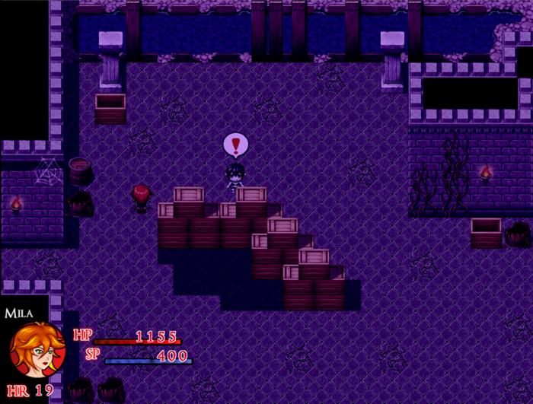

Once you’ve eluded Ashe, you can open the door to the west with the Raven Key. This will lead you to another hall separated by a bridge over water. In this room, check the barrels to collect a Medicinal Herb, Supply Cache (s), Jade Shard, and a Salutem Laurel. To the southwest, there is a room with a briefcase we cannot reach and a gold chest. We will return here later. There is also another room to the east which is locked by a simple lockpick. The rooms we can enter are the rooms directly north and northeast. The north room has vases with one of them containing Holy Water. The west side of this room is also separated by a wall we cannot cross yet. Return to the main hall and head east to find another hall with more rooms we can enter. There is a Ghoul and Nachzehrer you can fight here. All of the rooms on the southside can be opened and unlock doors from before that were previously locked. You can enter the rooms to the north if you like, but let’s head all the way east first and collect a necessary item.

This room is another prison. In the very last cell, you will find a vampire who you will recognize from an older bad ending. This vampiress, Gabrielle will assist Mila in exchange for releasing her from the prison cell. Accept her proposal and she will hand you the Hairpin Lockpick, essentially our second key of this dungeon. Once you’ve collected this, backtrack to the hall with the bridge as there is a door on the east side of the room we can now open with the lockpick. Inside is that chest that was blocked off before and it contains a Blaze Guard. This head armor will be useful during the upcoming boss fight.

Return to the hallway that connects to the prison. The room on the northwest contains nothing of note but a broken floor that we cannot cross. The room in the north center is filled with more poisonous tiles as well as a new enemy, the Vampire Lamia. These enemies are stronger than regular lamias but defeating them guarantees a Vampire Fang drop, so I recommend defeating her at some point. The room to the northeast has a few ghouls in it as well as an iron gate that can now be opened with the Hairpin Lockpick we obtained. Don’t forget to check the pots for another Supply Cache (s) and 260 Gold. Head to the next room through the iron gate. The next hallway is linear and separated by short walls you can use to avoid line of sight with the enemies. Head up the stairs on the west side of the room, but not before collecting the Supply Cache (s) in the barrel next to you..

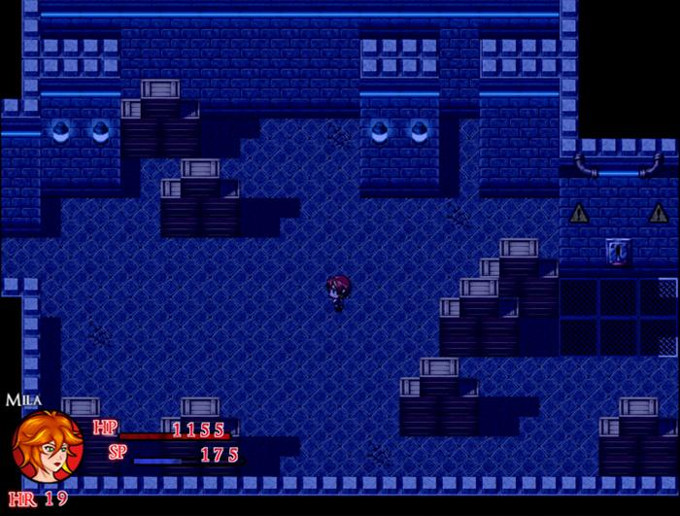

This floor is VERY dark. The power is out on this floor and you won’t be able to do much until you fix it. Luckily, the room to restore the power is the first room on the east side. In this room, simply flip the switch to get the lights and the power back on. As soon as you do that, Ashe will enter and unless you want to be chased by her, hide behind the boxes to the south of the room, stay out of her sight, and run past her when her back is turned. From that point, Ashe will begin patrolling the hall searching for you, making exploring a bit tricky. You will want to press the blue switch which will open 2 doors for you in that room (North and South respectively). They’ll only stay open for a few seconds so run to them quickly. Starting with the southernmost room, you’ll have to complete a simple switch puzzle which will unlock all of the red doors across the entire dungeon. Be sure to collect the Supply Cache (s), Amethyst Shard and Amethyst inside the cells. Return to the previous room and enter the other Blue Door.

In this room, the wall is jutting out slightly from the left. Check the shelves to find a Vulnerary then unlock the south gate with the lockpick. Go around the coffins and you will find a switch that causes the jutting wall to shift to the right. This will block off the way you entered this room, but it will also move aside a wall in the room to the west of this, allowing access to another optional treasure. Before we leave this room, it should be noted that there is a booby-trapped perfume by the coffins that will infect Mila with vampirism. Exit through the west door by the coffins and the door will lock behind you. Then enter the room to the left of the blue button and in that room you can open the chest containing the Valkyrie Ring. Head up the stairs and you will be back on the main floor. There is a unique ghoul you can fight in this room which will drop a vampire dust upon defeat. With the red button pressed, you will be able to open the door to the south of this room, leading you back to a room we explored when we first entered the clinic.

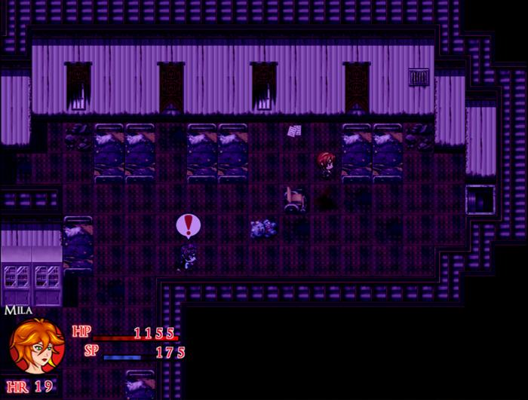

You may think you can just walk out the front door and escape, but no. The way out is locked and what’s worse, Ashe is now patrolling this floor. There is now also a Vampire Lamia you can fight in the poison garden at the center of this floor. In the west wing of this floor, you can use your Raven Key to unlock a door that leads to a water drainage room. Push the blue button, then leave. The room to the south can also be unlocked with the lockpick. Leading to a room with a Nachzehrer and a chest containing a Praesidio Laurel. In the east wing, return to the room where you first triggered the chest trap. We can also open the door at the back of the room with the lockpick. This leads to a hallway where you can collect a Mighty Tea from a chest and is also another way down to the floor below.

Return to the main hall of this floor and take any of the corridors north to reach the stairs leading to the second floor. In the west wing, there is another door which can be unlocked with your lockpick. Inside are a bunch of chests rife with goodies including:a Vulnerary, Supply Cache (L), Holy Water, Antitoxin, and most importantly of all, your whip!

(If you collected the Critical Whip at this point, it will also return to your inventory but will not be automatically equipped!)

In the east wing of the second floor, open the red door leading to a room with a Vampire Lamia. Defeat her and the wall to the right will move aside revealing a hidden passage. Enter the room to find another unique ghoul. This ghoul has some different attacks and can weaken Mila severely if she is hit by it. The ghoul will drop another vampire dust upon defeat, so beat him or skip him, but be sure to open the chest containing the Beetle Key. This key has two uses. Let’s get the first use back on the west wing of the first floor. There is a room with a ghoul and a chest containing a Sacred Elixir. We need to head back downstairs, specifically to the room with the blue button where Ashe was patrolling. On the west side of this room is a door originally locked by the red switch. Enter the room and head downstairs through the hall, unlocking the door at the end with your beetle key.

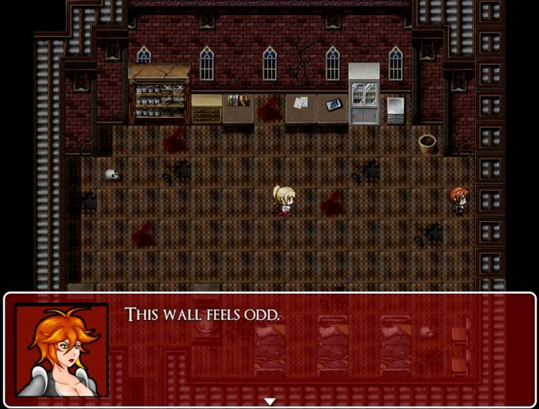

We are back inside the room that was blocked off earlier. Check the pots for 2 Medicinal Herbs, defeat the ghoul if you like, then knock over the chest using your whip. It contains the Snake Key, which we need to free Gabrielle! You can also unlock the door on the east side of the room for a shortcut back to the bridge room. Before heading towards Gabrielle, return to the room with the Gold Chest and the briefcase. If you drained the water earlier, the briefcase here can be reached and it contains a very valuable item: the Skeleton Lexicon! This item unlocks all gold chests. You can use it right now on the gold chest to unlock an Ethereal Scarf!

Check out the Gold Chests section of the guide for the location of all the chests in case you forgot!

Return to the prison cell where Gabrielle is, but before speaking with her, unlock the other cell doors to pick up a Diamond Shard and a Viribus Laurel. Speaking to Gabrielle will trigger another cutscene and Gabrielle will hand over the Pentagram Key. The cutscene will then lock you away from the prison cell and unlock Pic 86 in your Picture gallery. With the Pentagram key in hand, you can unlock the boss room on the first floor as well as the exit to the dungeon if you need to resupply or level up before the fight. You can also use this time to go gold chest hunting with your fancy new Skeleton Lexicon!

Once you are prepared, head for the east wing of the first floor to find the room locked with the Pentagram Key. Unlock it and a scene will play, forcing you into a fight with a stronger Nachzehrer, Dr. Gerver.
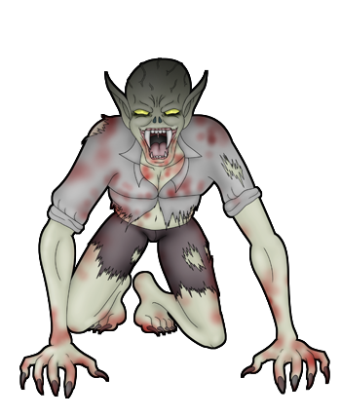
Dr. Gerver
Max HP:1500

Once Morgan’s dad is defeated, you’ll have a moment to heal up in the menus, but once you walk towards Morgan, your fight against her will begin.

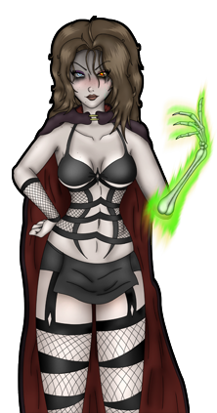
Morgan
Max HP:6700
Morgan starts the fight by summoning 2 ghouls to her side. While these ghouls are weak, they can inflict annoying status conditions on Mila, so your best bet is to clear them off with Cross skills as quickly as possible. Every other turn, Morgan will spend her turn resummoning the ghouls back, so use that to your advantage. Aside from summoning ghouls, Morgan mainly attacks with magical attacks, meaning high defense won’t do much good. Her attacks are mostly fire based, so equip the Blaze Guard you (hopefully) picked up earlier and Crystal Plate armor if you have it. Axe Skills also do extra damage against her and once she’s defeated, the other ghouls will fall immediately. Morgan shouldn’t give you much trouble if you have the equipment to deal with her. If you lose (or surrender) during this fight, there is an extended Bad Ending.

If you want an easy Crystal Plate, you can get one for free from the Gold Chest in the Mayor’s Office in Mor Town.

After the fight, Morgan will retreat to the room behind her and you will unlock Pic 87, 88, and 89
In your Picture Gallery. Heal up and restock your supplies if you have to, because this chapter isn’t over yet. We still have one more battle to get through! Following Morgan into the room will trigger a cutscene. Gabrielle enters the room through the window and bites Morgan. She then shares exposition with Mila explaining that she is Faye’s Mistress and has been looking for you all this time unknowingly. After this scene, the fight begins.

Gabrielle
Max HP:13,000

Gabrielle’s fight plays similarly to Morgan’s except that she has a silver weakness and her stats are inflated. If you still have that fire resistant equipment on, you’re in good shape as Gabrielle will bombard you with flame attacks that occasionally debilitate Mila with a burn. Be wary of your LP in this fight as Gabrielle can use the tease skill to unexpectedly drop your LP to 0 at a moment’s notice. As a vampire, Gabrielle occasionally bites too, but it is less frequent than the other skills mentioned. After a few turns Gabrielle will summon ghouls to her side and buff herself with the power of the Dark Orb. This will happen every few turns for the rest of the battle, if you defeat her reinforcements. If you lose (or surrender) during this fight, there is an extended Bad Ending.
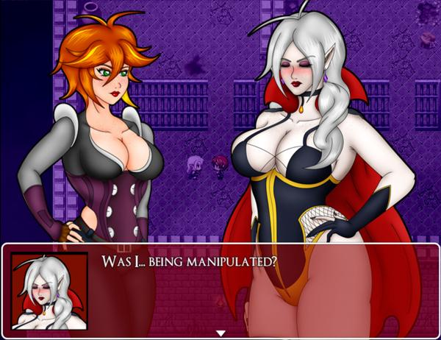

Once she goes down, Mila will collect the final Malisphere as well as Ashe’s sword “Nothung ''. She returns to Ashe who is no longer under mind control and explains the situation. Ashe will want to return to Noctorna HQ immediately and joins your party. You will then unlock Pic 90 and 91 in your Picture Gallery. After, you can choose to quickly head back to the surface or you can have Ashe help you clean up any leftover enemies still in the dungeon. While she is in your party, she will heal your wounds and revive you if you fall in battle. She also makes quick work of any enemy.you come across. You won’t be able to explore areas outside those of chapter 4, but she is useful for the time that you have her. Head to Noctorna HQ to continue.

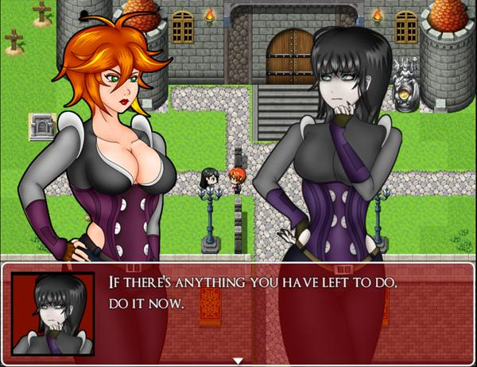
Back home, you’ll be prompted to speak with a very worried Faahlda. Ashe will leave your party and Faahlda will explain that if there are any other things you need to do, do them now.

This is a point of no return for the Vampire Route specifically. After the following scene, this route will become inaccessible unless you load a previous save.

Head downstairs to Rinaldo’s vault and watch the final cutscene of chapter 4.

CHAPTER 5

Once you’ve played through all of the cutscenes, you’ll wake up outside a thoroughly changed Noctorna HQ. The only familiar faces by your side are Ashe and Faahlda. Ashe tells you to speak with Faahlda, so go ahead and do so (Pic 92 will also be unlocked in the Picture Gallery). Faahlda will reveal her true Guardia form to you and share with you a bit about her power. You won’t have much time to chat, as a screaming villager rushes toward the three and exclaims that Mor Town is under siege by ghouls! While Mila and Ashe rush toward the town, Faahlda stays behind. Something feels off with her…

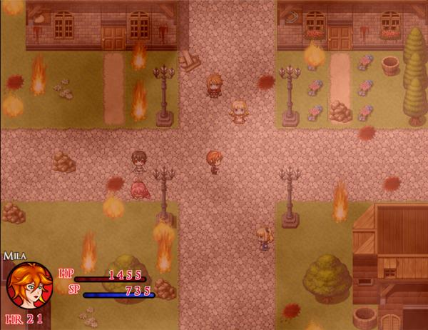
Mor Town is indeed on fire and crawling with ghouls! You’ll need to destroy all the ghouls in Mor Town Center to move on. Feel free to use your best skills to clear them out quickly. If you run low on SP, there is a chest of supplies by the general store to fully restock as often as you like. Before taking out the last ghoul, be sure your SP is topped off and you equip any fire resistant gear if you have it. A boss fight will immediately commence after the last ghoul is dead.
Or
Faye
Max HP: 9,400
Ellenore
Max Hp: 3,700
Bianca
Max Hp: 1,900

It turns out the ones behind the attack on the town were Faye and her minions! If you killed Bianca the bookworm vampire at any point in the story, she will join the other two in this fight. Faye has been given the power of fire and she will use it often. Ellenore and Bianca will serve as backup. Bianca will continuously buff her allies while Ellenore the librarian uses Faye’s old moveset to constantly pelt you with debuffs. These can be a deadly combo, so try and take them both out quickly before you get overwhelmed. With the other two out of the way, the fight becomes much more manageable. Just be aware that like in the first fight, Faye will announce she is using her strongest attack as she is close to defeat. Guard to get past this, otherwise, you’ll get paralyzed!
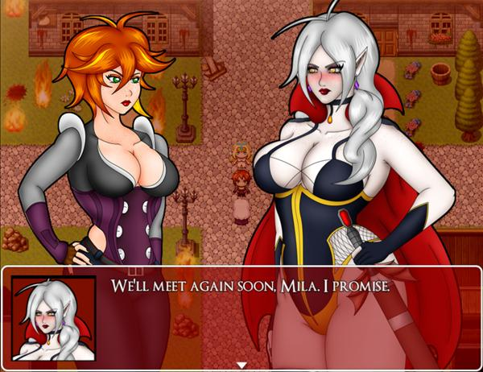
With the vampires defeated, Faye drops a mysterious glowing shard. Faye warps and snatches it from Mila’s hand and it turns out to be incredibly important! After a few cutscenes, she explains to you that what you picked up was a Polarisphere Shard, a piece of her Guardia power essentially. If all of the pieces can be returned, Faahlda’s power can be restored and she would be allowed to assist Mila. She mentions there being a test after all the pieces are collected, but for now, your job is to find all these shards. How will you do that exactly? Faahlda’s got you covered. She hands you the Fractured Polarisphere and with it you can better gauge where these shards are hidden. Pic 101 is also unlocked in the Picture Gallery.

It should be noted that the overworld is now dark and Mor Town is in rough shape. All of the shops are thankfully still open though and you can still complete contracts as normal. Ou can talk with the citizens if you like, but if you go to Mor Town East, there is a woman there who tells you she was bitten by a ghoul during the attack. If you give her holy water, you will heal her and she will give you an Ammo Pouch as a reward. If you continuously deny her holy water, she will eventually turn into a ghoul herself, so be sure you have one on hand unless you want to miss out on the reward.

Returning to the main content, there are three polarisphere shards to collect in total and you can obtain them in any order you like. You will be returning to former areas and some new ones. It should be noted that previous areas have been repopulated with stronger versions of enemies, which have a higher drop rate of vampire materials. If your level is low or you feel like you are underpowered, it may be a good idea to take out some of these enemies before jumping into the upcoming boss battles.

•The First Shard
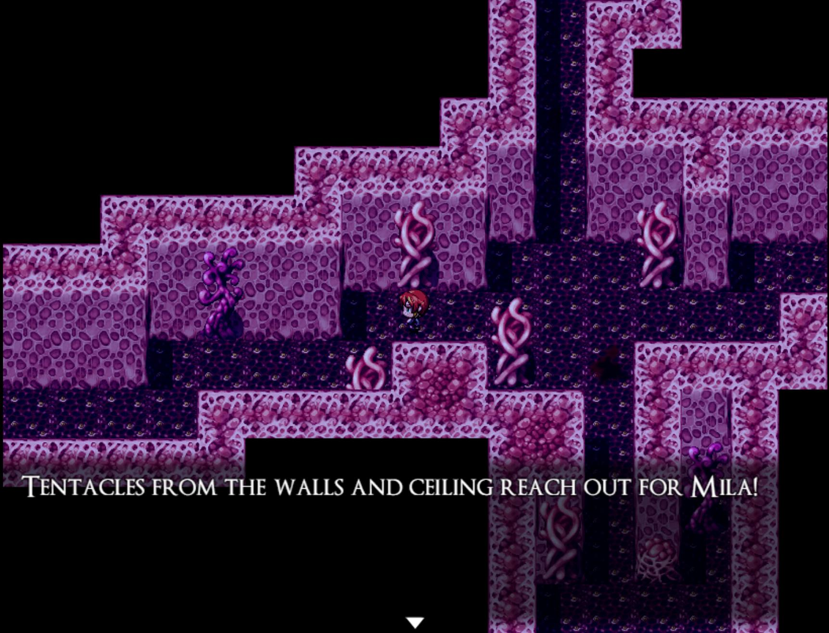

(If you picked up the Rubber Bodysuit from the Slime Cave near Fallholt, you’ll have a big advantage in this upcoming section.)

Head or warp to Humilem village. The vampiric cult has returned and they are now capable of doing a pretty powerful water attack against you. If your magic defense is low you’ll want to watch out! Enter the church to find an ominous green portal. Entering it will place you in a demonic, slimy sticky looking cave, filled with familiar vampiric tentacles.

This cave is a small maze and tentacles will attempt to grab Mila from the ceiling and walls. There are no items to find here, so it’s all a matter of navigating to the end of the maze. It’s relatively straightforward, but if you find yourself getting lost, check out the map below.
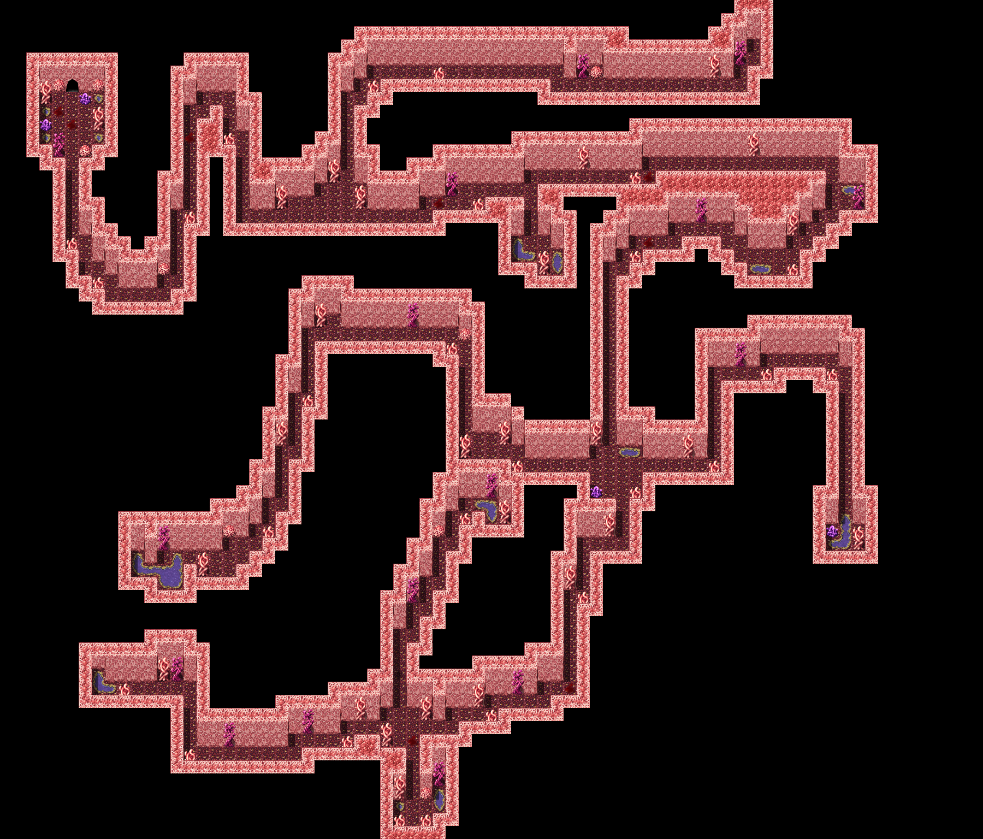

Your goal is to reach the room on the upper left hand side of the map. Once you get there, the Polarisphere will warn you that the boss fight is up ahead. Save and restore your health and supplies, then walk through to watch the cutscene and the fight will begin.

Viviene
Max HP: 8,500
Iris
Max Hp: 5,700

Iris has learned how to manipulate the tendrils herself. Because of that, each of these ladies will be able to act multiple times per turn and unlike the first Viviene fight, you won’t be able to slash off the tentacles to weaken her. As a matter of fact, Viviene’s water based attacks will be weakening YOU. Well, your defenses anyway. While both of their attacks start off relatively weak, this can change once the debuffs start piling up. One thing to note, if Viviene’s HP starts falling below Iris’, Iris will actually take the damage instead. Your best way of getting around this is to either focus on defeating Iris alone first, or using the Cross skills to attack both of them at once.

Once Viviene falls, you will obtain the first Polarisphere Shard. Iris will be returned to her old mental state and there will be a touching scene before you are given 5 minutes to get to the exit. A rather generous amount of time to escape. Though you can just leave immediately, continuing to talk to Iris will allow you to take her with you! You’ll move much slower out of the cave, but there are no more enemies to interrupt you. Whether you choose to take Iris with you or not, once you’ll be warped outside of the church. A job well done!

•The Second Shard
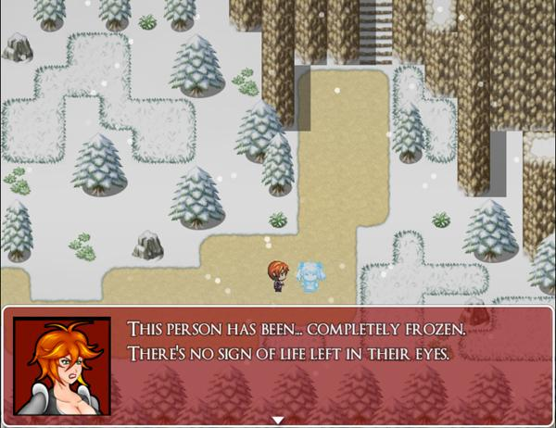
Warp to Fallholt and by the residential district in the west side of the city is an NPC named Vladislav who will give you an Ultimus Laurel for speaking to him. He’ll mention strange winds coming from the east, so leave the town, following the trail that leads east. The Tundra Trail is an area that was inaccessible before due to the strong winds. While the weather is still breezy, you are now able to enter and explore the place.

This area contains a new enemy type, the Fuyukiba. These icy vampires have a tendency to leave behind frozen husks of their victims, but they occasionally turn those that they like into vampires like them. These enemies sport a high magical attack stat, and their ice attacks can deal a lot of damage, so be aware of that if you decide to engage with them. Also, every few seconds, there will be a strong wind that blows through this map, obscuring your vision, and causing Mila to move slower and take a bite of damage.

This area has a few chests for you to collect. Inside you can find a Sapphire in the chest closest to the west, a Silver Ore in the chest towards the center of the map, and a chest containing 850 gold towards the east. In the southeast corner of the map, you can also find a cave. Inside, there are a bunch of frozen corpses, but more importantly, a chest containing a Fuyukiba Gown. This piece of equipment protects against ice and wind based attacks and will be helpful in the upcoming boss fight.

If you return to the Tundra Trail and follow the path heading east, you’ll reach the Tundra Tower. This winding tower is seven floors tall and as you continue to climb it, you’ll find it to be the home of the bat-like Frost Baitelle. These airborne enemies are fast and susceptible to silver and piercing damage. Though technically not undead enemies, they will resist Light based skills, so keep that in mind. Once you’ve climbed up to the top of floor 6, you’ll get a warning right before entering the boss room. Save and restore yourself with items and head through once you are ready.
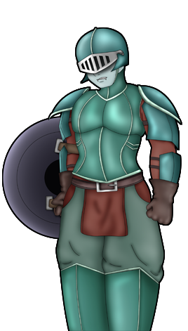
Charlotte
Max HP: 13,000
Vampire Elite Soldier
Max Hp: 4,500
Vampire Elite Maid
Max Hp: 4,700

Once again we come face to face with the former mayor of Mor Town. This time, she has some back up and the power of wind behind her. Her power of wind blows away any buffs you place on yourself, so don’t waste your precious LP on buffs. Speaking of LP, the Vampire Elite Maid is able to tease Mila, causing her to lose all of her LP as well as buff her allies and debuff your speed. With such low defense, the maid should be your first target to get a better control of the battle. The soldier, while sports the highest defense of the three, and focuses on physical attacks. He can be brought down fairly easy with some Bomb skills.Charlotte’s health is pretty high, but her defense is poor. Keep your health high throughout this battle so that Charlotte doesn’t catch you off guard with an unexpected third action during her turn! Once the three vampires are beaten you will obtain the second Polarisphere Shard. Pic 102-103 will also be unlocked in the Picture Gallery.

•The Third Shard
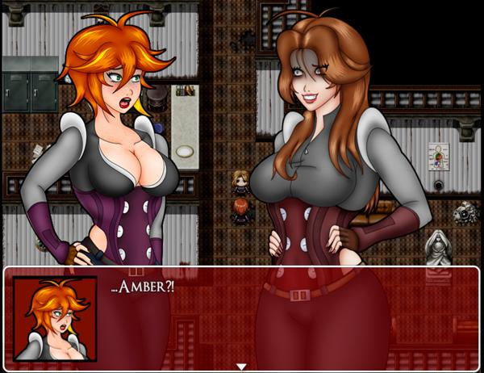
Warp to the Lingrave Clinic and enter it. You’ll find an off putting surprise as you walk in. Amber will attack you, but she just stares you down. There’s no way to lose this fight, so just defeat her quickly to move on. After the fight, Amber will run off to the west wing of the clinic and you must give chase. The polarisphere will resonate when you are in the right direction, so enter the room to the southwest corner of the hall. Once you enter, the door will be locked behind you and you’ll be trapped in a room with two WIghts, a new enemy type.

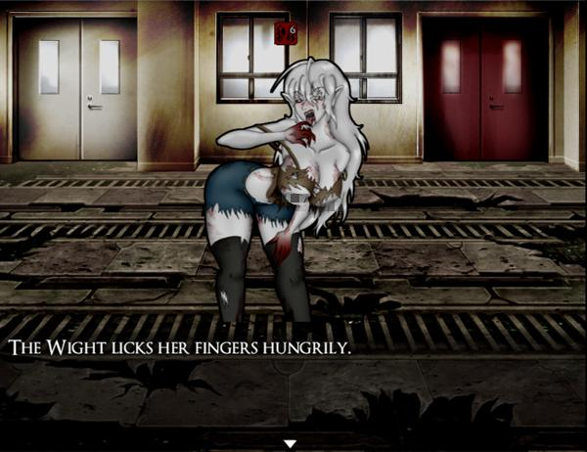

The Wights are similar to Nachzehrer in their high attack stat and skill set. One of the differences is that they have a high libido. If you are at half health, they will become dazed while staring at the weakened Mila. However, if your health reaches below 20%, they will attempt to mesmerize Mila out of a turn. This can be devastating if it lands, so be sure to keep your health topped off whenever you can. Once both of the Wights in the room are beaten, the door will unlock and a bat will fly out of the room you were in and the Polarisphere will resonate accordingly. Chase after the bat, heading towards the eastern wing of the clinic, but be aware that the clinic is now infested with multiple Wights that will chase after you if they make eye contact!

Enter the ritual room where you first faced off against Morgan in chapter 4. There, you will see Amber once again. Defeating her in this second encounter will reveal that she was seemingly made of some sort of mud. Save up and heal, then proceed into Morgan’s bedroom to start the next boss fight.
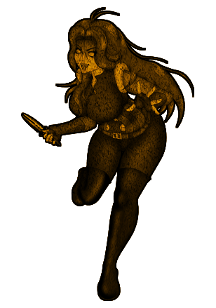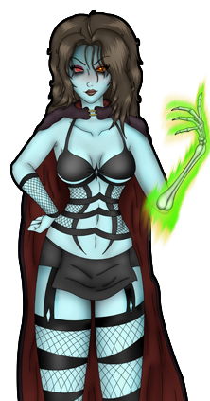
Morgan
Max HP: 9,800

Morgan, like in her first fight, is a boss that attacks you with sheer numbers. She starts the fight with Mud Soldiers at her side, but she will soon summon ghouls as well. While the ghouls can be destroyed easily enough, the Mud Soldiers are immortal as long as Morgan is alive. Don’t waste your attacks by targeting them! Morgan still has her old moveset of dark magic, but she can also use Earth based moves, which deal a substantial amount of damage, even when guarding or if your defense is high. Since Morgan is a vampire now, she is also susceptible to their inherent silver weakness, so use dagger skills to weaken her (Or Count Vorigan’s Cane if you have it!) If she has her ghouls out, attack them with the Cross skills and then use the Axe skills to deal high damage to her quickly! Once Morgan is down, she’ll drop the last Polarisphere Shard, but not before spitting out some ominous words about her Mistress, Gabrielle. Pic 104-107 will also be unlocked in the Picture Gallery.

•The Test of Resonance
Once you have collected the 3 Polarisphere Shards, you will be warped back to Noctorna HQ.
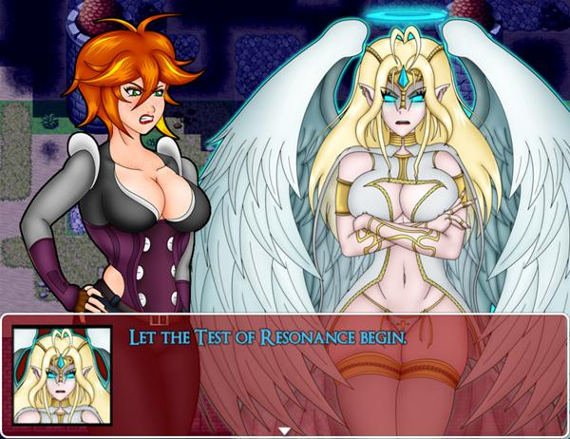
Using her power, Faahlda reunites all of the shards and restores the Polarisphere and her power back to full strength. Now there is just one more task you need to complete before Faahlda will assist you. Pass the Test of Resonance. To do this, you’ll need to defeat her in battle. If you feel that you are underleveled for this point in the game, Faahlda will continue to increase your level like normal and while the fight can be tricky, there is no consequence for losing, aside from having to start from the beginning. Once the scene with her is done, you will also unlock Pic 108 in the Picture Gallery.
Faahlda
Max HP: 15,000

Faahlda is resistant to all skill types outside of your standard whip skill, which she is slightly weak to. If you either obtained the Double Band from the Casino or the Dual Strike skill from the lamia contract, you’ll have an edge in this fight. You’ll also want to upgrade your whip as high as you are able to at this point to deal the most amount of damage possible. Faahlda’s attacks of note include a light arrow attack which strikes multiple times but has low accuracy and a skill which heals Faahlda when it lands. The last important factor to this fight is Faahlda’s ultimate move. She will activate an invincible form about every 5 turns or so and it will last 1-2 turns. While in this form, she will attack you with a devastating move that will likely end the fight if your health is low and you aren’t guarding. Your LP will likely remain high throughout the fight, so use any Light Skills you’ve obtained throughout the game to your advantage. Compassionate Soul is helpful to reclaim some HP lost after Faahlda’s ultimate and Brave Soul will increase your damage output. Try and time the use of these skills to the turn you think Faahlda will activate her invincible form!

Once Faahlda is defeated, her power will join with Mila and you will obtain her old Polarisphere. Faahlda also provides you with two new skills. Summon Faahlda will allow you to call Faahlda’s power in battle, raising all of your stats while the effect is active and providing you with an auto-life effect! If you fall in battle, you’ll automatically be revived once while it’s active! The second skill you will get is Call Faahlda. This skill is used outside of battle and allows you to spend your vampire materials to level up from anywhere! After this, Faahlda will also provide you with an overall stat boost!

This scene is then interjected by Ashe’s arrival. Through some exposition, Ashe explains that the secret to defeating Amber’s newfound power is to restore the Virgin’s Cross. The Virgin’s Child, which had been missing, is explained to be hidden in Mila’s mother’s grave. Beneath the grave is a ladder leading into the crypt. Once you are ready for another fight, proceed down.

Inside the crypt, it turns out that Mila’s mother is not dead, but rather undead. She is a vampire and has been sleeping silently inside of the crypt, kept dormant by the power of the Virgin’s Child which rests behind her. As soon as her mother gets a whiff of her scent, she springs to life and unfortunately for Mila, she will have to destroy her mother, who has become a mindless servant of Gabrielle.
Selina
Max HP: 8,000

Selina is an absolute joke of a boss after all the fights you’ve gone through. WIth Faahlda’s power, you should be able to make short work of her. Selina doesn’t have much experience as a vampire since she’s been asleep for most of it. All of her attacks are basic fare, so there isn’t anything she can throw at you that should come off as a surprise.

Once Mila’s mother is taken care of, you will return to the surface after another cutscene. Ashe will return to Mila the fully restored Virgin’s Cross and then leave your side once again. The Virgin’s Cross is actually a handy tool for taking down a certain powerful boss. You can use it in battle and while it’s effects are active, your resistance to Dark based skills is increased dramatically. Pic 109 will also be unlocked in the Picture Gallery.

You have all you need to take on Amber and with that, Faahlda creates a bridge of light, allowing you to reach the floating castle at last!

THIS IS THE END OF THE STORY SECTION OF THE WALKTHROUGH

This section covers all contracts and miscellaneous side quests that can be completed during the course of Crimson Veil as well as mention when and how the quest can be started.

CONTRACTS

•Contract 2: Avenge the Fallen Daughter
-Availability: At the end of Chapter 2
-Recommended Hunter Level: 7

After accepting the contract, meet your client just south of the armor shop in Mor Town Center. He will tell you his daughter was bitten by a red haired vampire who fled into the mountains when she was spotted. The daughter died and her father wants revenge. Go to the Mountainside area and go to the cave with the vampire lair inside, the one with the 4 coffins. Examine the northmost coffin to find none other than Evelyn! It turns out she didn’t end up killing herself and turned instead. She was the one who killed your client’s daughter and now she is thirsty for you.
Evelyn
Max HP:1900

Evelyn is like a bulkier version of Iris. She trades in speed for power and can use the Axe skill and the quick Knife skill. Start the battle off by using Dagger or Liquid Silver to weaken her blows and use Fire Bomb to numb her for a turn or two. Her physical defense is much greater than her magical defense, so Fire Bomb is your best bet. If you have Brave Soul, this is a good time to use it. Once you have beaten her, Evelyn will ask you to watch over Lucy for her and will surrender. Evelyn’s soul can finally be put to rest and you will get Evelyn’s Remains. Return the remains back to your client to receive your reward of 1200 Gold and an Ammo Pouch! You will also unlock Pic 18 in your Picture Gallery.

•Contract 3: The Scrawled Contract
-Availability: At the end of Chapter 2
-Recommended Hunter Level: 7

After reading through this fishy looking contract, return to the Abandoned Manor in Humilem Village. You will notice a shadowy figure towards the west side of the second floor. If you try to approach it, it will flee to the bedroom in the east. Once you enter that room, you’ll find nothing. Once you exit that room, the shadowy figure will reminisce on the state of the manor, then walk to the room across the hall. Finally enter that room to meet this mysterious character. It’s the vampire who attacked Evelyn during the events of Chapter 2. She is actually your client and she happens to be looking for a new blood thrall. Unless you want to become one, prepare for a fight.
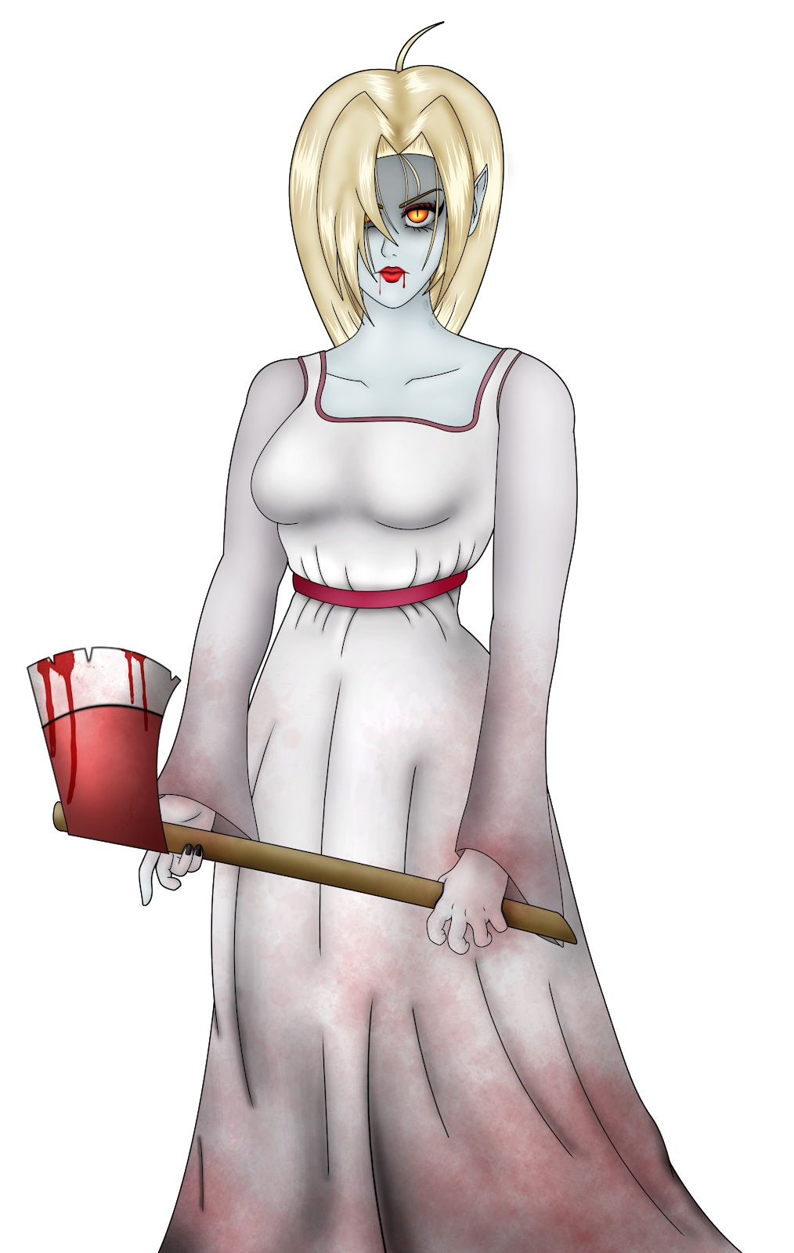
Karen
Max HP:2200

Karen’s gimmick is that she often attacks using the Axe skill, which can mean you’ll likely take a lot of damage when one of her attacks hits. Thankfully, the Axe skill has an unpredictable accuracy so there will be turns where she will miss, unless you get unlucky. Use Dagger and Liquid Silver to weaken her blows if she is dealing too much damage and heal if you are at less than half of your health. Pretty straight forward.

Well, you’ve killed your client, you will unlock Pic 19 in your Picture Gallery, but all she drops is a crummy Hymn Sheet. Take that Hymn Sheet to the Humilem Church and use it to play a haunting tune on the organ. After playing the song, the curtain will reveal your true reward, an Ultimus Laurel, which raises your HP, Attack, Defense, and Agility stats by 5!

•Contract 4: Dark Dreams
-Availability: At the end of Chapter 1
-Recommended Hunter Level: 4

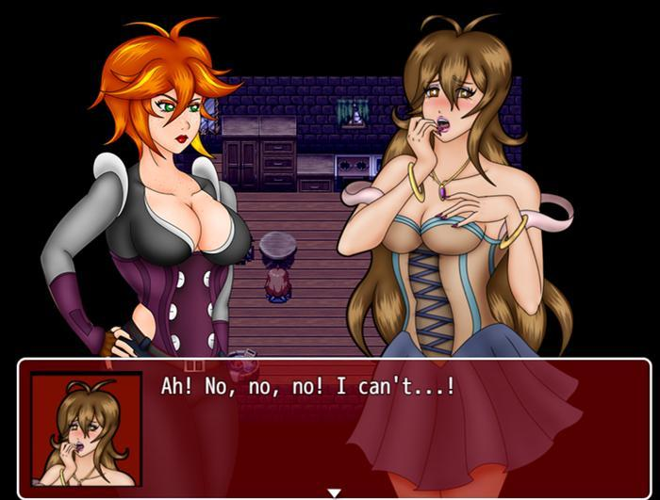

Head to East Mor Town and go to the second floor of the Eastern Shelter. Knock on the door second from the right and open the door to meet your client, Sybille. She tells you that she fears she is being stalked by a succubus and would like your protection while she sleeps. Speak with her a second time once you are ready to begin the job.

This quest will have 2 possible endings based on how you answer the choices you are presented with. Answering either positively or negatively will influence Sybille’s “Trust” level, thus affecting the second half of this questline. If your answers are mostly negative, you will get the less desirable outcome and a lesser reward. Still, if you would like to see both outcomes, merely save before speaking with Sybille a second time.

Sybille will try and fall asleep, but will remain restless and begin speaking to you. If you attempt to inquire further, she will begin to tell you of her past, but hesitate and tell you she needs more time. If you don’t press her, the conversation will end there and her Trust will decrease. Regardless of your choice, time will pass and she will open up and reveal her troubling past to you. After their chat, Sybille will ask if she is a burden to you. Choose the appropriate answer to affect her Trust and your client will finally head to bed.

Not long after, Mila dozes off only to see a succubus looming above Sybille and draining her energy. The succubus, Aeriseth, is unbeatable at this point. You can keep attacking, but she will merely tease you for a few turns while chatting with you. She will attempt to bribe you with gold in exchange for Sybille’s soul. If you accept, it will severely impact Sybille’s Trust towards you and you will only get a mocking chuckle from the succubus in return. Eventually, Aeriseth will get bored and put you to sleep, ending the fight.

You will wake up in a nightmare world that looks just like Noctorna HQ. There is a chest here you can grab with a free Vampire Dust. Go to the east side of the building to find a creature that looks like Maria, only with a freakish looking face. She will ask you a question and you are given 5 possible answers. The topmost answer will negatively affect Sybille’s Trust the most, while the one at the bottom will affect Sybille’s Trust the most positively. After speaking with that Maria creature, walk all the way to the west half to speak with a Bridgette looking creature. Same deal here with the answers. Lastly return to the east side of the room near the tables to find a Mate looking creature and answer her question. You’ll then be transported to a different area.

There is nothing and no one in this area, you are completely alone. If you keep running in a direction, you’ll just end up back the way that you came. Keep doing that a few times and you will suddenly find yourself surrounded by those creatures who questioned us earlier for a cheap scare. Mila will flee from them and then seemingly end up back in the same spot again, only this time, Sybille is standing there, looking off into the distance. This is where her Trust level affects the second part of this quest.

If Sybille doesn’t trust you…

Speak with Sybille and you will be transported out of the dream and back into her room, but neither she nor the succubus are anywhere to be found. When you leave her room you will hear some lewd noises coming from the room next door. The door is ajar, so you take a peek to see Sybille has been turned into a succubus herself and is enjoying her first meal. Utterly corrupted, you have no choice but to defeat your former client.
Succubus Sybille
Max HP:1200

Sybille is a lesser succubus and has not come into her powers yet. Her attack is not very high, although she can still inflict Bleeding on you with her claw swipe and after 3 turns, she will mercilessly drain your health with her succubus powers. Defeating her will earn you the Lesser Succubus Choker as well as Pic 20 and 21 in the Picture Gallery.

If Sybille does trust you…

You will emerge from the nightmare to see that Aeriseth is still draining your client. She’s shocked to see that you’ve broken her spell and you immediately charge at her.
Aeriseth
Max HP: 800

Aeriseth is a similar fight to Succubus Sybille. Her stats are a bit higher, but she has less HP.Once you deal at least 800 points of damage to her, she will end the battle and disappear, saying that her interest has shifted to you instead of Sybille. Sybille wakes up and everything is fine again! The only problem is, well, Sybille can’t exactly afford your services. She’ll give a mere 50 Gold. She’s a troubled soul with plenty of issues to sort out, so we’ll just have to accept it and move on.

As you leave the Eastern Shelter, you’ll bump into a little girl. She’s startled but then leaves you, heading towards the graveyard a bit to the south. Go on and speak to her to find out she’s been orphaned and has no one to care for her now. I think we know where this cheesy story is going… You of course take the little girl back to Sybille and have her take care of the girl in the place of compensation. After the sweet little scene, Mila will be rewarded with a new skill, Selfless Soul, which restores a small amount of SP in exchange for LP. You will also unlock Pic 20 and 21 in the Picture Gallery.

•Contract 5: Cleansing the Cathedral
-Availability: At the end of Chapter 2
-Recommended Hunter Level: 8

After accepting the contract, go to Besilly Cathedral and speak with the first blond nun by the entrance. She will introduce you to Sister Lily, a woman who looks strikingly similar to Iris. After a bit of PTSD flashbacks, Lily tasks you with defeating some ghouls in the Rotten Grove. As you step out of the cathedral, an injured nun stumbles toward you named Mother Clara. She’s pretty rude, but Lily comes outside to take care of her and urges you to clean up those ghouls in the Rotten Grove as soon as possible.

While on this quest, you will only be able to explore the initial area of the Rotten Grove!

3 Ghouls will spawn in this entrance area. Simply defeat all 3 and then head back to the cathedral, where the church bells have ominously stopped. Inside, Mother Clara will be waiting for you beside 2 unusually quiet nuns.She will pay you 800 Gold for your work and bark at you to leave. There is more to this Clara than meets the eye…

Return once again to the cathedral to find it completely empty. Head over to the small chapel on the right side and walk into the holy water to get Mila soaking wet. This may seem like a bit of a gag, but it has a purpose. Save and then walk to the room on the left side. Check the flowers on the table to get a small 20 Gold. Walk into either of the doors to enter Clara’s office. Inside the office is a red chest containing a rare Prism Core! Check the drawer next to it to get a Tourniquet.

Once you are in this office, you MUST read the journal on Clara’s table.You will discover that she is in fact one of Viviene’s old servants and wishes to continue her lofty goals. If you leave
this office without reading the entry, it will result in an immediate bad ending. After reading this passage, leave Clara’s office to bump into Lily, who has already been turned into a vampire by Clara.
Lily
Max HP: 1400

This fight shouldn’t give you too much of an issue. Lily doesn’t have much in the way of surprises in the way that she fights. Her attack isn’t particularly hard and she should go down with ease. Leave Clara’s office after the fight and return to the main area of the cathedral and you will see that the nuns have all been turned into vampires. You can fight them or ignore them, but once you have defeated the boss of this area, they will be gone regardless, so keep that in mind. Proceed to the chapel on the right to face off against Clara, this quest’s boss.
Clara
Max HP: Form 1: 1000+
Max HP: Form 2: 2000

Clara will start off as a rather tame battle, actually having even less attack than the corrupted nuns. During the second turn of the battle, if you fell into the holy water earlier, Clara will take an additional 350 damage at the start of the turn. Once Clara has been dealt at least 1000 damage, the battle truly begins. Clara’s actions become erratic and her attack and agility stats increase greatly. Use Brave Soul as soon as you are able to buff your defense. Even if you are at the recommended level, Clara may still outspeed you and move first. Liquid Silver can be more useful than Dagger for weakening Clara since it’s item priority makes it always go first. Fire Bombs are very ineffective against Clara with her high magical defense, so use physical skills like Axe or Knife instead.

Once she is beaten, Clara will fall into the holy water she very foolishly decided to stand near and burn in a blaze of glory. Leave the room to find a man shocked at the carnage you left behind in this holy place. He goes toward the altar to pray. Speak with the man again to receive a Felix Laurel, which raises your Luck stat by 4. You will also unlock Pic 22 in the Picture Gallery

•Contract 6: A Lesson in Botany
-Availability: At the end of Chapter 2
-Recommended Hunter Level: 10

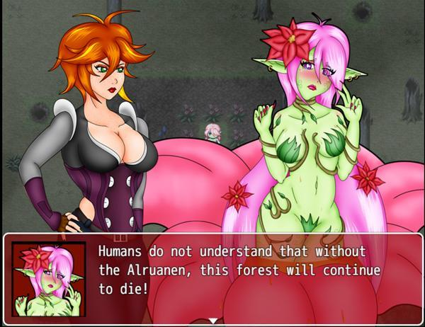

After accepting the contract, go to Mor Town West and speak with the bearded man standing in front of the crops. He tasks you with collecting a Devil’s Ribwort, a sort of root that is harvested from Alraune that lives in the Rotten Grove. He mentions that they use mind altering pollen and gives you a Gas Mask to protect you from it’s effects. You should equip this head gear immediately. Head on over to the Rotten Grove and head east through the forest maze, north through the pond area, and up the cliff on the west end of the area with the broken bridge.

As soon as you enter this area, Mila will comment on the sweet scent in the air. Speak with Alraune standing alone in the dirt. Her name is Marina and she explains to you that vampires have been murdering her kind to steal her nectar. Mila suspects that the vampires may be using this nectar to create some sort of mind altering substance. You are presented with two options and your quest will change based on your decision.

Inquire about the vampires…

If you press Marina for information on the vampires. She thinks they are in the southeast edge of the forest. From where Marina is standing if you just go south, you can actually jump down to quickly get back to the forest maze. Once you are in the maze, enter the area leading south. In that small grotto, you will find two Corrupted Nuns chatting. Mila hides behind some trees nearby to hear their conversation, but she is quickly noticed and the two vampires will attack. Beat them to receive the Stolen Alraune Nectar.

Return to Marina and hand over the nectar you collected. In return she will give you the Devil’s Ribwort that belonged to one of her Alraune friends. Marina has a desire to restore the forest to a healthy state, however, it would be difficult without more alraune around. She has the crazy idea of turning you into one to help her repopulate the forest and expels her pollen at you.
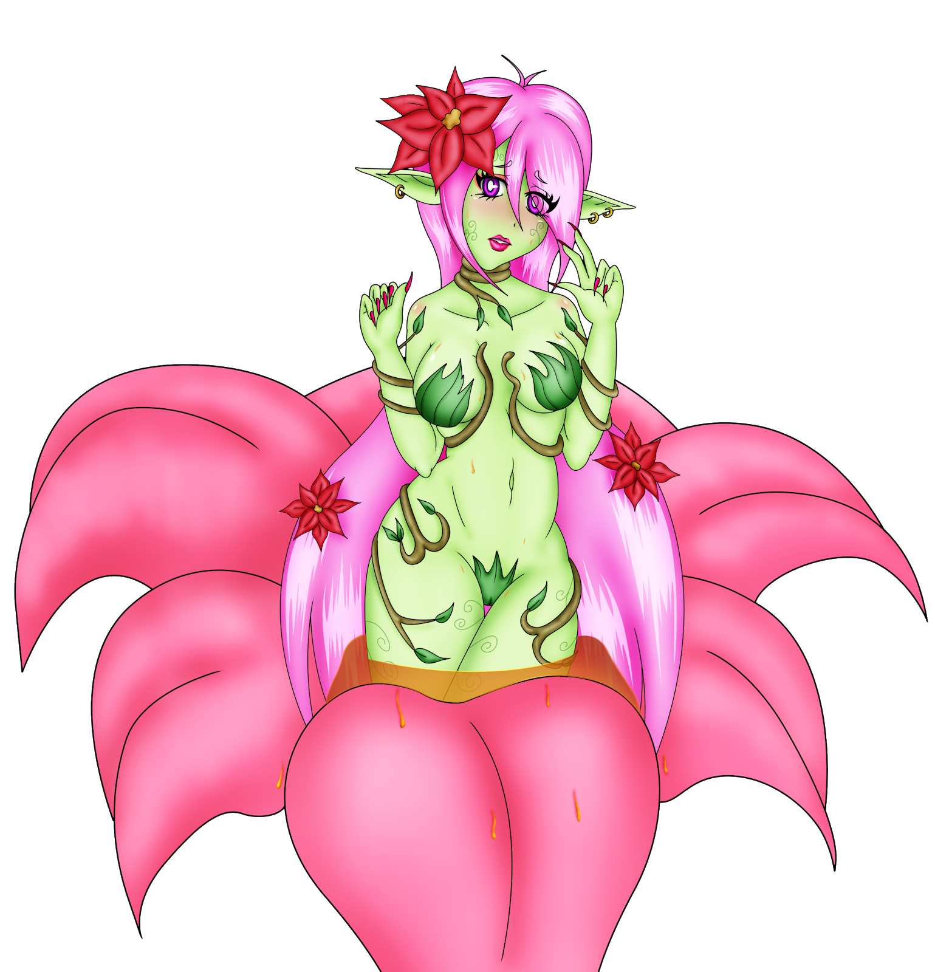
Marina
Max HP: 2600

Marina starts off the fight by spreading her sapping seeds all over you. During the entire course of the fight, a bit of your health will be sapped away and restore Marina’s health. Since she is not undead, liquid silver and daggers will not weaken her. She will occasionally use her pollen to make you woozy, preventing you from taking any action. If you are unlucky, she will mesmerize Mila, making her immobile for even longer! If you equipped the Gas Mask before the fight, you will be able to resist both status ailments. Also watch for her corrupting fluid, which will weaken Mila and temporarily lower her stats. Marina has a high amount of HP and a sizable attack stat. Her biggest weakness is her low agility and weakness to fire, so use Fire Bomb as your main attack. In addition to doing damage, the Fire Bomb can occasionally numb enemies which will likely skip Marina’s next action. Packing additional Supply Caches will be useful since you will be spending a lot of SP during this fight. Defeating Marina will get you a Celeritas Laurel.

Marina seems genuinely sorry for attacking you. If you speak with her again after the fight, Mila will apologize for hurting her and Marina will give you the Alraune Headdress. Return to your client in Mor Town West and turn in the Devil’s Ribwort to receive 2000 Gold and unlock Pic 30 and 31 in your Picture Gallery.

Harvest the Alraune…

If you choose to harvest Marina for the Devil’s Ribwort instead, you will immediately have to battle her. Follow the strategy posted above if you need help. After you have defeated her, return to your client in Mor Town West and turn in the Devil’s Ribwort to receive 2000 Gold and unlock Pic 30 and 31 in your Picture Gallery.

•Contract 7: The Blood Temple
-Availability: At the end of Chapter 2 and after speaking to the girl in the graveyard of Abelleth Village.
-Recommended Hunter Level: 13

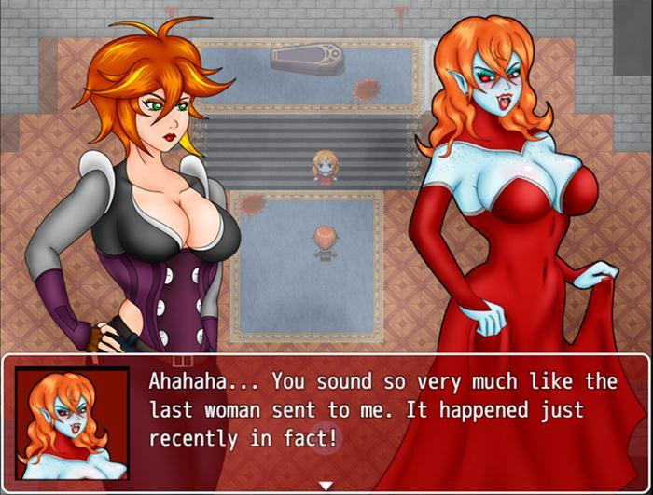

After accepting the contract, head to Abelleth Village’s graveyard. You arrive too late as your client has already been taken to the Blood Temple as a sacrifice. Head to the Village Elder’s Office and a woman will bump into you as you enter. Her name is Astoria and happens to be the lover of your client, Alexa. Astoria is confident that the village’s traditional ritual is a sham and wants to enter the Blood Temple herself to try and rescue Alexa. Though the temple itself is locked, Astoria stole the key from under the leaders’ nose. She will open the place up for you and await you inside.

The Blood Temple is located in a cave at the northern end of the Rotten Grove. Go down the hole and proceed north and you will find the temple’s large stone door. Shimmering on the floor nearby is the Stone Tablet that Astoria was carrying. Use it on the door to open the way into the temple.

Go through the first hall into a room which has 4 doors and a mirror in the center. All of the rooms are locked except for the leftmost room, so enter that room first. This room looks like a sort of lobby with large desks, a piano, and a suit of armor with a pool of blood on the floor and on the wall by it. Your attention should be drawn to the shimmering object on the table to the right. Examine it to pick up a Small Key. You can use this key to unlock any of the other 3 locked doors in the room before this. The last thing to mention in this room is the scattered notes on the centermost table. It will mention a trap that has been laid downstairs. Make a mental note of this.

Before we use that small key we just got, let’s go get the other 2 so we can open each door without having to backtrack. From the main room with 4 doors, head west into a hallway with a long dining table and stairs leading downstairs. Ignore the stairs for now and go north through the hall and take a right to go into the next room. It will appear as if you are outside, even though you are underground. On these grounds you’ll find more graves of the sacrifices that were sent down here. There is also a bridge crossing a small river that leads to a large stone slab with text on it. Shimmering in the water to your left will be another Small Key.

Exiting this room east will lead you to another hallway where you will be chased down by a now vamped Astoria. She reveals that Alaexa had already been turned by the time she arrived and Astoria willingly joined her in undeath. She’s thirsty and looking to make you her first bite.
Astoria
Max HP: 1200

Astoria is very weak, even if you are under the recommended level, her attacks shouldn’t even scratch you. She’s more interested in healing her wounds and slowing you down than actually attacking you. If the battle goes on for too long, she’ll eventually run out of SP to cast her healing and focus on attacking, but by that point she should be nearly defeated. Once the battle is over, Astoria becomes mist and disappears.

Head down the hallway and into the first room on the right. In this bathing hall, merely grab the last Small Key that is in the water. The second room on the right is an indoor garden filled with corrupting fluid. If you try to walk through this purple muck you’ll become infected with vampirism! There is a chest in this room as well, but it is blocked by some thorny plants we can’t get past yet.

Return to the main room with the 4 doors so that we can begin to unlock them. Starting with the rightmost door, check the glass cabinet for a Vulnerary, then inspect the rightmost wardrobe for a Liquid Silver,the wardrobe on the right wall for a Supply Cache (S), and of course the chest that contains an Ammo Pouch. The last thing to note in this room is the bed on the left. If you decide to use the bed at any point while Astoria still lives, you will get a Bad Ending.

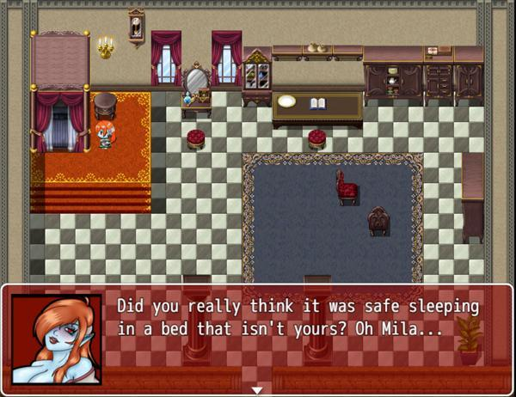

The door second to the right is a treasury room with 8 gold chests that are inaccessible. The red chest on the right contains 400 Gold and the chest on the left contains a Gothic Corset, a new Clothing equipment for Mila. Check the last locked door in the main room to enter a small library. There is a scrapped paper here that reads B-3, this will be important soon. There is an envelope on a desk from Alexa to Astoria you can read if you like and a statue you can inspect which has a button you can press. Press it to open a secret passageway in the room next door leading downstairs.

Return to the room with the piano and suit of armor and go down the newly unlocked passageway to enter a small wine basement with a chest containing Large Shears. You can use these shears on the thorny plants found in the garden to grab the chest containing a Torch. Now that we have the Torch and have beaten Astoria, we can go down the staircase found in the dining hall in the west section of the Blood Temple.

This room is pitch black, but once you’ve obtained the Torch, Mila will automatically light up the room. Astoria can be seen on the opposite wall walking down another flight of stairs, we should follow her. There is a locked gate immediately in front of you, but after you light the passageway, you can find a Gate Key shimmering on the floor that will unlock this gate. In this underground maze there are a few chests to collect. In the north end is a small chest containing 50 Gold, to the west is a chest containing a Supply Cache (M), a large chest to the east containing a Viribus Laurel, and finally to the south is a chest containing Holy Water. Our goal is to reach the staircase on the eastmost side, but there is another staircase leading down towards the center of this maze.

There is an eerie silence in this room. When you enter, you will find switches on both sides, labeled with a letter and a number. Take a moment to remember which panel is which before proceeding. On the north end of the room, is a dark chest containing the Vampire Corset, but be warned: once you have opened this chest, you will trigger a trap! Gas will begin to fill the room and you will have a mere 15 seconds to deactivate it before Mila will be consumed by the corrupting gas and turned into a vampire, leading to a Bad Ending. Flip the B-3 switch found in the second row on the right to deactivate the gas and unlock the gate to allow you to escape. Leave this trap room and venture through the maze leading to the rightmost side to get to the stairs that Astoria entered.

You will enter another quiet and foggy room. Save and proceed through the gate door which you can open without a key to find Astoria and her lover, Alexa. The two vampires will try and seduce Mila into joining them. If you accept their proposal, it will lead you to an extended Bad Ending where Mila will become a slave to Abelleth’s Guardian (You can read more details in the Side Quests Section.) If you deny their offer, you will have to face the two vampires at once
.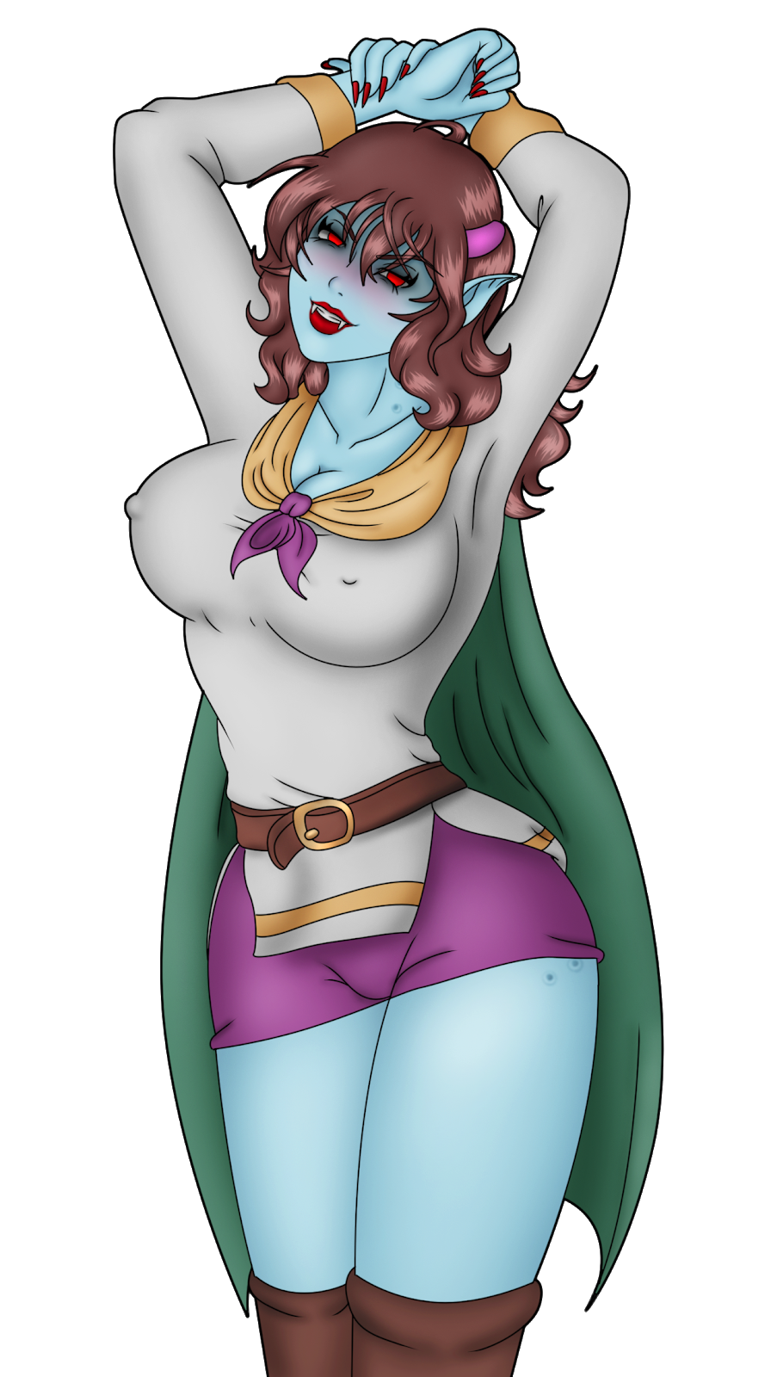
Astoria
Max HP: 1200
Alexa
Max HP: 1600

The two vampires will work as a team to defeat you. Alexa is the main attacker while Astoria provides her with support, casting healing and buffs on her while casting debuffs on you. Start the battle by using Liquid Silver on Alexa to weaken her attacks and then use Cross to cause damage to both vampires. If you have Knifera, use it on Alexa and try to defeat her first since she is the main threat. Astoria will rarely attack you and her damage output is pitiful. Leaving her to fend for herself will likely spell victory for you. Either way, while both of the vampires remain alive, they may occasionally waste a turn admiring each other so use those free turns to your advantage. Defeating the two of them will drop 2x Vampire Dust and a Ruby Spinel. After the battle, you will be given the option to quickly head back upstairs if you want to skip the return trip through the maze. Keep in mind that just to the north of this room is a chest with a Silver Ore, that you may miss if you choose to quickly head back up, although you can always come back for it later if you choose.

All that is left to do is to defeat the village’s Guardian. Now that the other two vampires are gone, you can also safely rest in the bed found in the rightmost room of the 4 door room. Once you are full on HP and SP, save and return to that outdoor area with the graves and inspect the large stone slab beyond the bridge. Place the ruby spinel in it to open a passageway leading to this quest’s boss.

In this crypt, the village’s Guardian will reveal herself. A buxom vampire dressed in red named Victoria will greet you, expecting another tasty meal. Mila will tell Victoria that she has already destroyed Alexa, her most recent catch. Hearing this, Victoria will want to replace her with Mila instead.
Victoria
Max HP: 3100

Victoria has stats appropriate to a village guardian with plenty of tricks of her sleeve to make this fight challenging if you aren’t prepared. Victoria can hit hard, buff herself, and summon a swarm of bats which hit multiple times and drain HP per hit. Her bat swarm attack in particular is deadly. While Victoria still has at least 75% of her health left, she may waste turns laughing at you instead. She will only begin to cast Blood Heal when she is at 20% health or less, so use these clues to gauge how close you are to finishing the fight. She doesn’t have any other distinct weakness from other vampires you’ve faced so far. Use the usual strategy of debuffing with Liquid Silver and Daggers first then using as many skills as possible. It should be noted that her Magic Defense is a bit lower than her Physical Defense, so Fire Bomb may be a good move against Victoria, especially if you are outspeeding her. Be VERY conscious of your health during this fight. If your HP reaches 20% or less, she will automatically inflict the Wounded status on you!

If you happen to lose against Victoria, she will turn you into a Ghoul and release you into the Rotten Grove to join the other wandering undead. If you do defeat her, you will unlock Pic 32 in your Picture Gallery. Victoria will also drop a House Key onto the floor which you can pick up. Your contract is complete, but there is one last thing we need to do. If you examine the House Keys you picked up, they will have an address on them: 341 Abelleth Village Residence. Return to Abelleth Village enter the house with that address using the House Key you collected. This is Alaexa’s house and the main trinket to get here is the Silver Ore found inside the chest. You can also read through Alaexa’s diary as well to find out what she was saving the ore for.

•Contract 8: The Lost Wife
-Availability: At the end of Chapter 2
-Recommended Hunter Level: 14

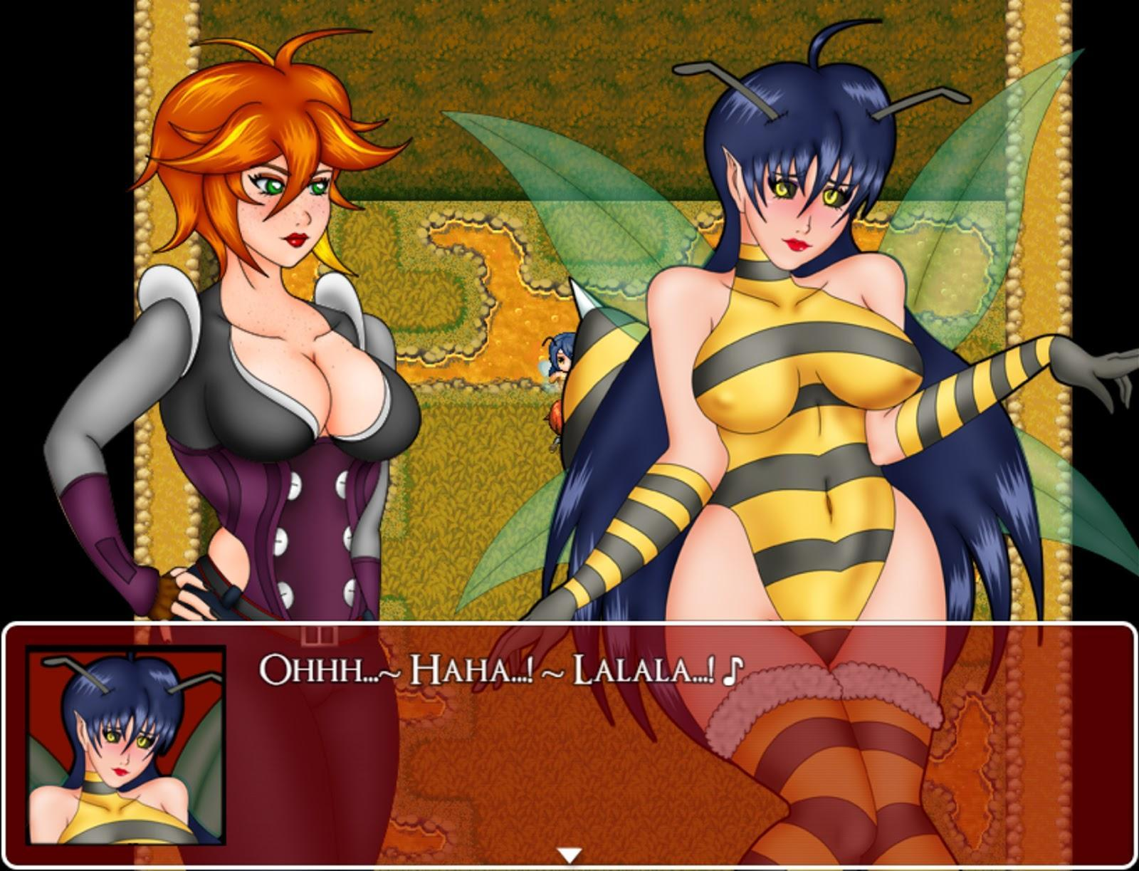

After accepting the contract, go to the flower shop in Mor Town Center to speak with your client. Once you have finished speaking with him, he will give you the Woods Map. With this, you’ll be able to get to a hidden area in Humilem Woods, so head there. Once you have arrived at the crossroads, you can check the map in your key items to see that you need to head North, West, and North to find Wheezie Woods.

Once you’ve entered this golden forest, you’ll see the Whezzia, bee-girls who seem uninterested in speaking with you. Head North to enter their hive and at the end you will meet the Whezzia Queen, although she too is rather uninterested in speaking with you. To grab her attention, go to any pool of honey to interact with it and take some Wheezie Honey. Doing this once is enough to grab the Queen’s attention. If you do this two more times however, the whole hive will be alerted to your presence and attempt to stop you, prompting a fight with some Wheezing Workers.

While individually they are weak, the Whezzia Workers have strength in numbers and may overwhelm you if you are too low level. Defeating them may occasionally grant more Wheezie Honey and some gold as well. The Wheezie Honey can be used as a healing item, but it’s not recommended that you use any for now. If you consume at least 3, speaking to the Whezzia Queen will always result in a Bad Ending. If you did this accidentally, you’ll need to return to the client in the Mor Flower Shop. Speak with him and Mila will… expel the honey from her body.

Once you have grabbed the Queen’s attention, speak with her again. The bipolar Queen seems unstable, but you can ask her a series of questions. Select the third option and then confirm the following question to see a bad ending. Select the fourth option to find out that the Queen is actually your client’s missing wife who was turned into one of the Whezzia. After the scene a fight will commence.
Betty
Max HP: 2300
Betty has low HP and low Defense, although her attack is higher to compensate. At the end of the first turn, she will summon two Whezzia Workers to the fight. If you got the Gas Mask from the alraune contract, you should equip it before the fight since both Betty and the workers can make Mila Woozy. The Cross and Cross skills are pretty ineffective in this fight. While they will hit all of the enemies, they do little damage to enemies who aren’t weak to the Light attribute. The Axe and Axera skills however are very effective and will do much more damage if you manage to land them. Once Betty is at 30% Health or lower, she will summon 2 more Whezzia Workers to help her.

The Queen is defeated and the rest of her workers scatter into the forest. Return to the Mor Flower shop again to report to your client. He will leave the shop without giving you your reward, so follow him outside and speak with him again. He will give you 800 Gold for your services as well as the Striped Dress. You will also unlock Pic 41 In your Picture Gallery.

•Contract 9: Suspicious Snake Oil
-Availability: At the end of Chapter 2
-Recommended Hunter Level: 15

After accepting the contract, head to Mor Town North and enter the house at the northeastern corner. Inside, you will meet your client who will explain the story of his missing wife and a shady business woman in South Mor Town. He hands you 600 Gold before you go. Once you are in South Mor Town, speak with the woman with the violet hair. She will ask if you are interested in purchasing her products. You can accept if you want, but all of her items are overpriced and pretty worthless. You’ll have a short chat, and she will invite you to her resort, which she opened recently, just outside of town. After the exchange, she will hand you a Member’s Card so that you can check the resort out for yourself. After the woman has left, leave Town and head to the resort which is just to the south.

Once you arrive at the Althaeban Resort, show the Member's Card to the guards and they will let you pass. If you enter the southmost tent, you can find Liquid Silver inside the jar to the left. Speak with the lady with the purple hair again and enter the resort lobby. She will have you fill out some paperwork. Once that’s done, you can try and enter the men’s restroom. Although it is locked, you can continue to pester the man inside. Keep doing this multiple times and he will eventually give you an Albatraoz Oil. If you check the trash bin in the women’s restroom, you can also find Alquarf Oil. Speak with the receptionist lady to turn in the paperwork and then speak with the woman on the left side of the room and she will take you to the spa room behind the curtains.

Mila will lay comfortably on the bed and you will be prompted if you want to get dressed or stay longer. If you stay longer, you will get a Bad Ending. Get dressed and then head outside to the southmost tent where you found the Liquid Silver. There, a woman will transform into a lamia before your eyes. Another lamia will enter as well and a fight will commence.

Newborn Lamia
Max HP: 1300
Lamia Servant
Max HP: 1850
The Newborn Lamia is a very weak enemy that shouldn’t be much of an issue. She acts as more of a supporting role for the lamia servant. The main thing you should be wary of is if either of them decides to coil you, restraining you from acting for a few turns. The lamia servant can not only weaken you, but also poison you for continuous damage. Lamias are susceptible to Piercing attacks, so spam Knifera whenever you can. The Lamias will also drop Antitoxin when defeated, which removes Poison and heals a bit of health.

The newborn Lamia is actually your client’s wife. After the scene, you will receive the Resort Key. Exiting the tent you will see more Lamias who will slowly move toward you. You can fight them for some extra gold if you like. Return to the Resort Lobby and head to the back of the room where there is a door that you can unlock using the Resort Key. Head down the steps and in the last room you will find the business woman from earlier, Nefertari. She will reveal herself to be a Lamia as well and a fight will commence.
Nefertari
Max HP: 5300
Nefertari, like the other Lamias, is weak to piercing, so Knifera should be your go to move during this fight.Nefertari can occasionally act twice per turn, so be prepared for that. Stacking multiple status effects is how this boss can get the better of you. If you have any Antitoxin left from defeating the Lamia Servants, this is a good fight to use them. If Nefertari brings you to 20% of your health, she will try and attempt to coax you into surrendering. If you fight back, you will inflict a bit of damage on her, but if you give in, she will inject Mila with her venom, dominating you and effectively ending the fight.

Once the Lamia Queen has been defeated, a scene will play out and you will be returned to your client’s house, where he will be reunited with his lamia-fied wife. He doesn’t seem to mind however, and will give you 950 Gold as a reward. More Importantly, the client’s wife will teach you the Light Skil Dual Lashings! You will also unlock Pic 42 in the Picture Gallery.

One last thing you can pick up is a Sunlite Tea from Delum at the Resort Lobby. He’ll be sitting by the massage room after you’ve completed the quest.

•Contract 10: Keeping Mindful
-Availability: At the end of Chapter 2
-Recommended Hunter Level: 17
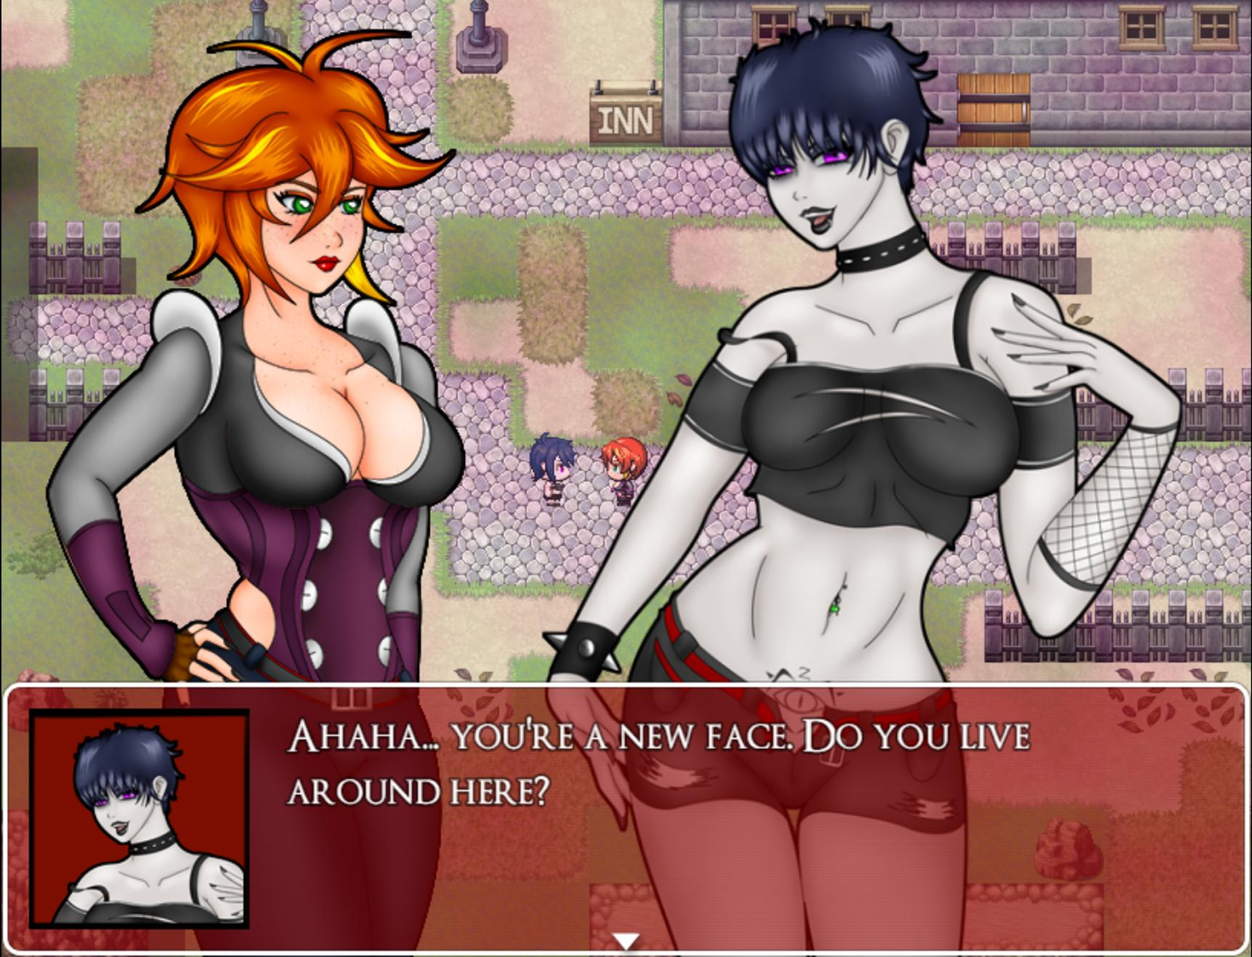
While this contract is doable at HR 17, it is recommended you at least reach Fallholt in chapter 3 to pick up stronger gear and skills before proceeding. The battle in this chapter will be challenging without proper preparation! Anyway, after accepting the contract, head to the small town of Ilbrooke which can be found in the southwest side of the Eastern Overworld. Upon arriving, there will be a cutscene where you will meet a mysterious woman in black. You’ll notice that the town is covered in a strange fog, yet this odd woman pays it no mind. During the conversation another young woman will bump into the two of you and then run away while dropping something onto the floor. The woman in black then invites you to follow her into the Ilbrooke Caves to the north end of town. Following the woman will result in a Bad Ending. Deny her proposal and the woman will leave and Mila will pick up the Ilbrooke Shack Key that was dropped on the floor.

Exploring the town, you’ll notice that most of its residents are nowhere to be seen. All the buildings are locked and the only people outside are three women acting incredibly strange. The northernmost building has one woman who is not acting odd and it’s the woman who bumped into you earlier. Speak with her and hand her the Ilbrooke Shack Key that you picked up earlier then follow her inside of the shack.

-It should be noted that you can also explore the caves to the north, but exploring too deep right now will result in a bad ending. Speaking to the woman in black outside of the caves will also have the option to give you a bad ending.

Speak to the woman again to find that she is your client, Melody. She explains that her town is being preyed on by an Hirnlienne, a brain-draining monster that leaves it’s victims as debauched shadows of their former selves. Under normal circumstances, you would have no hope to fight against this mesmerizing enemy. However, Melody provides you with a Tin Foil Hat. This headgear has pitiful stats, but it will be necessary to equip if you are to stand any chance against the Hirnlienne. Do so before going on any further. Once you have received your shiny nice headgear, check the barrels to collect 200 Gold and a Salutem Laurel. You are now ready to explore those caves to the north, so let’s head there.

Starting off, there are 3 entrances to the cave which lead to different areas. The cave itself is dark and contains Ghouls to fight against. You’ll also notice that there are holes strewn about the cave which you cannot pass. Throughout the cave are chests which contain “Sturdy Board”. You can use this item over any hole to cross them. There are a total of 3 levels in the Ilbrooke caves and your target is on the third. Follow the maps below if you need help navigating the maze.
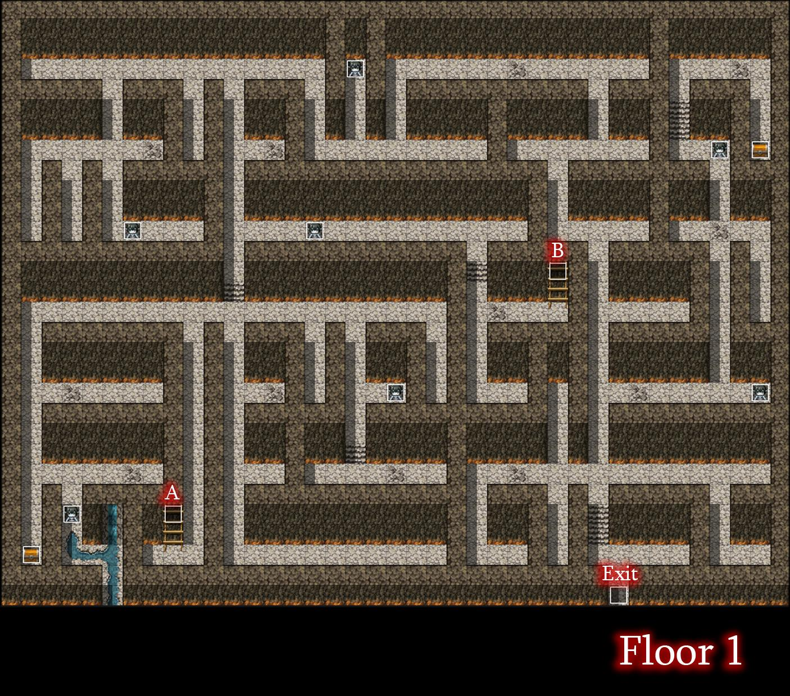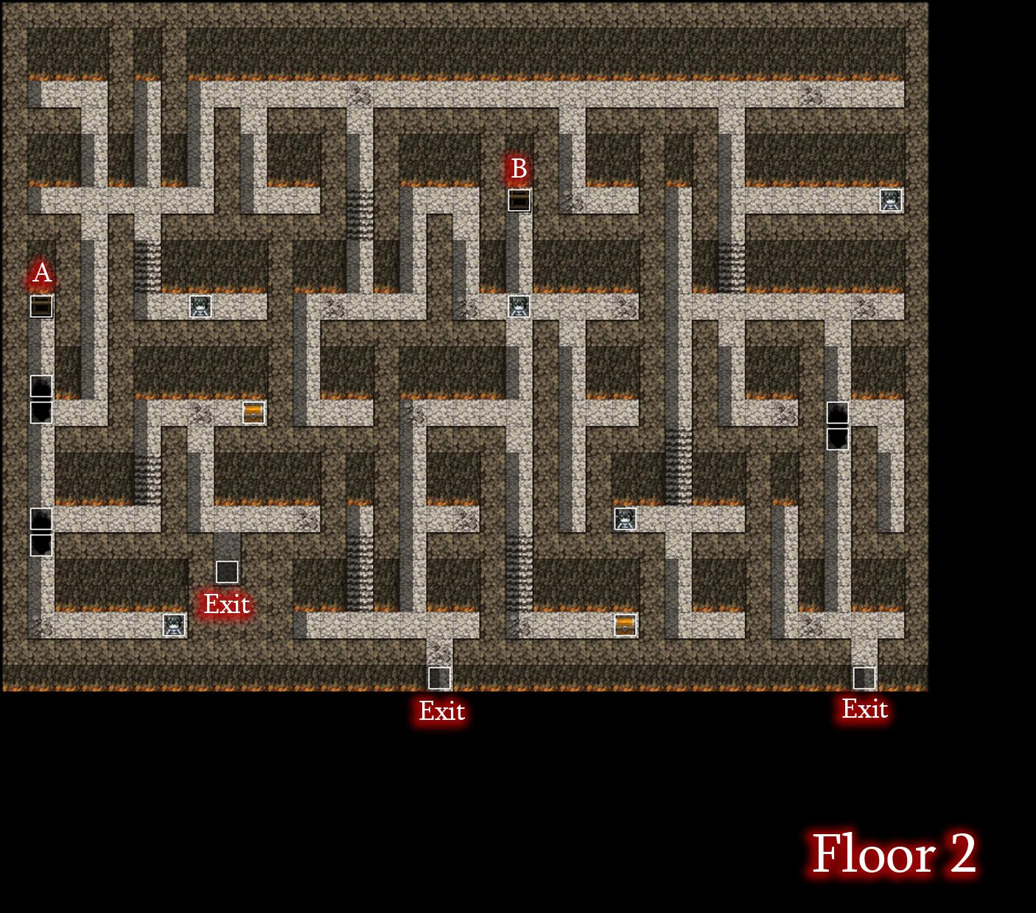
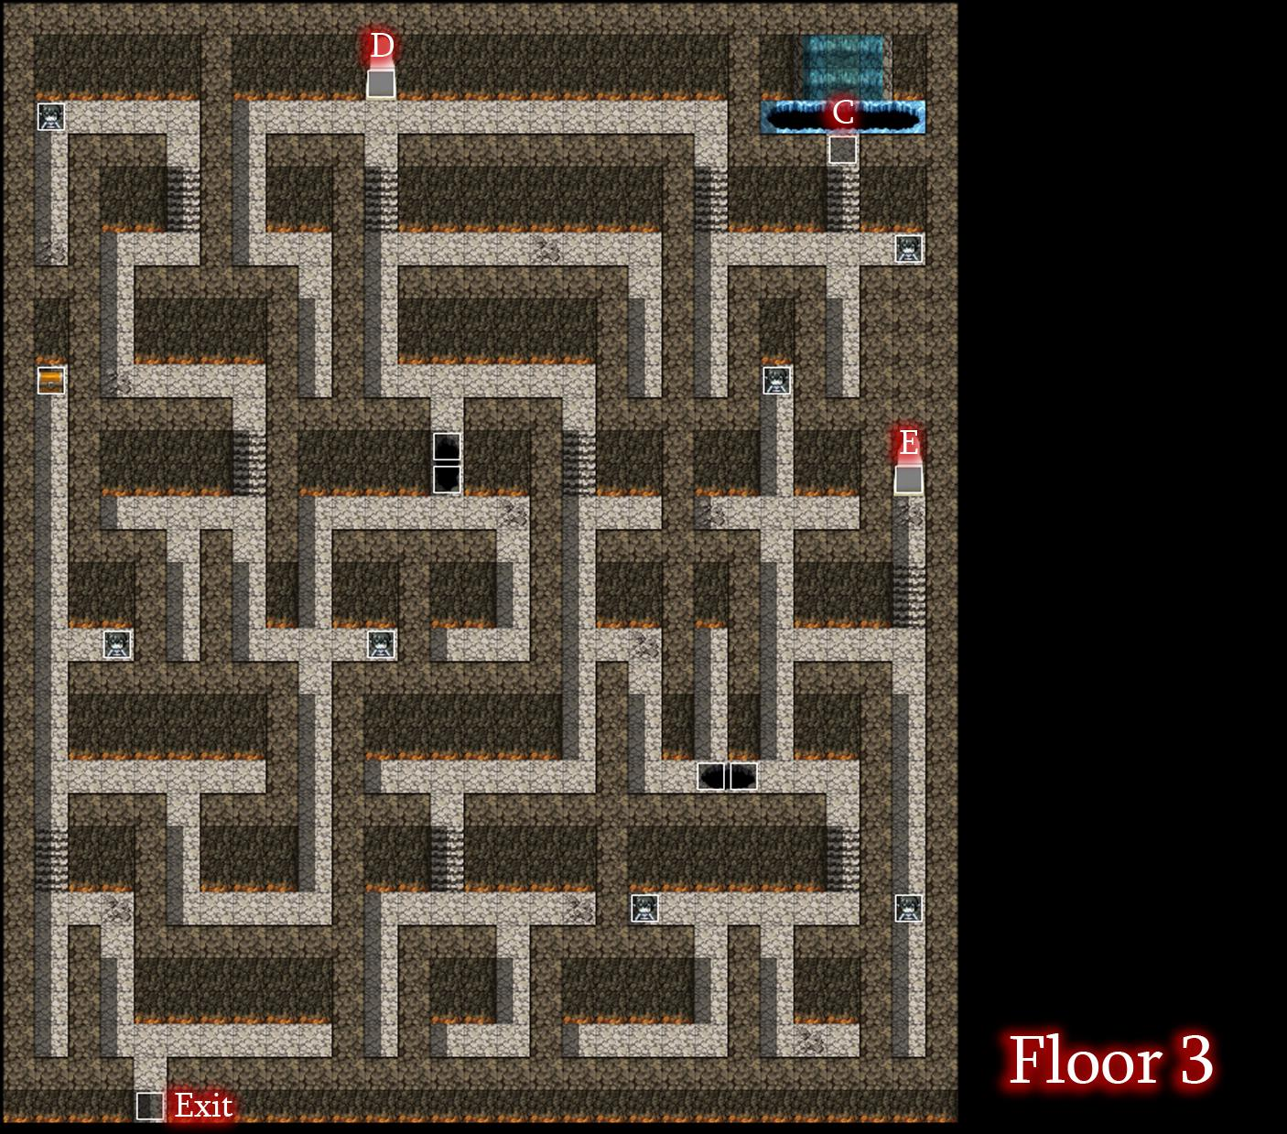
Before entering the cave that leads to floor 3, take a moment to roll the boulder down the hill to unlock a shortcut that will be useful soon. Once you have reached the third floor, you will need to go down the hole at point C to find the last Sturdy Board to cover the holes. After picking this up, you’ll be back at the first floor, but you can use that shortcut we opened up earlier to get right back up to floor 3. If you go through the entrance at point D, there will be a small section with 4 ghouls and a chest containing Silver Ore! Once you are ready to tackle the boss, head back to floor 3 and enter point E. Be absolutely sure you have your Tin Foil Hat equipped or it will result in an automatic loss!
Lillith
Max HP: 7200

The woman in black turned out to be the Hirnlienne all along! Many of her attacks are magical which means that you likely will not have the defense necessary to take minimal damage. High HP and stat boosting foods are recommended. Lilith has a 75% chance to take two actions each turn and she is rather fast. Plan each turn assuming that she will attack twice. Her physical attack isn’t very high, but she is capable of using Claw Swipe to cause continuous bleeding damage, and her Lewd Slime attack can lower your physical defense as well. Her nastiest attacks are the ones she is most likely to use often. Her Brain Drain skill recovers her health slightly while reducing your agility and her Brain Waves skill hits multiple times and reduces your magical resistance. If you completed the Casino Side Quest, the skill you earn from it will be invaluable in not only healing you, but also getting a lot of damage early on.

Once you’ve vanquished the goth mind sucker, you’ll automatically be returned to Melody. She will reward you with your pay of 2750 Gold and she will also comment on the item you picked up after defeating Lillith. With your newly obtained Mind’s Eye you will be able to check enemy weakness, resistances, and total HP! In addition an HP gauge is displayed for the remainder of the battle! With your contract complete, you will unlock Pic 64 and 65 in the Picture Gallery. Additionally an NPC named Chris will appear in the village after you’ve cleared the quest and he will give you a Celeritas Laurel for chatting with him.

•Contract 11: Beneath the Full Moon
-Availability: At the end of Chapter 3
-Recommended Hunter Level: 19

Head to the Fallholt Tavern and speak to the red haired guard sitting alone at the table. This is Quinn, a guard lacking a bit of self-confidence. She tasks you with helping her on an investigation regarding missing people. The outcome of this quest will change based on the way you answer questions throughout this quest, similar to the Succubus Quest from earlier. If you answer questions negatively, Quinn will end up as Lycanthrope herself and you will be forced to fight against her. This guide will show you the positive answers to keep her as a human, but feel free to go against it if you would like to see the other outcome.

Keep in mind that once you speak with Quinn, you will not be allowed to leave her side until you are done with the quest.
In the first conversation with her, answer “You’re on to something”. Quinn will then join your party and you must head to the western side of the city to question some of the townspeople. To the man, answer “Intervene”, for the old woman answer “Disregard her Comment”, for the man by the snow, your answer changes nothing. After speaking to the 3 people, head to the Fallholt Cathedral and speak with the church worker there. Afterwards, go outside for another scene and answer “Don’t say that”. Then, search the floor near the church to find the final clue to Quinn’s investigation, a tuft of bloody fur. Head to Fenrir Glade to track down your suspect. (Check the Side Quests section of the guide for more detail on Fenrir Glade.)

Once you are in the area, your way to the village will be blocked by Lycanthrope Guards. You will have to defeat them to get past them and Quinn is there to assist you a bit. Once they are out of the way, the Lycanthropes of the village will mob you. Either avoid them or take them all out, but your goal is the Queen’s home to the north of the village. You’ll once again have to fight against two more of her guards and once they are defeated, you have one last chance to heal up and save before going through a couple of scenes, culminating in two back-to-back battles in Fallholt.

Lycanthrope Elite/Quinn
Max HP: 3000

Both of these enemies are slightly stronger versions of the standard Lycanthrope enemy you have faced up until now. The strategy of this fight is the same no matter what. Both enemies have the same stat line. Focus on conserving your SP as much as you are able because unlike your HP, your SP will not be restored in the subsequent fight.

Sophia
Max HP: 8000

Sophia has high attack and speed, befitting a werewolf queen. Daggera is recommended to have in this fight and you’ll have a tough time against her without it. She attacks twice per turn and occasionally uses a skill which allows her to strike 3 times. This can be devastating if she uses it twice in a row, although this is unlikely. If you earned the Aeriseth Summon from an earlier quest, you will have another useful tool to combat her.

Completing this grueling fight, you will be transported back to the Queen’s home. Speak to Quinn one last time to complete the quest, earning you the Daggerga skill as well as Pic 81 in the Picture Gallery. Once you have cleared this quest, you can also speak to some NPCs for some goodies. If you go to Fenrir Lake, speak with the NPC Peranut on the northwest corner to receive a Salutem Laurel. Then, you can go to the Pot of Fallholt.There you can find a lycanthrope with silver hair named Erin who will give you a Silver Ore for speaking to her.

•Contract 12: The Tragic Bride
-Availability: At the end of Chapter 3
-Recommended Hunter Level: 20

This quest is relatively straight-forward, though it does have multiple endings. Your client Konrad will be waiting inside of Fallholt Cathedral. Speak to him and he will brief you on his Client, Jessica. You may have seen this character at multiple points during the adventure (It’s even possible to fight her early during the events of chapter 3!). She is a vampire, but like princess Anja, her mind has been returned to her after a chance encounter. After speaking with Konrad, you’ll have to visit Jessica at her home in the residential district of Fallholt, Residence A-3. She’ll give you her backstory and afterwards you are free to walk around her home. Something to note is that there is a pot on the second floor of her home that contains a Moonlite Tea. Be sure to grab it before returning to Konrad.

Speak with Konrad again and he will start preparing a meet up between Jessica and some suitors. Finally, return to Jessica one last time and once you are ready for a fight, agree to go with her to the meet up. During the scene at the cathedral, there are multiple opportunities to get a different ending. Jessica confesses her love to Mila and you can accept it to earn one ending. Deny her to proceed to the boss battle.
Jessica
Max HP: 6000

Due to being inside of the cathedral, Jessica’s health is constantly ticking down. This fight isn't particularly difficult, but it can be a bit annoying if you don’t understand how it works. Jessica’s primary move mesmerizes MIla, which will prevent you from taking any actions for a few turns. Combined with her ability to wound Mila with continuous damage, you can find yourself losing a lot of HP without realizing it. The trick is that her mesmerizing move almost always goes first. Slower moves like Axe, bomb, or any of the buffing skills will be canceled out of she decides you use this. Your best bet is to attack her with either the knife or dagger skills, since those have priority in battle. After a few rounds, Jessica should go down. Losing this battle will result in a slightly altered bad ending from the last mentioned one.

Once Jessica is beaten, you have the option of slaying her or sparing her. Whatever you decide to do, you will unlock the Crossga skill as well as Pic 99 in the Picture Gallery. If you spare Jessica, you can then visit her at her home whenever you like for a few optional conversations!

•Contract 13: The Forgotten Treasure
-Availability: At the end of Chapter 3
-Recommended Hunter Level: 22

It is recommended that you obtain the “Skeleton Lexicon” from chapter 4 before accepting this quest.

Oh boy! A treasure hunting expedition! I’m sure nothing could possibly go wrong!
Meet with your client, Rita, at the Port of Mor. She’ll give you a run down of the adventure you two will go on and will also mention to stock up before heading out to your destination since items are pricier in the desert town of Kedje. It would be wise to purchase several Supply Caches for the following quest just in case. You should also be carrying at least 500 Gold with you before you go. Once you are ready, get on the ship and sail to the Port of Kedje.

Once you’ve arrived at the port and read through the short scenes there, check the pot right by the port’s exit to get a free Garnet Shard. You won’t be able to explore the desert without Rita, so head into the nearby town of Kedje. There are two shops and a restaurant here. A store of note is the accessory stand with unique accessories you may find useful. If you are attempting this quest below the recommended level, you may want to pick up the Blaze Earrings. These will enhance the damage of your bomb skills, which is key to clearing this section efficiently.

You can speak with the locals for some lore and also warnings about Asenath’s tomb as well as her cursed guardians! Next to the restaurant is a vase containing 15 Gold. Inside the leftmost tent, check the barrels for: A Vulnerary, 20 Gold, and 80 Gold. You can also speak with Don here who will hand you a Felix Laurel. The rightmost tent has a couple of restaurant workers on break and you can find 100 Gold inside one of the barrels. Finally, inside the restaurant proper, you can order some food items for health and stat boosts if you like. Speaking with a silent man over and over again will reward you with a Ham & Cheese Sandwich.

Rita doesn’t know the direction to Asenath’s Tomb, so pick up the Tartuset Desert Map from the item stand of the west side for 500 gold.With the map in hand, speak with Rita again and you will be sent back to the field map. The tomb is far to the northwest. If you decide to explore the desert instead, you can find items hidden in the sand. There is a faint glow and examining it will reward you with the item. There are six items to get it total: A Praesidio Laurel to the south, Jade to the southwest, a Felix Laurel around the center of the desert leaning west, a Garnet to the East, a Diamond Shard to the north near the border of the desert, and finally another Jade in the northeast corner.

Arriving at the Pyramid will result in another cutscene. Follow Rita inside and help her move the structure to move further into the tomb. The next door will be locked, but by moving the nearby stone onto the switch, you can unlock it. Follow Rita into the chamber and then over to the large sphinx at the top of the room for another cutscene. You’ll be separated from Rita and she falls to the room below. The way out is shut, so you’ll have to rely on what you’ve got on you to get through this dungeon.

Start exploring Asenath’s Tomb beginning with this room. There is a Supply Cache (s), and 25 Gold found inside of some vases. Proceed to the west hallway.and go down the stairs. From the bottom of the staircase, ignore the south door and continue west.

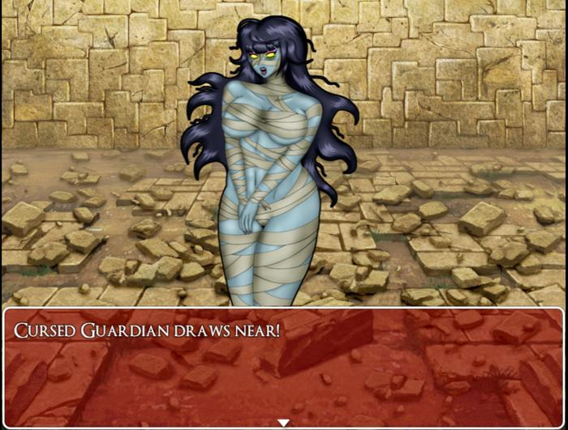
In this room you will have your first encounter with the Cursed Guardians. These mummies have high physical defense, but can be defeated easily with Bomb skills. They can also drain your health and inflict the Cursed state on Mila. While cursed, Your agility is drained and you will lose a small amount of SP and LP each turn. It can be detrimental in this dungeon if you don’t have a way to recover SP. Being cursed also slows you down outside of battle and you also cannot open chests while cursed. This will be relevant in an upcoming room.

Explore this west hall to collect a Salutem Laurel from a chest and a Supply Cache (s) in a vase. There is room that leads north, but you should ignore it. Inside is a trap which will toss you into a room filled with cursed guardians. You’ll have to defeat all of them to escape, which will put a dent in your resources. Continue east to find a similar room. This time there is a switch that you can press which causes a statue to move out of the way of another room’s entrance. This room is the queen’s treasure room, however, it is protected by a fog that will curse Mila as soon as she enters. If she remains in the room for more than 30 seconds, it will lead to a bad ending. We will need to double back to this room once the boss is taken care of. The last thing of note in this room is a chest containing a Medicinal Herb. Continue through the lower east exit. The other exit leads to a dead end. In this connecting hall there is an unmissable chest with a Praesidio Laurel in it and the other side leads to the east hall, connecting several important rooms.

Grab the Supply Cache (M) in the chest then go to the room to the northwest. It leads to a bath, which is the room where Rita fell down to, though she is nowhere to be seen. The door ahead is locked and the way to open it is by getting two keys that can be placed in the large crystals to the side of the door. Grab the Supply Cache (L) and Jade Shard from the vase then exit and make your way to the room next door. In this curious room, there are several switches, each marked with a roman numeral. What you want to do is press switches that add up to exactly 7 to unlock the vial at the center of the room. Getting the answer wrong will place a movable boulder in front of the room’s exit and the room will be filled with cursed fog. Failing to escape in the allotted time will result in a bad end. If you mess up along the way, press the 0 switch to reset the puzzle. Complete the puzzle to grab the Red Elixir.
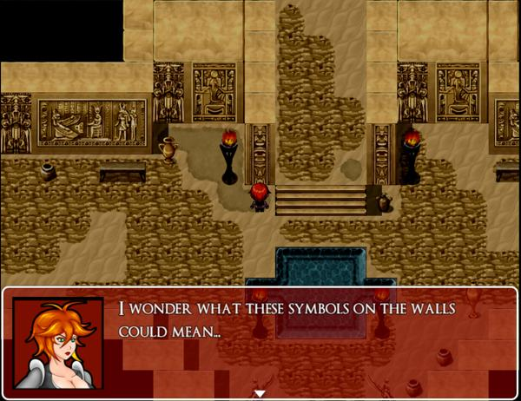
From the last hallway, enter the eastmost room to find a large sphinx statue, two sarcophaguses, and three movable boulders. Once you approach the boulders, the door will close behind you and cursed guardians will emerge from their rest to try and get at you. All that you have to do here is move two of the boulders onto the two switches to unlock the door and obtain the Turquoise Tablet from the sphinx. This is one of the keys needed to unlock the door in the bath.

For the last key, double back to the western stairwell. For an extra treasure, go there via the east stairwell to pick up a Ruby Shard inside of a chest. Once there, go through the southern exit. You’ll find a long claustrophobic corridor that leads to a statue. Pick up the Medicinal Herb and Vulnerary from the vases if you like and then use the Red Elixir when prompted and you will receive the Olivine Octagon. With both of these keys in hand, return to the bath and place the keys inside of the crystals. Heal up and be ready for a few fights.

Once you go through the chamber, you will be face to face with Asenath herself. She will try and mesmerize Mila and submitting to her will result in a bad ending. If you resist, she will summon more of her guardians to deal with you, Rita among them.
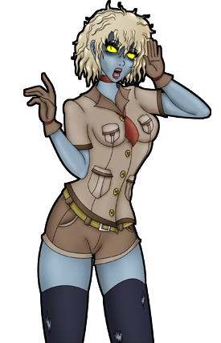
Mummy Horde
Max HP: 900 x 3
This fight isn’t tackled much differently than regular cursed guardians. In fact, they actually have less health than the ones you’ve fought individually. Use either cross or bomb skills, but don’t go too crzy using SP as there is another fight right after this.
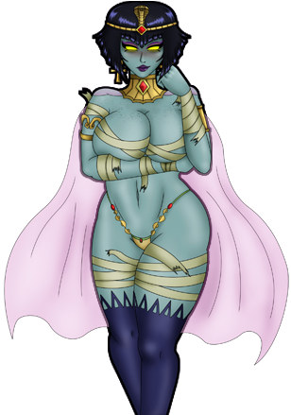
Asenath
Max HP: 10,500
Asenath’s gimmick is swapping between her undead and human forms. The only time you can do significant damage to her is while she is in her undead form. She will swap between them every four turns so use that knowledge to your advantage. Use the time where you can’t attack to heal or use buffs. Like the cursed guardians, Asenath is capable of draining HP as well as inflicting the curse state. Magna Flash is also effective, if you have it. This fight may take a little while, but you should have no issue as long as you remain patient and keep your HP high. Defeating Asenath will land you with Asenath’s Diadem as well as Pic 100 in the Picture Gallery! This headgear prevents curses, so go ahead and equip it to grab the real prize of this quest, the queen’s treasure! All of the cursed guardians will disappear after Asenath’s defeat, so it should be an easy sprint over to the treasure room. Here you will find six regular chests plus one gold chest! Inside the regular chests are one Silver Ore, a Sacred Elixir, 8000 Gold, Illustrious Garments, Ancient Royal Plate, and Pharaoh’s Heels! Take note that the armor found in these chests are permanently cursed, so you will need to equip Asenath’s Diadem to wear them without the drawbacks. If you did pick up the Skeleton Lexicon from chapter 4 before taking on this quest, go ahead and unlock the gold chest to unlock the Axera skill!

-SIDE QUESTS AND EXTENDED BAD ENDINGS

•Viviene’s Servant
-Availability: Accept Viviene’s proposal to become a vampire before her fight in Chapter 2
-Recommended Hunter Level: N/A

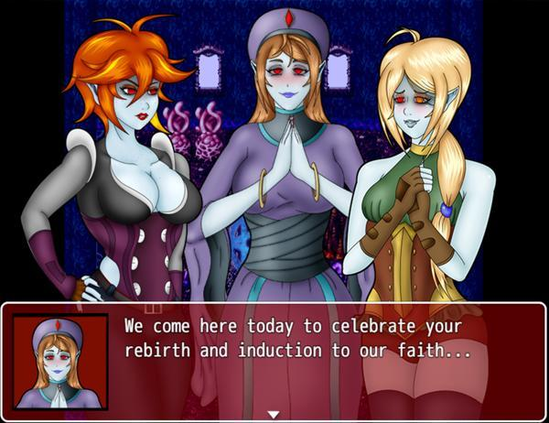

Despite all logical reasons, Mila surrenders to Viviene to become a servant of Satan. Viviene puts Mila under her control and receives the Eternal Blessing. Mila and Lucy will be turned into vampires and receive orders from their new mistress, Viviene to turn the members of Noctorna into blood thirsty vampires as well. After the scene, Mila’s memory will be wiped and will remain in her human form, thinking herself to be human as well.

Once you are back in control of Mila, you will notice that her sprite is a bit different, sporting red eyes! Keep in mind that since this is an extended Bad Ending, progress in the main story is no longer possible, so take caution to not save over your main file. All of your equipment will be taken away as well and your stats will reflect that of a vampire’s. You can re-enter the corrupted church and speak with Viviene and Lucy for a few interesting chats with them. If you leave south and enter the village, you will see all of the corrupted villagers return. You can share some nice conversations with your new brothers and sisters here too.

Your goal is to head to Noctorna HQ, but there’s lots of other scenes you can do before heading over there! You can begin by visiting Mor Town for a few extra scenes. It’s nighttime and most everyone has returned home. The only ones still awake are guards in Mor Town Center and shady folk in Mor Town East. Mila will comment on the scent of blood in the air making her thirsty. The guards here are on patrol and will not make suitable targets, however, if you enter the farm house here, a lone guard will be on break and you can visit him for a quick bite.

In Mor Town East, Mila can speak to a shady looking man there who will offer to make her into a prostitute. If you accept his proposal, Mila will be given three options for a tattoo design that will mark her as a prostitute. Your choice will be reflected in certain scenes, with some characters commenting on what they think of the design.
After you’ve made your decision, you can enter the eastern shelter where there are two clients willing to pay for a fun time with Mila. You can return any gold you make to Viviene for a short scene, but there is no ultimate reward for bringing her loads of gold! Oh well! On the second floor of the eastern shelter, you will also find Sybille, a character from an earlier contract! She will only appear if she is still alive at the end of her quest or if you have never accepted her quest. You can make her into a vampire, if you like.

As a vampire, the eastern part of the overworld is open for you to explore and there are scenes to be found in just about every area. You can find a scene outside of Besilly Cathedral, Abelleth Village, Ilbrooke, and Dorian Manor. All of these are areas you can explore more fully after completing chapter 2. (Be aware that the scene in Dorian Manor will end with it’s own bad ending). Once you are done exploring, return to Noctorna HQ.

In Noctorna HQ, you will attempt to take Maria as your first meal, however she will brandish a crucifix to force you to keep your distance, you must find another way. If you approach any of the holy items found throughout the HQ, Mila will turn away in fear. You can visit Mila’s room for a few interactables, particularly the mirror which will have Mila view her nonexistent reflection. Go to the bedrooms of the other Noctorna Hunters. Once you have bitten them, they will be subservient to you, obeying your commands. Once you have them both under your control, you can return to Maria, where your new slaves will rip away Maria’s crucifix, allowing you to get in close for a good bite. Once this scene is over, you will be returned to the Title Screen.

•Serenity Sleuth
-Availability: After the start of Chapter 2
-Recommended Hunter Level: N/A

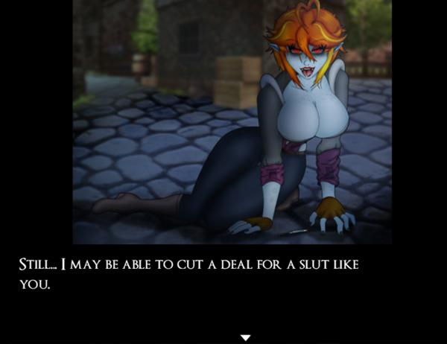
East Mor Town has a bad reputation for all of the shady things that go on there. One of it’s biggest issues is its drug problem. After you start Chapter 2, you can speak with a Serenity Dealer who will offer you to try the illegal drug. Should you refuse, you can speak with any of the guards to report him, ending his trafficking and unlocking you Pic 94 and 95 in the Picture Gallery. However, you can also accept the drug and use it if you prefer. Using Serenity has mostly negative effects. Mila will gain the “High” state, which raises her agility slightly, although her stats will be negatively impacted. Additionally, continued use of the drug will eventually cause Mila to become an addict. Her sprite will change and occasional detrimental effects will occur during battle. Purchasing more Serenity while an addict will cause the dealer to sell the drug at a higher price and attempting to purchase Serenity while an addict and without sufficient funds to pay for it will result in a bad ending. This ending can also be viewed during Viviene’s extended ending for slight changes in the art and dialogue. Mila should never speak with a guard while carrying Serenity in her inventory. She will be arrested and charged for possession. Should she fail to pay for bail, it will result in a game over. One last thing of note is that you can also reverse the effects of Serenity by visiting either Besilly Cathedral or Fallholt Cathedral. For 1500 Gold, the negative effects will be removed, however your permanent stat losses will not be restored and Mila will temporarily suffer from the “withdrawal” state. It will disappear on its own after some time has passed.

•The Heart of the Library
-Availability: Only if you did not slay the Bookworm at any point.
-Recommended Hunter Level: N/A

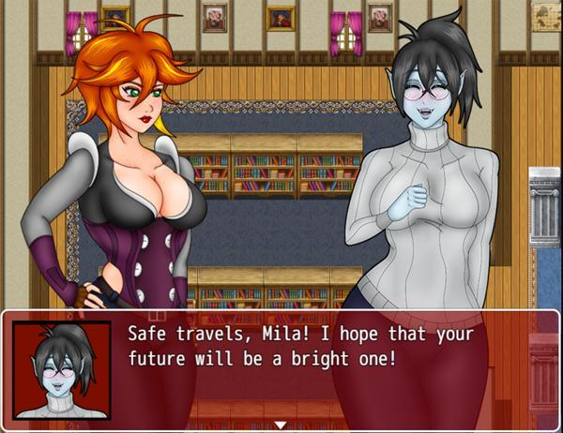

Return to Mor Town Center and you will find 2 guards speaking to an old lady. After she has yelled at them, the guards will leave and allow you to speak with her. It turns out this woman is the Bookworm’s grandmother. The Bookworm’s actual name is Bianca. Mila shows the Photograph she received from her and the old woman allows you to follow her into her house. When you speak with the old woman again, she asks if you can deliver something to Bianca if you run into her again. She gives you the Ragged Book. Return to the Cliffside Library and give this item to Bianca. She will be unable to control her emotions and give you a peek underneath her sweater. The two of you make up and it seems that this vampire girl will not cause you any trouble for the time being. Mila learns to be merciful and will gain the Light Skill, Compassionate Soul along with Pic 17 in your Picture Gallery. Compassionate Soul is an incredibly useful Light Skill which raises the amount of HP you regain at the end of each turn! Also, if you didn’t grab the Treat Wound skill while the library was still a mess, speak with Bianca one more time and she will teach it to you.

•Dubious Ingredients
-Availability: At the end of Chapter 2
-Recommended Hunter Level: N/A

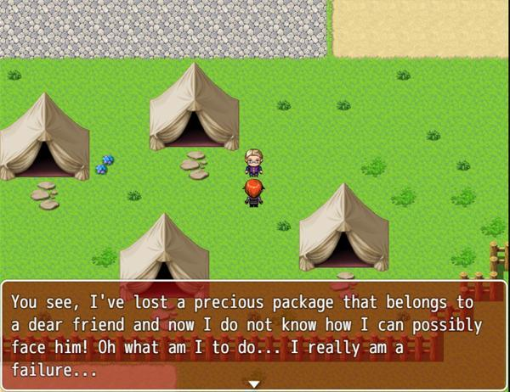

Go to Mor Town South and speak with a man standing by some tents. This incredibly odd man wants you to go to the Rotten Grove and collect some mushrooms for him. If you accept his request he will give you half of your reward immediately which is 200 Gold. Simply go to the Forest Maze section of the Rotten Grove and look around for Wild Mushrooms growing on the ground. There are several of these growing in this area and you must collect 5 of them to continue.There is no required combat during this quest, but if this is your first time visiting this area, be cautious of the durable Nosferatu enemies.

Return to South Mor Town and speak with the client again to see him jumping for joy at your return. He will pay you the remaining 200 Gold he owes you and task you with delivering one last item for him. He will give you the Package and tell you to deliver it to someone waiting for you at the abandoned house in East Mor Town. Mila will protest this, but the man’s demeanor will change to something much more sinister… It seems the choice of what to do with this package is up to you. If you deliver it to the abandoned house, you will get a Bad Ending in which Mila is turning into a vampire drug junkie.

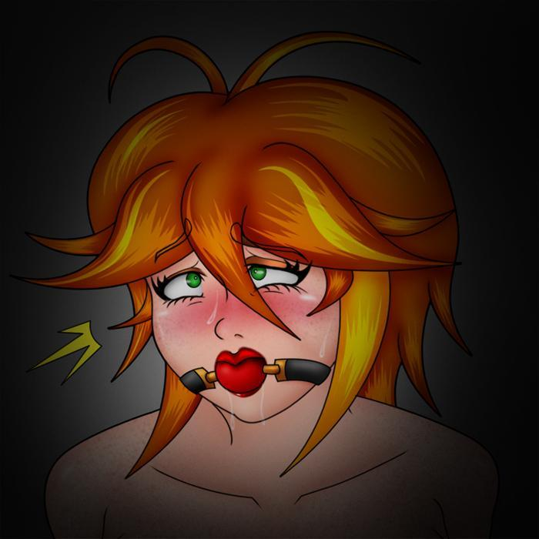

Give the package to one of the guards in front of the Mayor’s office instead and they will reward you with a Guardsman’s Pendant as well as unlocking Pic 25-29 in your Picture Gallery.

•Becoming a Member of the Blood Temple
-Availability: At the end of Chapter 2, while on the Blood Temple Contract
-Recommended Hunter Level: 11

Before the fight with Astoria and Alexa, they will attempt to seduce you into joining them. If you choose not to resist, the two of them will feed on Mila and turn her into a vampire. After control is returned to you, you will be controlling a naked, vamped Mila. Speak with Alexa and they will tell you that they must all report to their mistress. They will turn into mist and leave you behind to explore the temple as a vampire. You have the option to transform into a bat by selecting the Bat Form skill from the menu. While in the bat form, you will move much faster. If you would like to revert, use the True Form skill. Keep in mind that the Bat Form will use up about half of your SP, so if you revert you won’t be able to turn into a bat again. Make your way through the maze and back into the main halls of the temple. You can interact with all sorts of objects within the temple to get some unique dialogue from Vampire Mila. Once you’ve had your fun, meet up with Astoria and Alexa in the outdoor looking area by the stone slab. You will descend down into the crypt to greet your mistress, Victoria. Once you watch this scene, you will be returned to the Title Screen.

•A Simple Delivery
-Availability: After speaking with Dealer in Chapter 3
-Recommended Hunter Level: 50

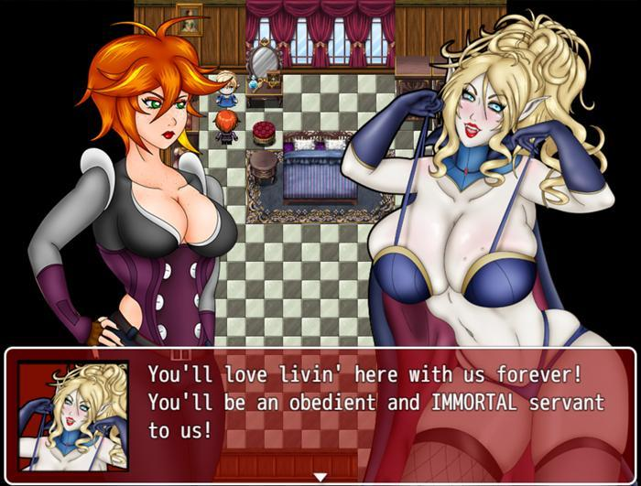

While the level of this quest is very high, the majority of it can be completed at around HR:10, although you will want to return with a higher level and better skills before facing the main boss. You will be prompted before it’s time to face him, so don’t worry about fighting him accidentally. My personal recommendation is to return to this quest once you have received some important items and skills in Chapter 5.

Return to Dealer at any point after receiving the dagger. He wants you to deliver a proposal to Lord Dorian and hands you 3000 Gold up front just for hearing him out. He does have another reward for you if you accept and return afterward, however. Speak with him and he will hand you the Proposal Letter. With that out of the way, leave Mor Town and head east towards the sea and you will find a castle surrounded by mountains. Cross the bridge leading to the castle. Follow the road and open the gate, which will lead you to the front door of Dorian Manor.

Once inside, you will be greeted by the manor’s maid girl. Dorian is unavailable, but she asks you to join them for dinner and walks toward the room in the east hall. The only room you can explore at the moment is a messy closet which has nothing to see inside. Follow the maid into the dining room and she will serve you a meal. Though the meal is quite good, it turns out the maid is quite hungry too and will transform into a vampire before your eyes.

Vampire Maid
Max HP: 1300

The maid doesn’t have anything special up her sleeve. She is just a standard enemy which you should be able to defeat with ease if you are at least level 10. With the maid defeated you will unlock Pic 33 in your Picture Gallery. We can now explore the mansion and get some goodies inside.

Start with the second floor and enter the first room on the left. By checking the wardrobe on the north wall you will find an Elixir. In the second room, you will notice something shining in the wardrobe to the left, although the wardrobe itself is locked and you cannot reach it. The wardrobe above it contains a Viribus Laurel and there is an Ammo Pouch and a Moonlite Tea inside the drawers and wardrobe on the north wall respectively. The last room on the right has 800 Gold in the middle wardrobe on the left wall as well as the last dark chest containing the Vampire Headdress. Head back downstairs and go to the end of the west hallway and you will exit the mansion to find a chest containing 950 Gold. Return to the west hallway and there will be two rooms to the north and south. The south door is locked, so enter the northern room to enter a library with a woman standing by a bookshelf. Speak with the woman to begin a boss fight.

Genevieve
Max HP: 1400

Genevieve is the first of Dorian’s brides who excels in magic. Her agility is fairly high, but her physical attack and defense are nothing to write home about. Her most devastating move is her Invoke Fire spell which can hit extremely hard. Keep your HP high at all times so that she doesn’t surprise you with her fire spell and defeat you! When Genevieve is at less than 40% of her health she will use Blood Heal to recover health.

After the fight Genevieve will seemingly turn into ash and disappear, but as you get close to the door, she will reemerge to tease you some more. She wants to introduce you to her Lord, but he is weak and recovering. She asks you to wait in the gallery across the hall for her and even unlocks the door so you can enter. Make sure your HP is at full and proceed into the gallery to the south.

Dorian’s personal gallery is a dim room with all kinds of artsy objects. In the middle of the room is a portrait of a woman you can examine. You will notice that the portrait also has a small keyhole towards the bottom… While looking at this artwork, Dorian’s second bride will surprise you, looking to punish you for entering Dorian’s personal gallery.

Scarlett
Max HP: 1650

Scarlett has very high agility and a good amount of attack. Her most devastating attack is her Summon Bats ability which hits multiple times and drains HP. Scarlett can also Wound you to further reduce your HP slowly.

After beating Scarlett, she will tell you to try and open the lock on the portrait if you can and then vanish. We need to find the key hidden somewhere in the mansion. Return to the middle room on the second floor to find a vampire frantically searching through her wardrobes. You’ll notice that the shimmering object in the closet has gone missing too. If you speak with the vampire she’ll ask you to help her look for her lost key. Speak with her a second time and the ditzy vamp will realize you’re actually a human. She’ll ask you a few questions, but regardless of your answers, you’ll have to fight her next.

Claudia
Max HP: 2150

This thick vampire has high defense and a lot of HP. She likes to hit you with very accurate bites to drain your health quickly, but she will also waste turns giggling to herself. Claudia has one very exploitable weakness that she will outright tell you if your HP falls below 20%. Her weakness to fire is very high. Spam Fire Bombs on her and you will find her to be an easy adversary. After beating Claudia, she will drop the Elegant Key onto the floor. Use the Elegant Key on the portrait lock to obtain the Master’s Key. This key can be used on the door found on the 3rd floor. You will have to fight the quest’s boss after this door and losing to him before reaching Chapter 5 means following the Vampire route (After reaching chapter 5, this route becomes inaccessible. To continue towards the vampire route, check the Vampire Route section of this guide).

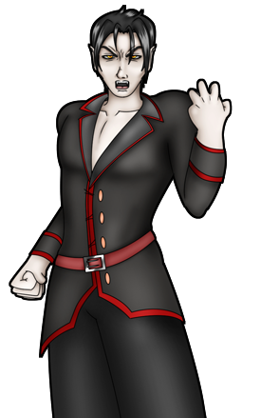
Dorian
Max HP: 10,000+

Dorian’s first form is a similar fight to that of his brides. His stats are much higher and he will act twice per turn. His Hellfire skill is also a stronger version of Genevieve’s fire based skill. Set up some buffs, like Compassionate Soul and Brave Soul and feel free to use Magna Flash as soon as you need it, since this will be a longer fight. The Dagger skills are the ones you will really want to prioritize using to keep his damage output under control. If you have the Daggerga skill, it provides a different debuff than the Daggera and Dagger skills, which means they can be stacked to debilitate Dorian even further! Once he is weakened use the Bomb skills to lay on the damage. The Bomb’s multi-hit property gives you a high damage output, especially if one of those hits becomes a critical one! Once you have dealt close to 10,000, Dorian will transform into a monstrous beast and the real fight will begin.

Dorian 2nd
Max HP: 25,000

Dorian’s second form is beefy. He is resistant to most skill types outside of Fire and Light and is capable of acting up to three times per turn. All of his attacks do a great deal of base damage, even when guarding, so it’s vital that you keep your health high throughout the fight. Setting up multiple buffs is not advised, as Dorian can use a skill which removes all of them. If you have obtained the summon skill from chapter 5, you will want to use it in this half of the fight. The stat boost and auto-life are the only buff exempt from Dorian’s buff-clearing skill. Dorian’s ultimate attack requires that he charge for a turn before unleashing it. This skill can be telegraphed as he uses it every 5-6 turns. You’ll either need to guard or use the item obtained in chapter 5 to reduce the damage. The bomb and Dagger skills continue to be your main source of damage each round. If you have any Supply Cache (L) on you, this is the fight to use it in.

Once Dorian is defeated and you’ve watched the subsequent scene, return to Dealer to claim the Dawnstone, an item necessary to forge the strongest weapon in the game, the Dawn Bringer!

•The Cursed Attire
-Availability: Anytime
-Recommended Hunter Level: N/A

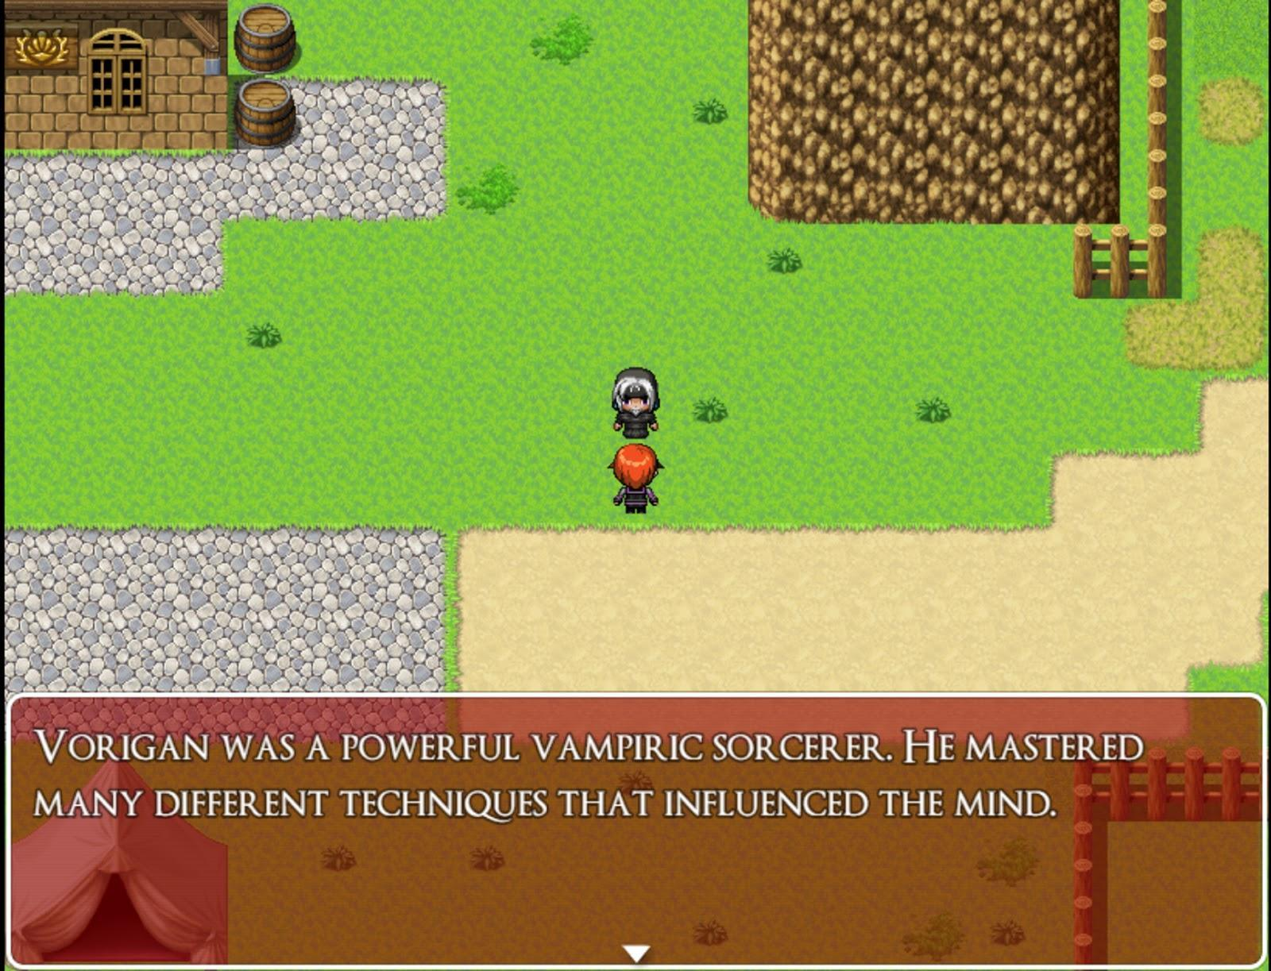
In Mor Town South, you can find an NPC that will tell you about cursed vampire equipment. Once you have collected all 4 pieces, you can return them to him and he will destroy them. In exchange, you will be rewarded with Pic 45 for your Picture Gallery and Count Vorigan’s Cane, a very useful item that acts like using a liquid silver toward all undead enemies! It’s reusable too, so feel free to sell off any Liquid Silver you have as they have just become irrelevant! Keep in mind that if you choose to ignore the man’s warning about the equipment being cursed and decide to wear all of the equipment, you will get a bad ending instead and become Count Vorigan’s newest servant.

The locations for each piece are:
Vampire Cape: Dining Room Basement in the Abandoned Manor (Humilem Village)
Vampire Boots: By the large tree in the center of the Forest Maze (Rotten Grove)
Vampire Corset: Trap Room (Blood Temple)
Vampire Headdress: Third Guest Room on the right (Dorian Manor)

•A Major Wager
-Availability: Chapter 3 after reaching Fallholt and completing contract 4
-Recommended Hunter Level: N/A

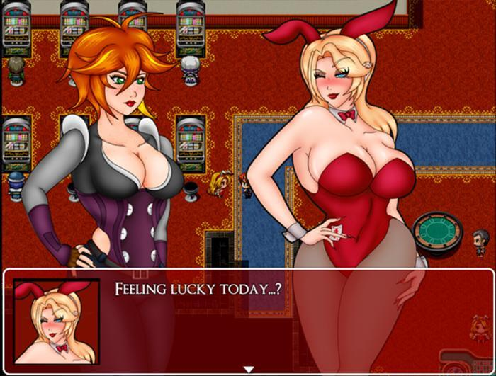

This casino area is a diversion you can spend some time on to earn gold or exclusive items. If you have the patience or get lucky, you can win the Critical Whip here, which is a whip that is guaranteed to land a critical hit, if it lands. Additionally, power ups like laurels and ammo pouches can be earned here indefinitely.

Speak with the blonde bunny girl at the entrance to receive the Casino Coin Purse and 100 Casino Coins to get started! With this, you will be able to collect and track how many coins you have collected at the casino. Use it directly from the menu. Once the bunny girl leaves you can start playing the slot machines. The machines on the bottom row are single coin machines while the top row are ten coin machines. Speak with the same bunny girl and she will tell you that if you earn 500 coins while playing, she will show you a backroom where higher stakes gambling takes place. To help a bit, you can find 80 coins for free by checking the glowing area on the southeast end of the casino.

Once you’ve either earned or purchased 500 coins (check the counter with the two bunny girls to purchase coins or cash out for gold), speak with the blonde bunny girl again and she will lead you downstairs to the private slot machine. She will ask you to try it out. Either play or refuse. Regardless of your choice, she will then want to play another game with you, a game with higher stakes.

It turns out that wasn’t your average bunny girl, but rather Aeriseth in disguise. She’s hungry for Mila’s soul but will give you a chance to fight back against her in a game of chance. You will have to face her in a game of blackjack. If you are unfamiliar with the rules, be sure you read them over as she explains them to you.

Aeriseth
Max HP: 9000

Despite this elder succubus’ high HP, the rules of this fight make that number somewhat irrelevant. All you need to do to defeat her is win three rounds of blackjack without losing three rounds first. You are unable to use healing items or any kind of skills that affect the parameters of the fight. Either select attack or guard and Aeriseth will begin dealing you a hand.

Once you’ve beaten her, Aeriseth will assist you in battle by giving you the Summon Aeriseth Skill. Not only does she swear her loyalty to you, but you also Pic 48 for your Picture Gallery! One last thing to note is if you speak with Aeriseth upstairs, she will give you the Bunny Girl Ears, which increases the odds of winning at the slot machines while you are wearing them. You can also choose to go downstairs and rematch your succubus servant to a game of blackjack, for a bit of fun.

•Turned into a Bunny Succubus
-Availability: Lose the card game against Aeriseth
-Recommended Hunter Level: N/A

So, you lost the card game against Aeriseth. Your luck has caused Mila to spend the rest of her days as a lesser succubus under the dominance of her new mistress. Aeriseth will task you with helping out the waiting staff. You can get a short scene of Aeriseth dominating Mila’s mind by speaking with her again. Otherwise, speak with the green bunny girl near the tables. She’ll explain to you your job and then 3 npcs will call you to order something. Speak with all three of them first to get their orders and then speak with the bartender on the right side of the wall. He will only hand you 1 drink, so you will need to pick the drink of the customer you wish to service. Each of the customers you select will give you a slightly different bad ending.

•Slime Cave
-Availability: Chapter 3 after reaching Fallholt and have Hunting Bow obtained
-Recommended Hunter Level: 7

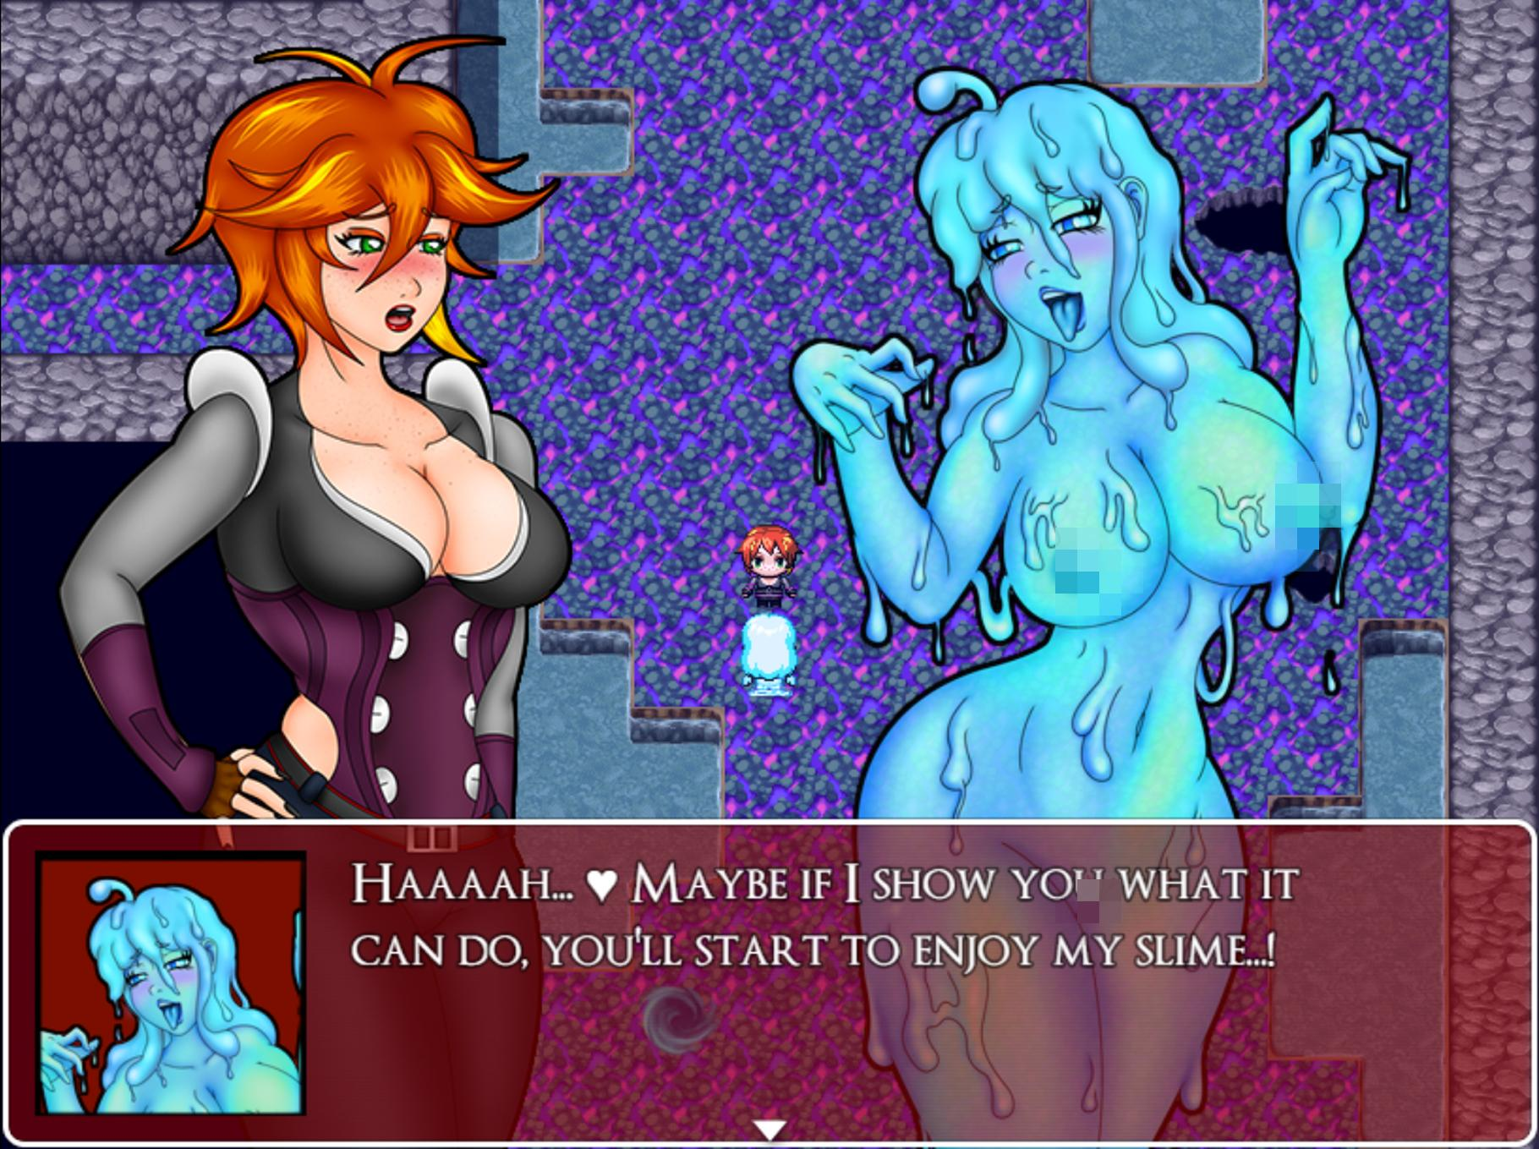

The Slime Cave is an area not tied to any specific side quest. You can enter and leave as you wish. There are some chests to find here. Explore the cave to find chests containing a Rubber Body Suit, 1200 Gold, and a Gold Crown, which doubles gold dropped by enemies! You can find regular slimes here which you can collect slime jelly from, but you can also fight slime girls who drop different varieties of slime girl jelly. Blue are common, pink are rare, and liquid metals are very rare.

If you spot a liquid Metal Slime Girl, be sure to try and beat it! It’s jelly is worth a whopping 10,000 gold if you manage to defeat it! Liquid Metal Slime Girls have incredibly high defense and speed. Only your regular attacks will damage it, doing a mere 1 damage. These slimes have 3 HP total, so you will need to successfully land 3 hits or get a critical hit to defeat it. Liquid Metal Slimegirls often run away so it will be a challenge to defeat one! Liquid Metal Slimegirls can be easily defeated if you manage to win the Critical Whip at the Casino in Fallholt! If you beat any of the slimgirls and collect their jelly, bring them to Jauffre and he will reward you with gold. The first time you do this, you will unlock Pic 47 for your Picture Gallery.

•Turned into a Slime Girl
-Availability: Lose to a Slimegirl
-Recommended Hunter Level: N/A

If you are beaten by any of the slimegirls, Mila will be corrupted and transformed into one of them herself. Depending on the slime girl that defeated her, she will transform into one of three different varieties. There are a few differences in the dialogues of the slimegirls you interact with depending on which kind of slime Mila was turned into. There isn’t much to this section, simply go towards the entrance of the cave to see how the scene plays out.

•Fenrir Glade
-Availability: Chapter 3 after reaching Fallholt
-Recommended Hunter Level: 12

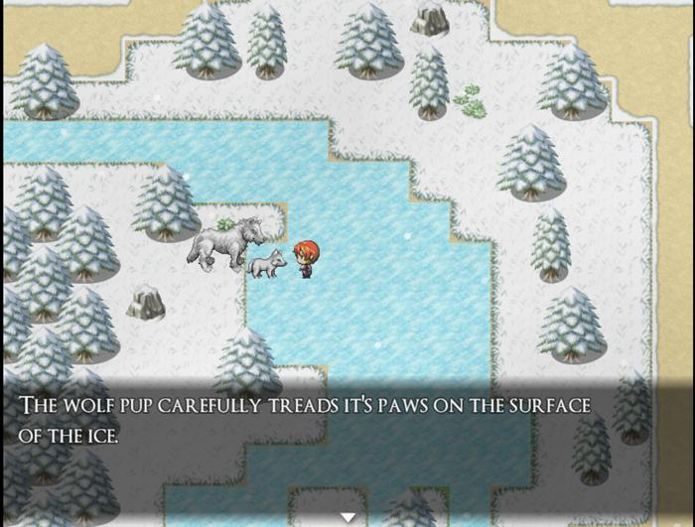

This forest is home to the Lycanthrope people as well as friendly wolves. Humans aren’t usually allowed in, but special cases are made for those who can prove their worth in battle. When you enter this frozen forest, you can find a chest to the right which contains a White Wolf Pendant, a decent accessory at this point in the game. Going north from here will lead you to a cavern. There is a chest outside of the cave containing 400 gold, but this cave will remain empty until you complete chapter 3. At which point, you can return here for an optional boss fight.
Jaclyn
Max HP: 6000

Jaclyn is a vampiric dominatrix living in the secluded cave which she has transformed into her own dungeon. She beckons you to join her, but if you refuse, you will be forced into a fight against her. Jaclyn is able to seduce Mila, entrancing her and making her incapable of making a move for 2-3 turns. She can also tease Mila and reduce her LP to 0, so try not to rely on LP skills such as purify too much in this fight. Defeating Jaclyn will earn you a Dominatrix Cap and unlock Pic 79 in the Picture Gallery.

From the entrance of Fenrir Glade, you head west to find two Lycanthrope Guards blocking your way. In order to enter, you will need to show your strength and defeat them both.
Lycanthrope Guards
Max HP: 1300 x2

The Cross skills aren’t particularly effective in this fight. While they do hit both enemies, both of the wolf girls resist Light type skills. You are better off taking them out one by one. The Dagger skills do tremendous damage to Lycanthropes due to their silver weakness. Axera also does solid damage, if you have the skill at this point in the game. Defeating them grants you access to Crescent Village and there are lots of goodies to grab here!

The main draw of this village is the tent with the torches in front of it. Here you can turn the gems you have collected throughout your fights and use them to upgrade your equipment! Speak to the lycan girl to the left for a full rundown, but be sure to take advantage of this useful feature while you are here!

Inside the village, speak to the red haired lycanthrope by the cooking spit to receive Cooked Rabbit Legs. Check the barrels in the north to collect 120 gold and a Garnet. Check the barrels inside the tents for 40 Gold, an Amethyst Shard, a Garnet Shard, and a Moonlite Tea. In the playground area to the left, there is a chest containing an Ammo Pouch as well as a young Lycanthrope girl who may become a relevant character at some point in the story… Finally, if you follow the frozen river to the west of the village, you will reach Fenrir Lake, which contains a sliding puzzle with a Diamond Shard as it’s reward. There’s multiple solutions to this sliding puzzle, but here is the one I found:
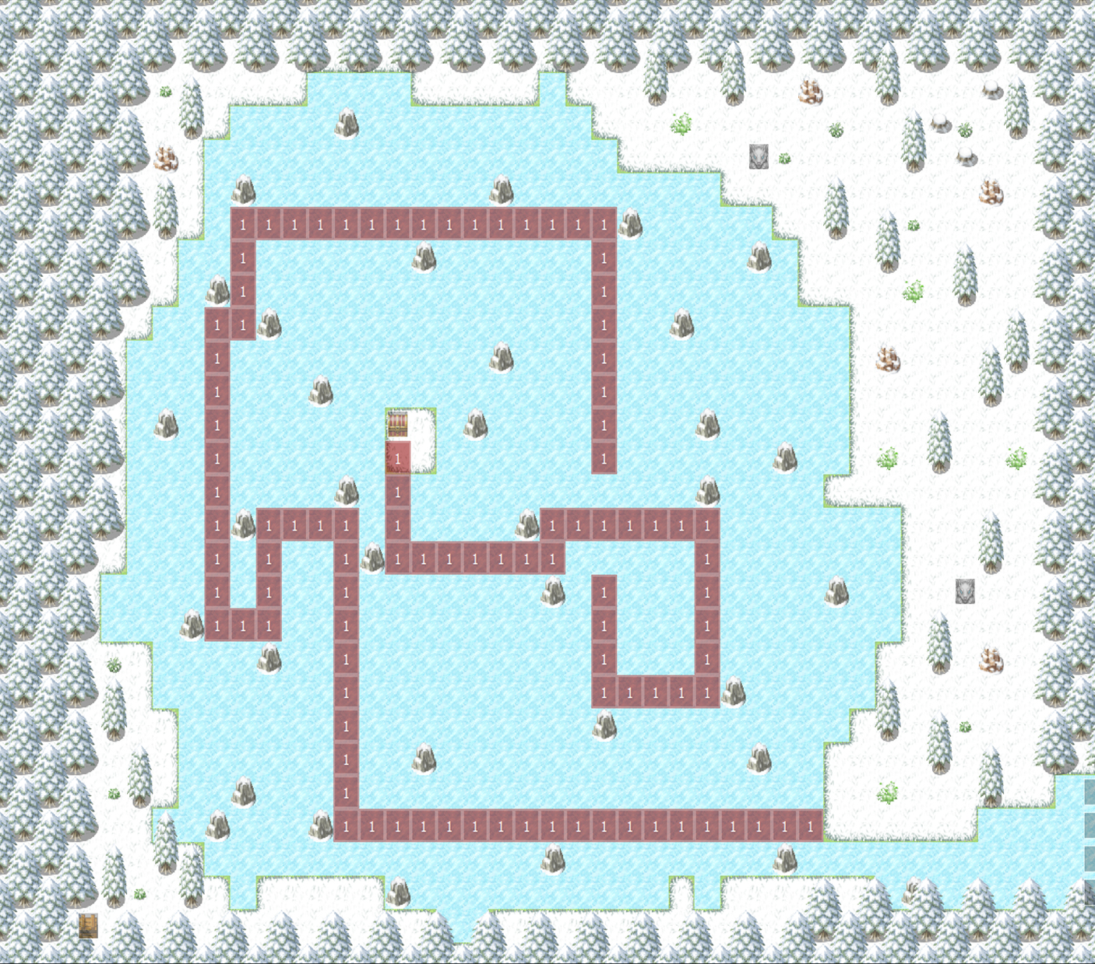

The Queen’s room is inaccessible until you return her for a contract that is unlocked after completing Chapter 3.

•Records of a Bookworm
-Availability: After completing chapter 2
-Recommended Hunter Level: N/A

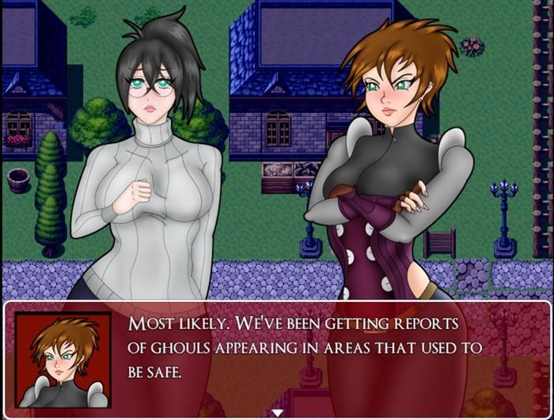
(If you spared Bianca on both occasions, you will need to have completed the side quest “The Heart of the Library” before this quest becomes available.)
This prequel story can be found by reading the shining book located in either the Cliffside Library Lobby or Faye’s laboratory, the same room where you fought her. Once you begin reading, you will be put in the shoes of Bianca. Since this quest is primarily story based, I’ll only be covering the short bits of gameplay.

Once you are in control of Bianca, leave her home to watch a cutscene with two mean girls. From there, head into Mor Town West and speak with the blonde woman to start another scene. The woman will leave and you will receive the Harvest from the farmer, Mr. Winkler. He informs Bianca to follow the blonde woman, named Mrs. Sauer, in regards to getting a job at the Cliffside Library. Follow her to Mor Town North and speak with her. After getting the information, you can return to Bianca’s home where her Grandmother is waiting for her outside. She’ll snap a picture of Bianca and hand it to her as a souvenir. You’ll receive the Photograph item which you can still view as usual.

After the scene of Bianca and her Grandmother speaking about the library reopening, you’ll have control of her again. This time your objective is to make it all the way up to the Cliffside Library. The woods are brighter and there are no enemies to deal with at this time. There are also no items to be found, so exploration isn’t necessary. Just head up to your destination. Once at the Library, speak to the Librarian for a series of cutscenes that connect to one another. You will regain control of Bianca briefly at her house. Leave her house to continue more scenes. You’ll once again regain control at the library. You can try and interact with the dragon statue for a quick gag, but speak with Mrs. Sauer to continue.

When you regain control of Bianca, you will be outside of the Library in the pouring rain. You now need to make your way down the mountain. The catch is, there are now ghouls blocking your path. You can easily escape from them if they catch you, but you can get surrounded by them in the narrow paths if you aren’t careful. Ghouls only attack, so you don’t need to worry about them inflicting the vampirism status on you. You can also enter the cave from which the Ghouls emerged from. This is the small vampire lair we know from the main story, but there is a deeper cave not normally accessible here. If you choose to enter it, know that it will result in a Bad Ending. Maneuver your way around the ghouls heading toward the exit to the overworld. You’ll run into Iris and she will take you to the Mor Tavern for a few drinks.

Bianca has a few too many drinks and when you regain control over her, she’ll be rather loopy and slow. If you speak to the last man at the counter, you will get a Bad Ending if you accept his proposal. Otherwise, exit the bar and walk back towards Bianca’s house. There will be a long string of cutscenes that play into each other, culminating in Bianca's inevitable turning. Once the scenes end, you’ll be in control of a naked, bitten Bianca who must now obey her mistress’ call. Walk to the coffin room downstairs and speak to the librarian for more scenes. Finally, you will have control of Bianca one last time and all you need to do is exit the room you are in and watch the last cutscenes. After the scenes, the quest is complete and you will unlock Pic 55-63 for your Picture Gallery! If you ever want to replay this quest, you can simply read the diary again at any time.

•Bianca’s Request
-Availability: Only if you did not slay the Bookworm at any point and after completing the “Records of a Bookworm” quest.
-Recommended Hunter Level: N/A

(The reward for the quest can also be obtained if you killed Bianca, though you will still need to complete the “Record of a Bookworm” quest before you can claim it.)

After reading the diary, speak with Bianca. She will mention to you that she is looking for a novel that she hasn’t read in years and would like to again. Unfortunately, the book was checked out of the Cliffside Library and she has no way of going out and getting another one. You are tasked with finding her a copy!

This quest is simple enough. Once you have reached Fallholt Castle, go to the library there and speak with the maid at the lower left corner of the library and she will provide you with the book. Simply return it to Bianca and she will hand you a combat manual that will earn you the Knifega Skill, the highest level knife skill!

If Bianca is dead, go to the library in Fallholt Castle after completing the diary quest and defeating the chapter 3 boss. Speak with the maid looking at a bookshelf near the middle of the room and she will hand you the same combat manual.

•Bianca’s Second Request
-Availability: After completing the “Bianca’s Request” and have reached chapter 4
-Recommended Hunter Level: N/A
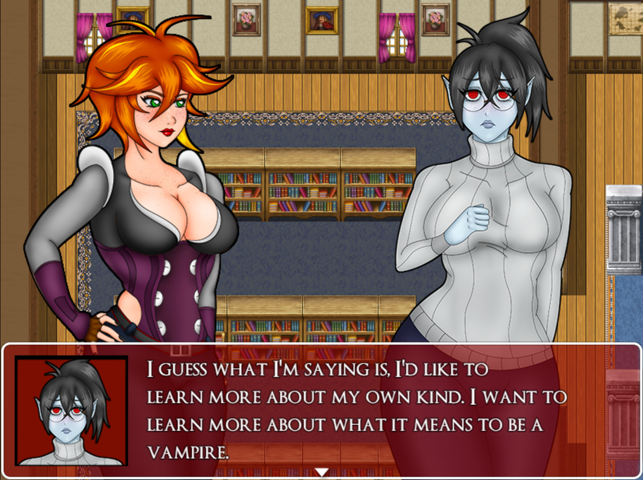
Speak to Bianca at the Cliffside Library to find out that she is a bit down. She wants to learn more about being a vampire and tasks you with finding a record of an older, experienced vampire. You can find one in the library of Dorian’s Manor (view the sidequest “A Simple Delivery” for more details). Records of the Dracul can be found sitting on a table in the library. Take it back to Bianca and she will reward you with another book which when read grants you the powerful Bombga skill!

•Bianca’s Final Request
-Availability: After completing the “Bianca’s Second Request” and have reached chapter 5
-Recommended Hunter Level: N/A
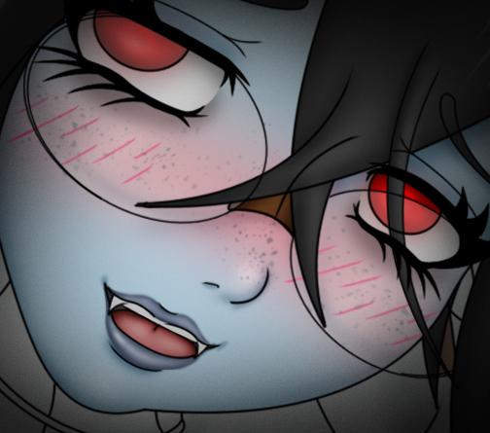
The final quest tied to Bianca is really more of a formality. If you’ve done everything else to reach this point, you’ve done your fair share of backtracking. All you need to do to complete this quest is agree to go with Bianca to visit her grandmother. Once you view the scene, you will be rewarded with the Light Skill Compassionate Soul + along with Pic 110 and 111 in your Picture Gallery!

•The Rocky Relationship
-Availability: Multiple Points from Chapter 1-3
-Recommended Hunter Level: N/A
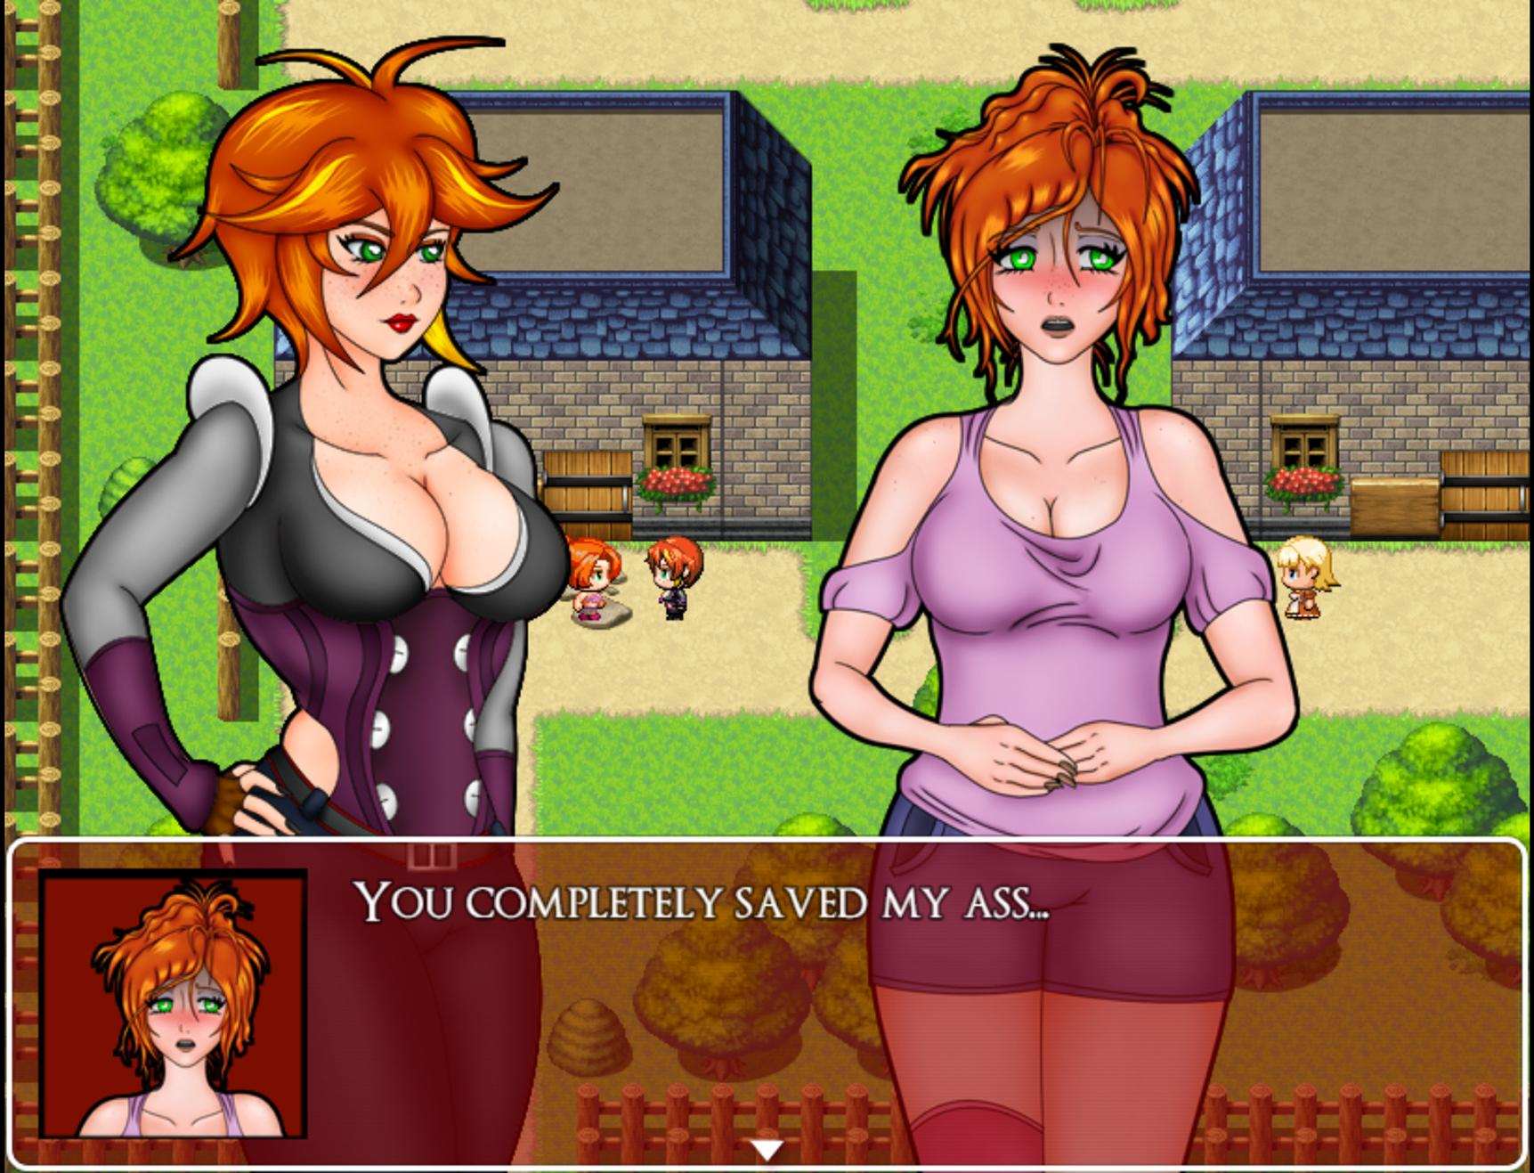
Jessica is the central focus of contract 12, but she can actually be interacted with at several points in the story before then. While there are no tangible rewards for viewing these scenes, dialogue in contract 12 will change slightly depending on which scenes you viewed before then. Here I will list all the locations and times when you can view each scene.

1 Mor Town Center. Available until the first contract is accepted.
2 Mor Town West. Available from defeating the librarian until Faye is defeated.
3 Mor Town North. Available after defeating Faye until the start of chapter 2. Viewing this scene alters future dialogue!
4 Mor Town East. Available from the beginning of chapter 2 until you enter Humilem Village.
5 Mor Town Flower Shop. Available from first dialogue with Viviene until the vampires appear in Humilem village.
6 Mor Town North. Available after beating Viviene until the end of chapter 2. Viewing this scene alters future dialogue!
7 Fallholt Cathedral. Available from the arrival in Fallholt until after the first visit with Princess Anja.
8 Fallholt, Residential Area. Available after the first scene with Princess Anja until the Castle is swarmed by vampires.
9 Fallholt, Behind the Cathedral. Available while vampires are swarming the castle until Charlotte is defeated. This scene includes a fight and a unique bad ending. Viewing this scene alters future dialogue!

•A Bat out of Her Element
-Availability: After Chapter 3
-Recommended Hunter Level: 22
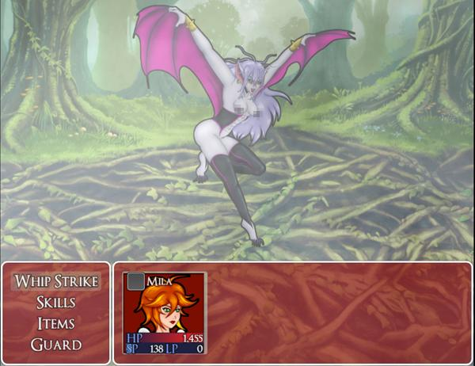

Pull up to Mor Town Tavern and speak to the woman right by the entrance to the contracts room to receive this quest. She’ll task you with taking down a Baitelle, a sort of bat harpie. She tells you that it can be found in the Rotten Grove, but not specifically where. That’s where I come in!
The Baitelle can be found in the pond area of the rotten grove, just east of the forest maze. She’ll be fluttering above the first cliff so just interact with her to engage.

Baitelle
Max HP: 2250

The Baitelle’s primary gimmick is the ability to fly high into the air and strike down a turn or so later. This move gets over your guard skill, so be sure to cap off your HP with an item or skill to make sure the attack doesn’t take you out. The Baitelle can also fly high to recover some health, but will only do this when her health is low. The Baitelle is fast and hits pretty hard and while her bites can’t inflict vampirism, they are more accurate and daze Mila which can put you in a bad spot. Their main weakness is knife and dagger skills, so put those to use whenever you can. Thankfully, the Baitelle will still drop a Vampire Fang after it dies, despite not actually being a vampire. Return to the woman at the Tavern to collect your reward, a Deep Bloody Plate and a Moonlite Tea as well as Pic 97 and 98 for your Picture Gallery!

•The Fall of Noctorna
-Availability: Lose to Gabrielle in Chapter 4 and become her underling
-Recommended Hunter Level: N/A

If you surrender to Gabrielle and accept her proposal to become her underling, she will oblige and you will be taken to a short scene where you corrupt the members of Noctorna, culminating in the return of Alexandria. All of the members will then be transported to Alexandria’s new castle and then you must speak with all of the newborn vampires to complete this bad ending.

VAMPIRE ROUTE

Chapter V-1

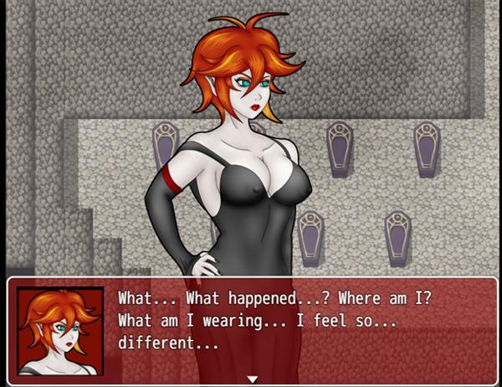

Would you rather become a vampire than continuing on as a vampire hunter? After completing chapter 2, you will have the option to forgo the main story and begin a new one where Mila will work alongside other vampires instead. This route does not feature bad endings for losing to enemies, but rather you will get scenes for progressing the story and defeating human enemies. To begin the Vampire Route, you must follow the sidequest “A Simple Delivery” and lose to Lord Dorian.

After being defeated by Dorian and watching the scene, you will be in control of Mila once again as well as unlock Pic 34 in your Picture Gallery. Mila will reawaken as an Ancient Vampire. You can check her status in the menu to see all that has changed. All of your previous equipment and items will all be gone, but more importantly, Mila’s memory seems to be mostly gone. She doesn’t understand why she has woken up here or anything else about her previous life as a hunter. From the coffin room, proceed upstairs to return to the dining hall of the mansion. Leave that room and a new vampire maid will greet you. She calls you her mistress with utmost respect and says that Dorian has been waiting to speak with you.

You can explore the mansion and speak with Dorian’s other brides for some dialogue. You’ll notice that Claudia’s demeanor in particular has changed quite a bit since you last saw her. Once you are ready, speak with Dorian in his quarters. He laments that it is his fault that you have lost your memory. Genevieve enters the room and states that if Mila drinks blood, her memories may return to her. As soon as she states this, the mansion comes under attack by vampire hunters. Follow Genevieve downstairs to confront the problem.

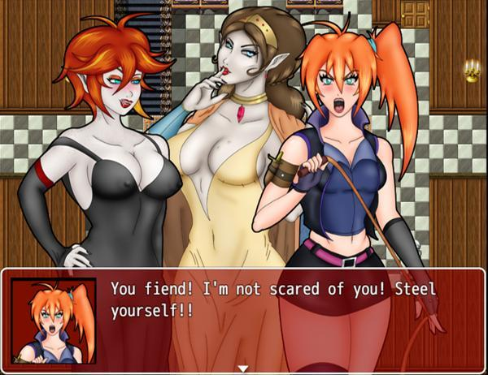

A group of vampire hunters have come to wreck your home and Genevive sees this as a grand opportunity to test your new powers.

Ophelia
Max HP: 1350

Ophelia is a well trained vampire hunter, but she is still nothing compared to your strength. Ophelia will use most of your old skills like Knife, Axe, Cross, etc. She and other hunters you fight also have the ability to perform 2 actions per turn. The only skill available to you at this time is Bite. If it lands, Ophelia will be given the vampirism status and lose health each turn. Halfway through the fight, Ophelia will cast Brave Soul on herself as well as recover all HP and statuses on her. Once she’s beaten, Mila will enjoy her first feeding.

Mila will fall unconscious after tasting Ophelia’s virgin blood. She will be reawakened by Dorian and Genevieve and some of her memories will have returned to her. Dorian will reveal that Mila has been dormant for over a century and the world outside has changed drastically. He tasks Mila with visiting a contact in Mor Town’s antique shop. Afterwards, he gives you the Cursed Whip, your new weapon! Mila will also reach Hunter rank 2 and learn the Mesmerize skill.You will also unlock Pic 35 in the Picture Gallery.

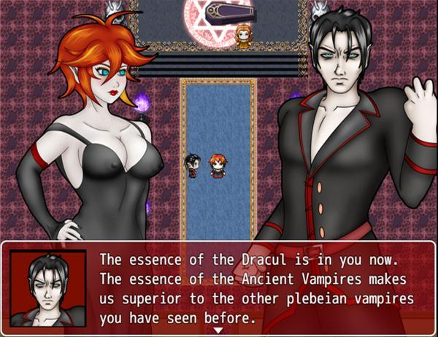

If you head into the closet downstairs, you will find Ophelia. Her mind is broken and all she can think about now is you. She is slowly turning into a vampire now, let’s return once her transformation is complete. You will immediately notice how much the world has changed as soon as you leave the mansion and enter the overworld. The color pallete is drab and the villages you visit will be very different than they were a century ago.

Before we visit Dorian’s contact, let’s quickly go over any collectibles there are to obtain at this point. It should be stated that while exploring the towns you must avoid contact with any vampire hunters patrolling the streets. If they spot you, you will be forced into a battle against many hunters at once. Your only choice is to run, however, the hunters you leave behind will sound an alarm causing all hunters in the vicinity to track you down and corner you. If you get surrounded by them, it’s game over. For that reason, Saving is impossible while in towns.
All other NPCs are safe to talk to. They will not notice your vampiric appearance.

•Abelleth Town (Future)

To the north of the village in front of the now closed Silver Mine is a gold chest with 300 Gold and near the southern exit is a red chest containing Low Quality Blood, a weak healing item. Check the barrels to collect 150 Gold, a Garnet Shard, and a Moonlite Tea.

•Ilbrooke (Future)

The devastated town is home to a few collectibles and not much more. Check the chests and barrels to obtain: a Lesser Succubus Choker, 2x Low Quality Blood, a Garnet, and a Bloody Plate.

•The Rotten Grove (Future)

The Rotten Grove still has a bunch of Ghouls and Nosferatu, though they will no longer attack you. This is also the first area where you can begin fighting off vampire hunters for Gold and Experience. Let me briefly explain how the leveling system works in the Vampire Route. When you defeat a vampire hunter, you will be given the option to either Turn the hunter, or Drain them. If you turn the hunter, there will be a short scene showing you biting the hunter you just defeated. The hunter will then collapse and after about a minute, they will turn into a vampiric ally that you can speak to. If you drain them instead, it will skip the biting scene and the hunter will collapse just as before, only will instead rise as a ghoul. You will level up every time you obtain 10 Blood Points. You gain 3 points for draining a victim and 2 points for turning a victim. During the story, you will run into virgins, which will net you 10 Blood Points regardless of whether you turn them or drain them. Blood Points cannot be tracked within the status menu.

There are quite a few collectibles to be found here. The layout of this forest has remained the same, so I will be referring to the item placements as I have been. The first area has a green chest in the northern portion that contains Good Quality Blood. The graveyard to the west has no items to get, so go east into the forest maze. To the northwest is a green chest with a Celeritas Laurel, towards the center-east is another chest with a Viribus Laurel, towards the southwest is a chest with Low Quality Blood, and finally at a small opening to the southeast of the maze is a chest with Vile Poison. Vile Poison works similarly to Liquid Silver in the standard route.

In the small grotto area south of the Forest Maze is a chest with a Mana Talisman, which raises your SP by 25 points. Return to the Forest Maze and go north to enter a section of the broken bridge area to open a chest containing a Praesidio Laurel. Run to the eastern pond area, climbing the cliffs to reach the other side of the broken bridge area. If you go towards the Blood Temple, you’ll see that the entrance has been blocked off by a vampire hunter. There will be a chest containing a Dark Dress here. Lastly, return to the pond area via the ground path of the bridge area to collect a green chest in the northeast section with a Low Quality Blood. Follow the pond leading all the way south to reach a chest containing a Salutem Laurel.

There are additional fights to be found in the Rotten Grove if you are looking for more of a challenge. I suggest you be at least HR 6 before attempting these fights. South of the Forest Maze, in the small grotto, you will find the gold knight Johannes and at the west end of the forest where the cemetery is, you will encounter Alyena. Speak with them and select the first option to begin the battle

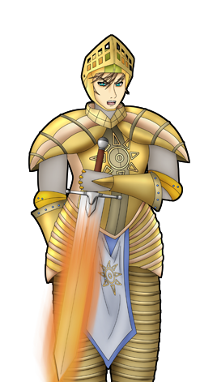
Johannes
Max HP: 7600
Johannes is a multiphase boss. Initially, his attacks shouldn’t do too much. He is also immune to the Vampire and Entranced statuses. Johannes also likes to block attacks, so you should focus on just attacking and healing if needed, but save any stronger moves for the next phases. Once you have dealt at least 3800 damage to Johannes, his stats will increase for a few turns and he will recover all of his HP. If you bring him down to half health a second time, he will again increase his stats, though this time will sacrifice most of his defense for raw attack power. His attacks deal very heavy damage at this point, especially the multi hitting fire bomb move. Guarding if you are close to half health of less may be a good option at this stage. Johannes uses up so much power he will occasionally fatigue himself and miss a turn or two. This is your chance to either recover or go in for stronger attacks. While in this last form, he also loses his immunity to Vampire and Entranced statuses so take advantage of that. Defeating him will earn you Johannes’ Plate and Unlock Pic 43 in your Picture Gallery.

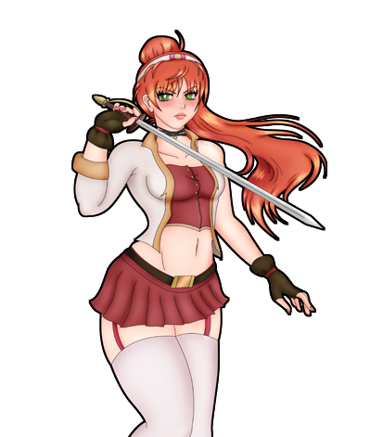
Alyena
Max HP: 1850

Alyena goes back and forth between attacking with her blade and using magical spells. Every two turns, she will switch between these stances so that you can anticipate what she will do next. She has a variety of attacks in both forms, but her most damaging move is her Fencing Blade skill while she is in her sword form. Alyena is susceptible to Mesmerize and if you use it on her a turn after she has switched forms and it lands, she will miss the chance to switch forms. I recommend doing this while she is in her magical form, because it is much easier to deal with the attacks she uses while in this form. About halfway through the fight, she will power herself up, much like Ophelia did during her battle, so keep that in mind. Defeating her will earn you Alyena’s Ring and Unlock Pic 44 in your Picture Gallery.
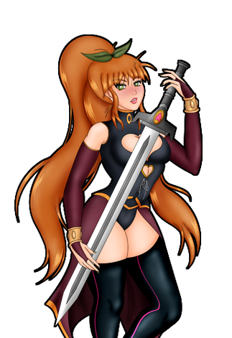
Jaina
Max HP: 5000

Jaina is fast, VERY fast. You are not likely to go first in this fight, so be prepared for that. One of Jaina’s main attacks is the bomb skill, which you should know occasionally prevents you from attacking. Combined with her ability to occasionally attack twice may put you in a tough spot if you are unprepared. Jaina has low HP compared to the other hunters though, so just keep up the pressure with status effects and you’ll be fine. You will receive Jaina’s Pendant after defeating her and unlock Pic 80 in the Picture Gallery.

•Noctorna HQ (Future)

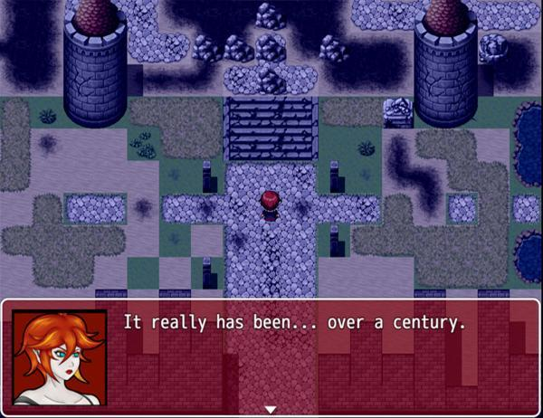

Your old HQ lies in ruins, all that remains are memories and a few pickups. There is a shadowy figure among the ruins. Once it notices your presence, it will flee north. Check all the shimmering spots to find a Broken Whip, Rusted Noctorna Armour, and a Rusted Noctorna Helmet. The two armor pieces can be equipped immediately, but the Broken Whip is currently useless.

•Mor Town (Future)

Mor Town has seen the most changes in layout in the time gap. Starting with Mor Town North, you can collect Low Quality Blood in a chest to the west and a Brew of Mana to the east between two houses. In Mor Town West, you can find 200 Gold near the connection to Mor Town North, a Vile Poison between, and an Amethyst Shard inside of a barrel near the farmlands. Mor Town South is the base of operations for the Knights of Friedrich, your new nemeses. Next to the Antique Shop is a chest with a Viribus Laurel. In Mor Town East, enter the East Shelter to find a chest containing a Sapphire Tiara. All of the shops here are closed, so we will have to do our shopping elsewhere. In the northwest is a chest with a Ghost Pendant, to the northeast is a chest with Steel Plate armor, and to the southwest is a chest with a Reinforced Corset.There is also a barrel containing 50 Gold.

Head inside the Antique Shop in South Mor Town to meet Dorian’s contact. He happens to be the bald man who sent you to meet Dorian over a century ago! His name is Dealer and although you request his help, he refuses. Mila will attempt to dominate his mind, but unbeknownst to her, Dealer is much too powerful to be overtaken. After the lewd scene, he will task you with bringing to him Eliza Friedrich, the leader of the Knights of Friedrich. This is no small feat, as she is sure to be well guarded, but you’ll have to do this if you are to get Dealer’s assistance. Once the conversation has ended, you will unlock Pic 36 in the Picture Gallery. There is also a book you can read in the Antique shop which will unlock all of the standard route’s Pics in your Picture Gallery! Once you step out of the antique shop, you will sense that Ophelia’s transformation is finally complete. If you would like to divert from the story for a moment and purchase some items, check Ophelia in the Pets section of this guide.

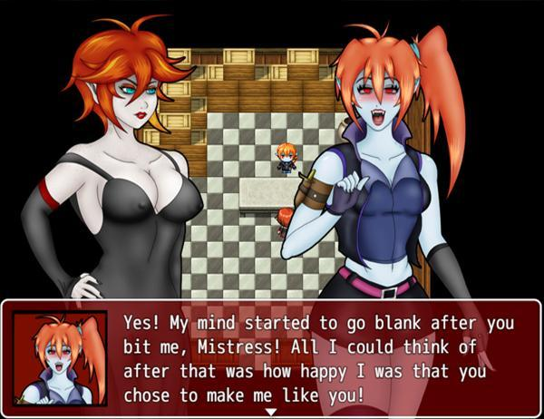

You’ll need to find the whereabouts of Eliza before you can continue. If you enter the Tavern in Mor Town center, there will be some hunters gathered around a table who are all perfectly safe to speak to (they’re on break after all!) One of the hunters will mention Eliza heading towards the Cliffside Library so let’s head there. Speak to a man sitting at the westmost table before you leave. He will give you a Defense Brooch.

•Eastern Mountains (Future)

In this initial area you can find a chest containing a Low Quality Blood, and another with some Lucky Panties. The alcove leading east has a chest with a Brew of Mana. Go up the mountain cliff towards the library and enter the cave that used to be a vampire lair. There is a lone hunter here you can fight if you like and a chest containing a Celeritas Laurel. Once you are in front of the library, be sure to save if you haven’t already.

•Cliffside Library (Future)

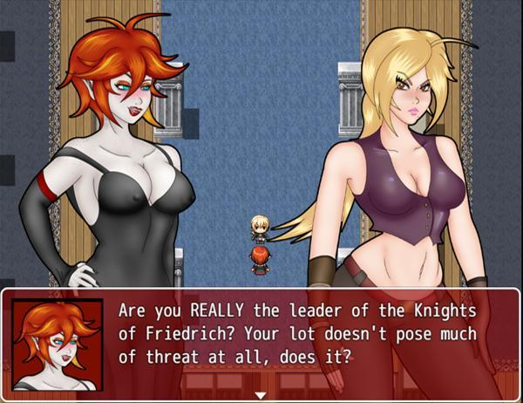

The library’s appearance will vary based on whether or not you killed the Bookworm vampire at any point for beginning the Vampire Route. If she was slain, the library will be in an even worse shape than it was before and the Vampire Hunter Leader we believe to be Eliza will have found and killed her targeted vampire. If the bookworm was never slain, the library will be in pristine condition and the Vampire Hunter Leader will still be searching for her target. Either way, a boss fight will commence.

Vampire Hunter Leader
Max HP: 5900

The hunter leader has a ton of HP, but your damage output should be more than enough to make this fight a drawn out victory. A few things to note, the hunter leader will purify herself if you land a Bite on her and when she is close to health she will begin to use Brave Soul to buff her attack and defense. Use Mesmerize as much as you can here. It is a very useful stalling tool against this boss.

Once the hunter is down, Mila will turn her into a vampire to obtain information out of her. We find out that she isn’t actually Eliza Friedrich, but just the leader of this particular group of hunters tasked with defeating the vampire in the mountains. Mila sends the former hunter leader out to find out information on Eliza’s whereabouts and you will unlock Pic 37 in your Picture Gallery.

Before you leave the library, if you never killed the Bookworm in the standard route, she will be on the west side of the library and you can speak to her. After speaking with her, Bianca the Bookworm will become your newest Pet. She will wait for you in Dorian Manor. Check the Pets section for more information on Bianca.

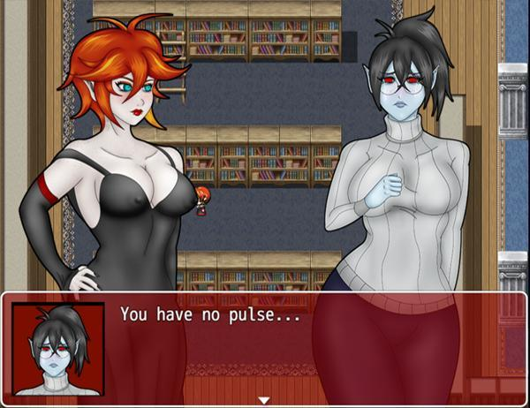

Return to Dorian Manor and a scene will play with Mila recounting the recent events. Once the scene is over, you will be forced to speak with Claudia, who will return to you your Quick Travel Widget, allowing you to return to Dorian Manor from any Gemmare Statue. To proceed to the next chapter, return to the coffin room where the vampire route first began and rest in your coffin.

Chapter V-2

While resting in her coffin, Mila’s slumber is interrupted by Geneveive. She tells Mila that the hunter she turned recounts that Eliza Friedrich is currently in Humilem Village. That is your next destination, however Genny also tasks her to be on the lookout for something called a Malisphere, which sounds familiar to Mila. Once the scene is over, you will unlock Pic 67 in your Picture Gallery. Attempt to leave the Manor where another scene will play involving Claudia and Ophelia. Claudia now seems to be looking for Eliza as well, though she doesn’t seem to want to work together with Mila. Once the scene is done, head west toward Humilem Village.

The road to Humilem Village now has a road leading you in the right direction. Once you are a bit deep in the woods, there will be a scene where you will encounter a blonde warrior named Vicilla. During this scene, a choice will be presented which will alter a few events in this chapter. You can either choose to attack Vicilla, or leave her be.
If you attacked Vicilla…
Vicilla
Max HP: 4500
Vicilla has high attack, but low defense and abysmal magical defense. She is also more susceptible to being entranced than the average boss enemy. Her main form of attack is using her axe and axera skills, which hit hard, but are inaccurate. Once she is taken care of, you will unlock Pic 74 in your Picture Gallery. Enter Humilem Village.

If you let Vicilla go…

Vicilla will leave your side and return to searching for her partner in the woods. Follow the path into Humilem Village.

•Humilem Village (Future)

Humilem Village has been reestablished with citizens and even though Mila is here looking for Eliza, turning the poorly guarded town into a lair for the undead becomes her new goal. Speak with everyone in the town to attack them. Check every area, including the insides of houses for villagers. Whether you decide to turn them into vampires or ghouls has no effect on how the story plays out, so do whatever you like. Collectibles in the village include: Low Quality Blood, 25 Gold, 35 Gold, 15 Gold, Draught of Mana, 20 Gold, 100 Gold, and a Mana Talisman. Once you have attacked everyone, a scene will play out in the village’s main square depending on your choice with Vicilla from earlier.

If you attacked Vicilla…

You will be introduced to the hunteress, Eve. Although your vampiric minions surround her, you’ll still have to face off against her to continue.
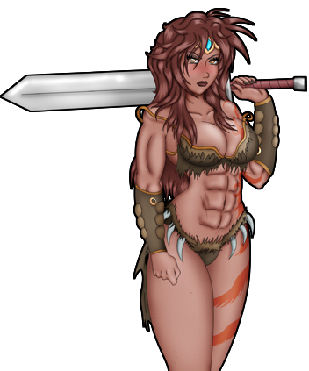
Eve
Max HP: 4900
Much like the fight against Vicilla, Eve sports high attack and low defense, although her speed is higher. Eve uses sword skills to attack, including a multi-hitting attack.

If you let Vicilla go…

Eve and Vicilla
Max HP: 4900
Despite having to face off against two hunters from the get go, don’t waste your time attacking Vicilla. After a few short rounds, she will flee the fight and abandon Eve. Eve sports high attack and low defense. Watch out for her multi-hitting sword attack.

Once Eve is down, Mila will claim her. The entranced Eve will lead the way towards where she was meeting with Eliza Friedrich, The Friedrich Knights Sanctuary. After this scene, you will also unlock Pic 68-73 and Pic 75 in your Picture Gallery.

•Friedrich Knights Sanctuary
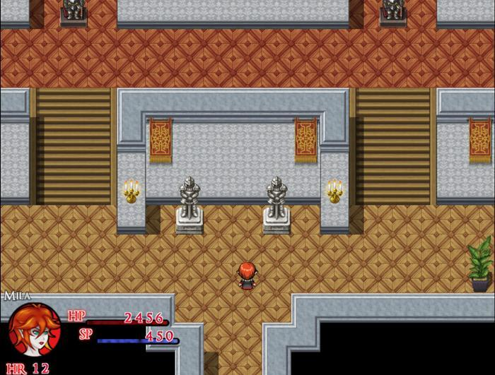
This three floor mansion is one big puzzle. The goal is to open the locked door on the third floor by entering a 4 digit passcode. The first clue can be found in the room immediately to your right on the first floor. On a scrap of paper, you can deduce that the third digit is 3. Be sure to pick up the Hex Plate in the chest too. The second clue is in the room across from this one. Check the bookshelf and a scrap of paper will fall out of it. Check the paper which will read that the second digit is the suits of armor in the main hall. Don’t be fooled by the statues of armor, the correct answer for this is 2! Before you leave this room, grab the Vile Poison from the cabinet on the western wall.

The third clue is on the second floor in east room 2B. The note with the clue states that the first digit is the number of plants found in the mansion. If you go through each room, you will find that your answer is 8. Remember to check the vase for another Vile Poison and the next door room for 65 Gold. In the west hallway, check the rooms to find a Viribus Laurel, and a Pendant of Ruin. The final clue is found on the second floor hallway leading to the third floor. Glass can be found on the floor coming from the broken window in the center. If you go outside and around the mansion to investigate, you will find a scrap of paper with the fourth digit, 9. You now have the entire code:8239. Be sure to save before walking through the door.

As you enter a scene will play and Mila will find what seems to be the Malisphere she was looking for. Before she can get a good look at it, a wolf girl steals it from her grasp. She calls herself Eliza Friedrich but runs away before you can fight against her. Mila will then be surrounded by three vampire hunters, which you will need to fight against. Using the flame skill is recommended since it can hit all of your targets at once! Once the hunters are taken care of, leave the mansion and towards the back of the village that was gated off. The gateway is now open and you will face off against the main boss of this chapter, which is dependent on your choice with Vicilla from earlier.

If you attacked Vicilla…
Eliza Friedrich
Max HP: 7000
This wolf’s defining trait is her high agility and high attack. From the beginning of the fight, she will cast Brave Soul on herself and increase her attack and defense. Try to play defensively until her buff wears off so that she doesn’t catch you off guard. Once her buffs are gone, try whittling away her life by stacking damaging debuffs with Vile Poison, Claw Swipe, and all flame attacks. Be aware however that as a werewolf, Eliza is immune to the vampirism stat.

If you let Vicilla go…
Newborn Wolf Vicilla
Max HP: 6000
Vicilla has an enormous attack stat with access to high damaging skills like Axe and Axera. Use Blood Aegis if you have access to it to buff up your defense. Take advantage of Vicilla’s near non-existent magical defense. Casting flame skills to burn her will not only be an effective way to damage her, but the burn will also cripple her attack stat. Try to always keep your Health high so as to not be taken off guard by a devastating critical hit from her. Beating her will unlock Pic 74 in your Picture Gallery.

Once the fight is over, there will be another cutscene and you will ultimately be transported in front of Dorian Manor. To continue the story, just head inside to trigger an event. Alternatively, you can return to Humilem Village to find both Eve and Vicilla by the church who are now vampires themselves. You can speak with both of them, but the main prize is inside of the church, which is a chest containing an Ultimus Laurel! Once you are back at the manor and watch the cutscene, follow Genevieve into the third bedroom and speak with her to trigger another cutscene. After this scene, you will also unlock Pic 76 and Pic 77 in your Picture Gallery. Return and speak with Maye outside to watch the final scene for chapter 2-V.

PETS

During the course of the vampire routes there will be certain characters that you will be able to dominate and turn into your slaves. These characters can be trained to grow stronger while earning you Blood Points to level up at the same time. Each time your Pet increases in level, a new conversation with them is unlocked. Some Pets will have added benefits to training them, for example your first Pet, Ophelia will run a simple shop at level 1, but will add more items to her stock the more you train her. Pets gain experience each time you battle them, even if you lose. Defeating them yields more experience however. They also gain a small amount of experience whenever you have a conversation with them. As of version 2.3 Pets are capped to level 2.

•Ophelia
-Availability: After speaking with Dealer for the first time

Ophelia will be waiting for you in the closet space of Dorian Manor. Once you have had her initial speech, she will sell her own stock of items for you to purchase.

Ophelia Lv. 1
Max HP: 1850

Item Stock:
Low Quality Blood - 30
Brew of Mana - 150
Vile Poison - 250
Ruby Tiara -250

Ophelia Lv. 2
Max HP: 2500

Item Stock:
Low Quality Blood - 30
Brew of Mana - 150
Vile Poison - 250
Viribus Laurel - 800
Salutem Laurel - 800
Praesidio Laurel - 800
Celeritas Laurel - 800
Bloody Plate - 1000
Dark Dress - 1200
Ruby Tiara -250

•Bianca
-Availability: If she was never slain during the standard route; after defeating the vampire hunter leader at Cliffside Library

Bianca will be waiting for you on the leftmost bedroom on the second floor after you have recruited her. Bianca offers the quickest training of any Pet in the game.

Bianca Lv. 1
Max HP: 750

Bianca Lv. 2
Max HP: 1600

Gold Chests

Gold chests can be found throughout the game, but they cannot be unlocked until you obtain the Skeleton Lexicon in the dungeon of Chapter 4.Here, I will be marking the locations of each Gold Chest as well as the contents of each.

Mor Town Mayor’s Office - Crystal Plate
Humilem Village House - Ammo Pouch
Lingrave Clinic Dungeon - Ethereal Scarf
Blood Temple Treasures Room - Prism Core, 3000 Gold, Noble Robe, Sacred Elixir, Celeritas Laurel, 4200 Gold, Sapphire, Jade, Viribus Laurel, Ammo Pouch.
Abelleth Village Silver Mine - Silver Ore
Fallholt Castle Armory - Silver Ore
Fallholt Castle Treasure Room - Diamond, Prism Core
Crescent Village Alpha’s Hut - Moonstone
Pyramid of Asenath, Queen’s Treasure Room- “Axera” Skill

